Iitllillt imllnllimlilm 111! lillll 11! f i! f 111111 < 11 v t i I! f I iiiiitiiin

J 3()3

H W WHITMAN JR SECURITY ENGR CONSULTANTS F’O BOX 48086 ATLANTA GA 30362-1083

OCIATED LOCKSMITHS OF AMERICA, INC.

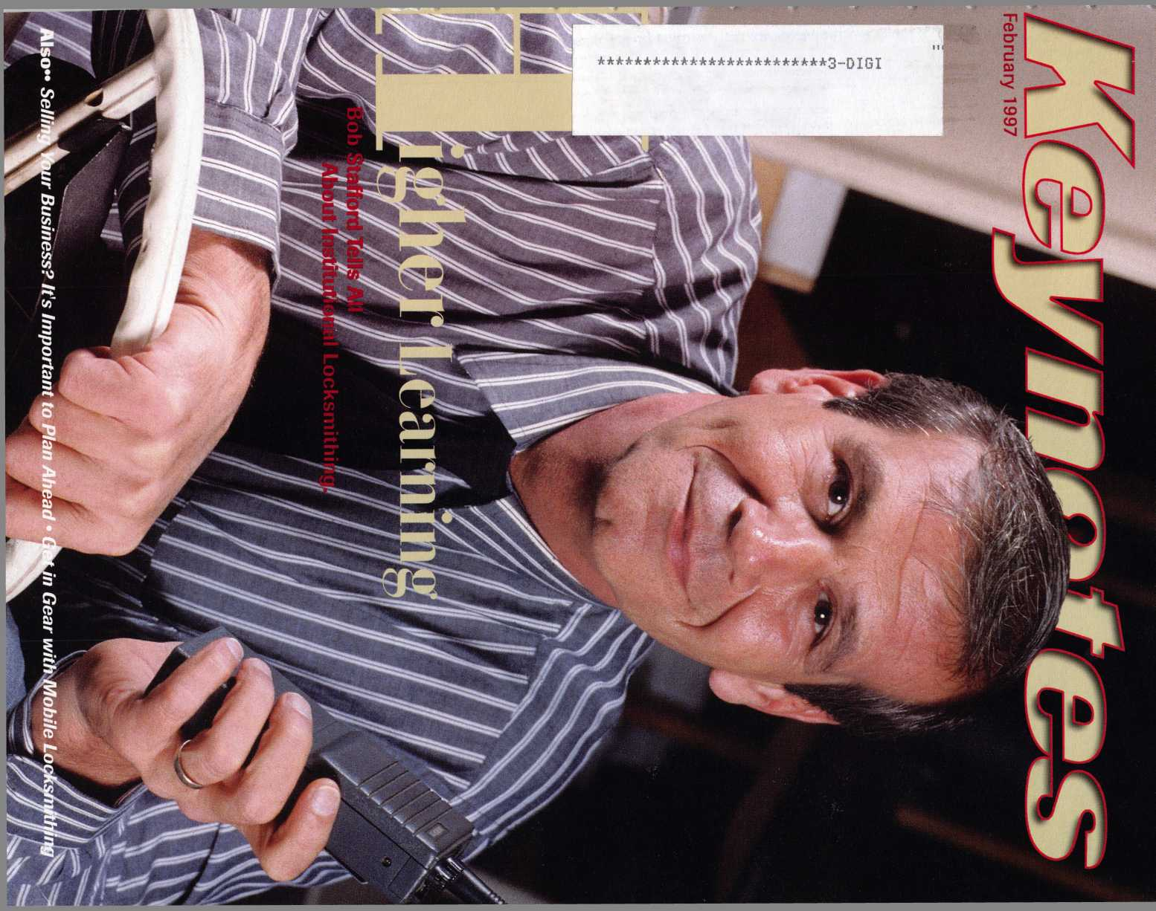

Trade Show

iay 5-10 The Galt House

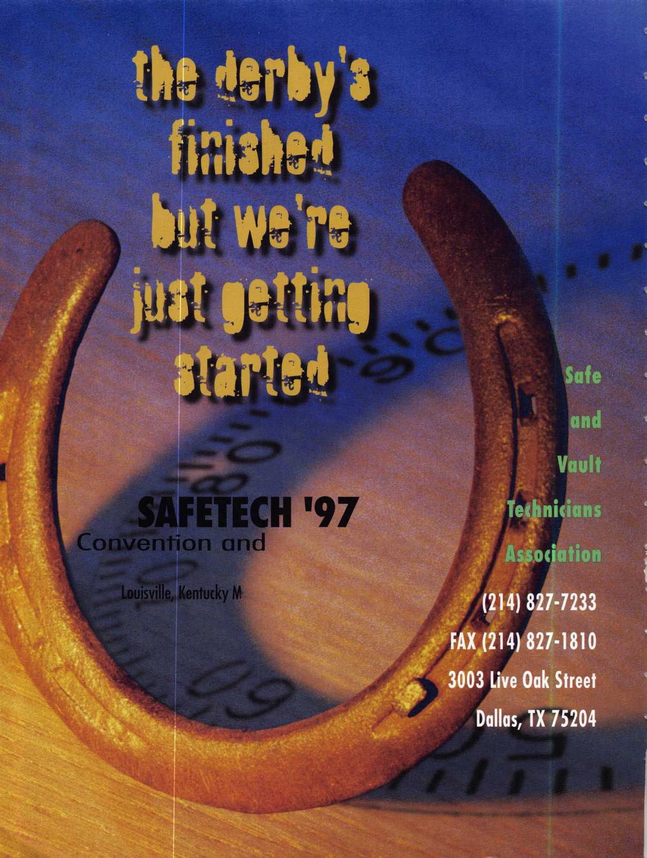

**Silllll**

**AUGUST 2,1997 CONVENTION CENTER HOTEL**

**RENO, NEVADA**

**WITH QUESTIONS OR COMMENTS CONTACT:**

**ASSOCIATED LOCKSMITHS OF AMERICA, INC 3003 LIVE OAK ST.**

**DALLAS, TEXAS 75204**

**214-827-1701**

**800-532-2562**



A Word With

David Lowell

‘You all have been very supportive of the changes we are making”

This month our feature articles are on specialization and you will be introduced to several  
locksmiths who have chosen to specialize in varying degrees. Also featured are continuing

rticles from Sal Dulcamara, CML (Impressioning), Bob De Weese, CPL (Apprentice Corner)  
nd Paul Chandler, CRL (CCTV).

Plans for the ALOA ’97 Security Expo in Reno are underway and Carmen Murphey gives

rou an overview of the fun things that are planned to help you relax and enjoy the show. You

•eally don’t want to miss this ALOA ’97 because it has been arranged with an ear to your  
iuggestions, making it truly “your show.”

Speaking of trade shows, for those of you who want to get the best the industry has to

ffer in safe and vault education, and product expo, mark your calendar for the SAFETECH

97 convention in Louisville, KY, May 5—10.

Recently, some of you—as well as non-ALOA locksmiths—have been using the Internet  
is a forum for your opinions about ALOA and the rest of the industry. I am really excited

about this forum and hope that you continue to voice your thoughts. I have tried very hard  
to ensure that our board and staff are responsive to you, the membership. Through input like  
this, we can all work to make our association and the locksmith industry better.

In an effort to be more responsive to your needs, we will be conducting a survey of our  
membership in the next few months. It is very important that each of you participate in this  
survey. With the knowledge gained, we will be able to target membership benefits and  
future programs for you.

The ALOA nominating committee really has its work cut out for them this year. As you  
know, all of the officers and two-thirds of the directors’ positions will be elected at the July  
1997 membership meeting. Some of the existing board members will be leaving the board  
for various reasons. So if you feel you would like to contribute your knowledge, expertise and  
npinion to making our association better, now is the time to fill out those board applications  
ind send them to the nominating committee chairman, Breck Camp, CML. They will be  
meeting at the spring board meeting in the middle of March to work on preparing a slate of  
zandidates.

Speaking of education, have I told you lately how much I have enjoyed serving as your  
president? I know that it’s been the convention in the past to reserve a statement like that in  
i farewell statement, but as some of the directors will concur, I’m not one to always follow  
zonvention. You all have been very supportive of the changes we are making to meet your  
needs and I have been especially pleased with the way your board of directors has responded  
to strategic planning and the willingness to put the membership needs first. Keep up the  
input and I will make every effort to respond.

-David Lowell, CML, CMS

Keynotes

February 1997

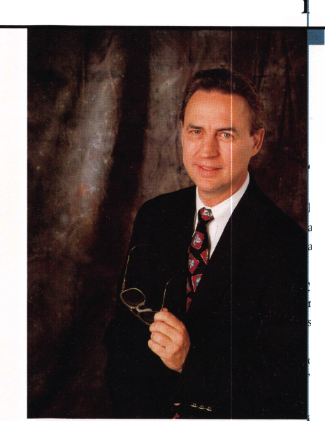

Staff)

Executive

Board

Editor Associate Editor Art Director/Designer Advertising Sales

Contributing Authors

Publications Committee

ALOA Professional Staff

Staff Administrator Office Manager Receptionist Comptroller Financial Assistant Associate Executive Director Meetings & Education Coordinator Administrative Assistant Membership Coordinator Mailroom Assistant

Anne McDonald Davis, ABC

Laurie Kline

Derek Holiman

Mary Sadler

Anelia M. Banda

Jerome V. Andrews, CML

Charles Cameron,CML

Paul Chandler, CRL

Claire Cohen, CML

Don Coleman, CPL, CPP

Bob De Weese, CPL

Ray D’Adamo, CML

Sal Dulcamara, CML

Joe Esposito, CML

James Glazier, CML

Jon Griswold, CML

A.J. Hoffman, CML

Ken Holmlund, CRL

Tom Hood, CML

Richard A. Lacy, CPL

Barry Leas, CRL

Ray Lusk, CML

Mark Ohno

David Parrott

Henry H. Printz,CML

Randy Simpson, CML

Robert Stafford, CPL

Dave Thielen

James Watt, CML, CPS

John D. Cannon, CML, Chairman

Jerome Andrews, CML

AJ. Hoffman, CML

Tony Ramunno, CML, CPS

Donald E. Rule', CML

James Watt, CML, CPS

Evelyn Wersonick, CML, CPS (Trustee)

Charles W. Gibson, Jr.

Mary May

Margo E. Vela

Kathy J. Romo

Debra Bradshaw

Carmen D. Murphey, CMP

Jessica Vasquez

Janelle Vergara

Brandon Durrett

Jesse Morales Jr.

Complete address and phone number listings for the ALOA Board and Keynotes authors are available in your membership directory or by contacting the ALOA office at (214)827-1701.



lission Statement: The Associated Locksmiths of America, Inc. is dedicated to enhancing the professionalism, education and ethics among locksmiths and ose in related sectors of the physical security industry. With approximately 10,000 members in the United States, Canada and the freeworld, ALOA is poised to jlp members obtain the knowledge, the strength, and the confidence to perform their role in the physical security field with pride and dignity. But it is only rough active involvement and participation that ALOA can fully achieve its potential-and can help members to achieve theirs.

olicies: Keynotes® is the official publication of the Associated Locksmiths of America, Inc. (ALOA). Keynotes® acts as a moderator without approving, disap- oving. or guaranteeing the validity or accuracy of any data, claim, or opinion appearing under a byline or obtained or quoted from an acknowledged source, le opinions expressed by the authors do not necessarily reflect the official views of ALOA. Also, appearance of advertisements and new products or service formation does not constitute an endorsement of products or services featured by the Association. The Association does not accept responsibility for the inac- iracy of any data, claim, or opinion appearing in this publication, due to typographical errors on the part of the authors, Association staff or its agents, ditor’s Note: This publication is designed to provide accurate and authoritative information in regard to the subject matter covered. It is provided and dis- iminated with the understanding that the publisher is not engaged in rendering legal or other professional services. If legal advice and other expert assistance required, the services of a competent professional should be sought.

uthors’ Payment: Effective Nov. 1,1995, payment will be made for original articles submitted exclusively to Keynotes® magazine at a rate of: technical arti- ss-$75 per page, double-spaced with standard one-inch margins; and business/human interest articles—$50 per page, double-spaced with standard one- ch margins. (If only a portion of an eligible article is published, payment will be made for that portion only.) Authors will be paid $10 for each photograph, lart, exhibit or illustration that is utilized for their article. Maximum payment for both copy and photos is $350 for technical articles and $150 for jsiness/human interest articles.

lyment will not be offered for articles submitted by ALOA employees or members of the ALOA Board of Directors (unless material is of a technical nature), nor r articles submitted by a company that promote that company’s products or services. ALOA reserves the right not to pay for articles submitted by an individ- il(s) that promote a particular company's products or services.

•isclaimer: The Associated Locksmiths of America, Inc., (ALOA), reserves the right to refuse any article for any reason. Additionally, ALOA reserves the right edit, amend or modify any article submitted for publication in order to presen/e technical accuracy, clarity, fairness or grammatical correctness. ALOA will ake the best efforts to notify the author of any changes. The extent of ALOA’s liability for any article or information contained therein will be a notice of correc- >n or retraction in the next possible issue.

Bynotes® (ISSN 0277 0792) is published monthly except for the combined July/August issue by The Associated Locksmiths of America, Inc., 3003 Live Oak St., alias, TX 75204-6186. Telephone: (214) 827-1701; FAX (214) 827-1810; e-mail [aloa@anet-dfw.com](mailto:aloa@anet-dfw.com). Subscription rates for members-$15.00 per year. Second ass postage paid at Dallas, Texas. POSTMASTER: Send address changes to: Keynotes, 3003 Live Oak St., Dallas, TX 75204-6186. © Copyright 1997, All rights served. No part of the contents may be reproduced or reprinted in any form without prior written permission of the publisher.

President

David M. Lowell, CML, CMS

(602) 263-7716

Regional Vice Presidents

Southeast

Dallas C. Brooks

Chairman: Finance Committee

(334) 826-8990

North Central

David A. Paulsrud, Sr., CML

Chairman: ALOA Scholarship Foundation, Inc.

(612) 533-6164

South Central

Carl King, CML

Chairman: Bylaws Committee

Curator: ALOA Museum

(713) 465-2500

Southwest

John I. Shandy, CML

Chairman: Membership Committee

(303) 443-9740

Northeast

John D. Cannon, CML

Chairman: Publications Committee

(703) 960-6413

Northwest

James M. Watt, CML, CPS Chairman: PRP Committee (406) 549-7667

Secretary

Ricardo Ohmit, CM L (217) 384-6006

Tmstees:

Breck H. Camp, CML, Chairman (770) 455-6244 Henry H. Printz, CML (201) 538-2737

Evelyn V. Wersonick CML, CPS

(505) 247-9413

Leonard J. Passarello, CPL

(416) 752-7210

Edwin Toepfer, RL

(416) 225-5589

Directors

Dana L. Barnum, CML Chairman: Chapters Committee (610) 565-9900 James H. Glazier, CML Chairman: Education Committee (301) 831-5454 John J. Greenan

Chairman: Legislative Committee (773) 486-2030 Barry K. Leas, CRL (610) 272-9292 Raymond C. Lusk, CML Chairman: Convention Committee (509) 624-3152 Jeffrey S. Nunberg, CML (305) 324-8800

Anthony J. Ramunno, CML, CPS Chairman: Library/Museum Committee (330) 782-6204 Randy L. Simpson, CML Chairman: Public Relations Committee

1. 780-7026 Robert H. Stafford, CPL Chairman: Grievance Committee (860) 768-7917

William T. Straub, CML

1. 779-0383 Bruce J. Tarbet, CML (601) 924-4184

Chairmen of International Affairs

Laurence P. Mills Australia (129) 958-0445 Hans Mejlshede, CML Europe

Members-at-Large

Jerome V. Andrews, CML

(860) 621-3601

Steven G. Engel, CML, CPP

Chairman: Strategic Planning Committee

(414) 731-5400

Thomas Freehling, CML

(320) 629-6538

AJ. Hoffman, CML

(714) 474-8877

J. Thomas Hood, CML

(610) 539-9555

Donald E. Rule', CML

(601) 324-2658

February 1997

***Keynotes***



**Ff? hr ii ary**

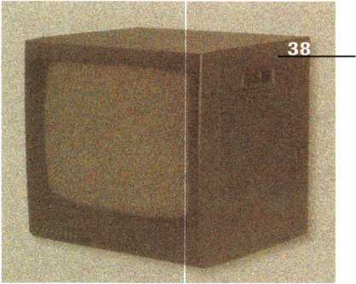

2

A Word With David Lowell

9

Legislative Comment

By John Greenan

52

o

o

C

2

3

PRP Report

By James Watt, CML, CMS

56

Focus on Education

Invest a little and get a lot. By James Glazier, CML

59

Chapter News

Pinpointing goals and working towards them.

By Dana Barnum, CML

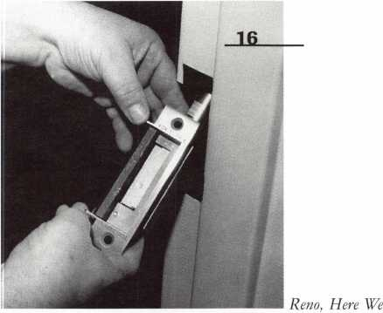

6

Mail Box

Questions and answers

10

Upcoming Events

Anyone who’s anyone will be in Reno!

11

Applicants for Membership

Scheduled for clearance by March l

12

Industry News

New faces in the workplace

14

Security Marketplace

New gadgets abound

53

Come. By Carmen D. Murphey, CMP

a

CD

8

8

a

3

CD

3

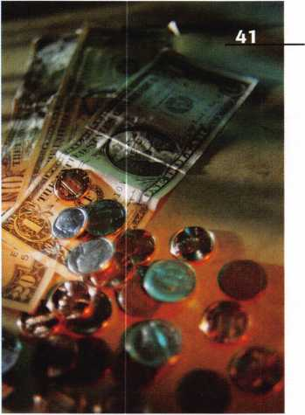

55

ALOA Extra

Collecting donations for a good cause.

60

Back Page

A rather artistic locksmith. By Laurie Kline

43

Buyers’ Guide

New stuff’s arriving all the time.

44

Associate Members

See who supports ALOA

49

Classifieds

Businesses, equipment, and career moves



55

Ad Index

Index to Advertisers for this issue



Keynotes

February 1997

Featured:also

16

Installing the Von Duprin 6210  
Electric Strike

Eight easy-to-follow steps? Yep, it’s true. Business owners  
can get years of protection and convenience.

By Patrick R. Olmstead

19

impressioning, Part Two

You can do it: more details on the practicalities of impres-  
sioning.

By Sal Dulcamara, CML

24

Apprentice Comen  
A Vandal’s Worst Nightmare

Super glue doesn’t have a chance with this tough-as-steel,  
quick-to-install, long lasting product.

By Bob DeWeese, CPL

36

GM Ignitions After The Saginaw

Think the Saginaw was easy to work? Steer your way to the  
new column from GM.

By Ken Holmlund, CRL

38

Cover

Higher Learning

You’ve heard about Bob Stafford—now get the inside scoop on the man who believes education is a locksmith’s most powerful tool.

By Laurie Kline

26

Does Your Institution Really Want Key Control?

What happens when a key falls into (and quickly out of) pos­session? The damage can be quite costly.

By Robert H. Stafford, CPL

CCTV: M is for Monitor

What it sees is what you get. Get information on monitors that really go the distance.

By Paul F. Chandler, CRL

41

Planning For The Successful Sale of Your Business

There’s a lot to think about once you’ve decided to make the change. And the more you plan, the better off you’ll be.

By G. Stephen Thoma



28

Mobile Locksmithing in the 90s

In for a long, bumpy ride? Get inside the rig of a locksmith on the go.

By Ken Holmlund, CRL

34

The Most Specialized Guy I Know

When Ollie counts to three, you better be ready! After all, there are some strong advantages to owning and operating a specialized business.

By Paul F. Chandler, CRL

February 1997

Keynotes

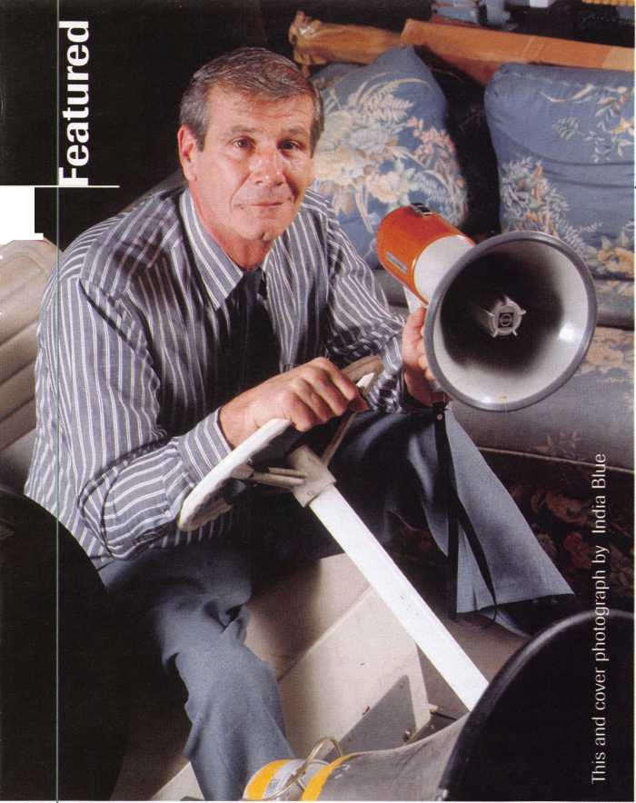

A

**Keynotes**

Mail Box



Dept]

**If you have an opinion to offer on**

**the letter(s) printed in Keynotes each  
month, let us know! Submissions to the  
“Keynotes Mail Box” department are  
printed on a space-available basis.  
Write to: Keynotes Mail Box;**

**Associated Locksmiths of America, Inc.; 3003 Live Oak Street; Dallas TX 75204; or FAX C214) 827-1810.**

It’s the Law in Illinois

Letter to the Editor:

For many years, Eve stood by and let other people tell me what I needed to do. After ten years as a part time locksmith, I entered the profession as a full time locksmith. That was about ten years ago, and I became part­ner with my father-in-law in a lockshop about five years ago. He has 50 years of locksmithing experience.

I thought that ALOA was for the little guy as well as the big guy. Now I’m not so sure. I have three close friends who are lock­smiths in a 2 5-mile radius of our shop. Two of them (both ALOA members) will more than likely go out of business due to the new Illinois Locksmith Law—a law that you helped pass. You want everybody to support ALOA, but I don’t think you did the same for them or for people who are not members. This law is very costly at $500 for a locksmith license and another $500 for an agency license. One of my friends made $5000 last year. He’s only been in business for five years and most of his money goes into stock and expenses.

I think it’s time ALOA talks to its mem­bers and gets a better idea of what they want—all of them. It’s probably too late for Illinois, but don’t make that same mistake again in another state. In a time when people are saying they want less government, why are you helping to give us more? Look at the prob­lems Texas and other states are having.

I urge all of us to take a long look at what we really want—more regulation or less? We should ask ourselves and others, “Is this what we really want?”

One final note to all locksmiths: it’s time we get off our backsides and speak out for what we want—all of us. It only takes a few minutes to call or write and express our opinions.

Stephen M. Strutt, CRL #17324

Response from John Greenan

Stephen,

Thank you for taking the time to express your feelings concerning the Illinois lock-

6 | KeynotesFebruary 1997

smith licensing law. As you stated, the ini­tial license cost is $500, and renewal licens­es will be $450 (these are three-year licens­es, which averages out to about $150 per year). Your friend would not need an agency license unless he has employees. The lock­smiths in Illinois who supported the passage of HBS-49 took every possible measure to include all locksmiths both large and small. The fee structure was not set by the lock­smiths, but by the Department of Profes­sional Regulations based on fees charged to other related industries that are licensed. I don’t feel $150 a year is an excessive fee. I sincerely hope your friends reconsider their commitment to their business and apply for their licenses. I feel very confident that they will be glad they did in the future.

The problems in Texas are a perfect example of how licensing will help lock­smiths. It should also be obvious to every­one by now that the alarm industry is going to promote legislation to license the access control industry. The Illinois locksmiths recognized these problems three years ago and worked to make the necessary changes before they became critical problems.

I fully agree with you that the ALOA members should take the time to express their desires of what they expect from their association. President David Lowell has made a great effort to encourage the board to listen to the members’ input. It is the members’ privilege to address the board on what they feel is most important to them.

What to Write?

The poet Robert Frost once said: “Half the world is composed of people who have something to say and can’t, and the other half have nothing to say and keep on saying it!” We think alot of our members fall into the first category and we’d like to encourage everyone to speak out about their industry and their association.

But—what do you have to say? How about ...

* community safety concerns in your area;
* local association concerns and projects;
* reports from attending other industry

shows and conventions;

* comments on ACE classes or other educa­tional experiences;
* feedback from attending the ALOA con­vention;
* ideas about ALOA’s future and member priorities;
* thoughts on licensing in your state;
* ethics concerns;
* questions about membership benefits or services overall.

It’s understandable that most of the time when we hear from you, it’s because you’re dissatisfied with a product or a service, or you have an immediate, short-term concern about an issue. At the same time, we’d like to encourage you to consider taking a moment in the coming year to sit down and write us a letter about something that is going to matter for a long time—such as the direction of ALOA or the changing skills required for locksmiths. You probably are laughing at the very idea that you have TIME to do this and run a business too ... but remember—ALOA is made up of people just like you, many of who we never hear from other than an annual dues check or a convention registration form.

It’s not as hard as you think and it proba­bly won’t take as long either. Just pick up your pen or sit down at your computer and write: “Dear ALOA, Here’s what I think.” We’ll listen.

Anne McDonald Davis, ABC Editor

Got your membership or class certificate thumb-tacked on the wall? Short of renting a spotlight and a billboard, a wooden pocket plaque is the coolest way to bring attention to your ALOA accomplishments.

Get a pocket plaque and show off a little. Because ALOA firmly believes suc­cesses should be proudly displayed. But renting a skywriter might be a little much.

Pocket plaques are on sale for 12 bucks. Get 'em while they're cheap.* After all, those thumb-tack holes start off small, but they always get bigger.



Associated Locksmiths of America, Inc. 3003 Live Oak Street Dallas, TX 75204 (214) 824-1701

While Supplies Last

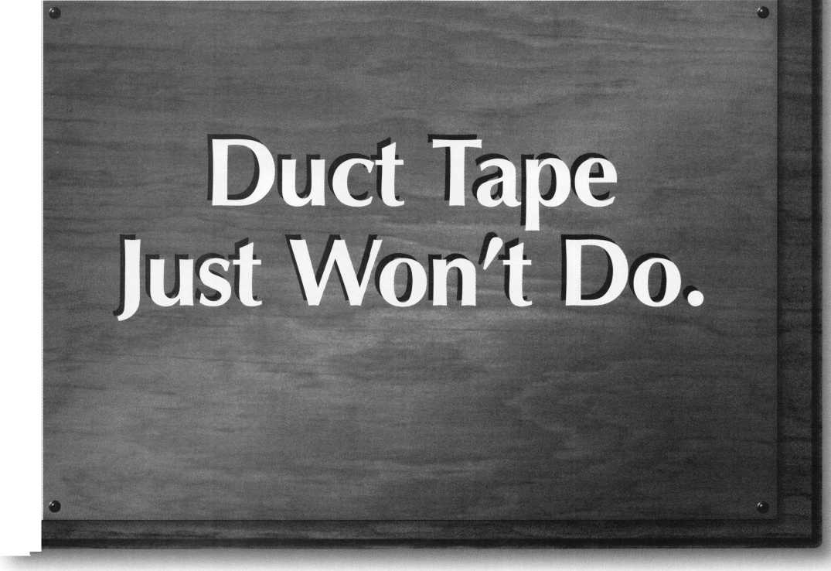

**and Canada ««ng the andser^iacCeCseSSing |“;Web**

\ ‘j*-* jK 7 L

**°^ie^wor^n^‘ y**

**'//^wWt/si^QnMetrcWm**

Welcome to

**Make sure to stop by and check out our Forums and Employment Listings!**

**Our Press Page is updated daily, Make SIMON your first stop of the day for breaking industry news!**

**Member Index Press Releases**

**The Security Information Management On-Line Network**

**Associations**

**Employment**

**Check out our links!**

SIMON- The Security Information Management On-Line Network.

The SIMON image is a Registered Trademark of Locksmith Publishing Corp1

l FreeJnfomiation^Readei^Service^Card #1

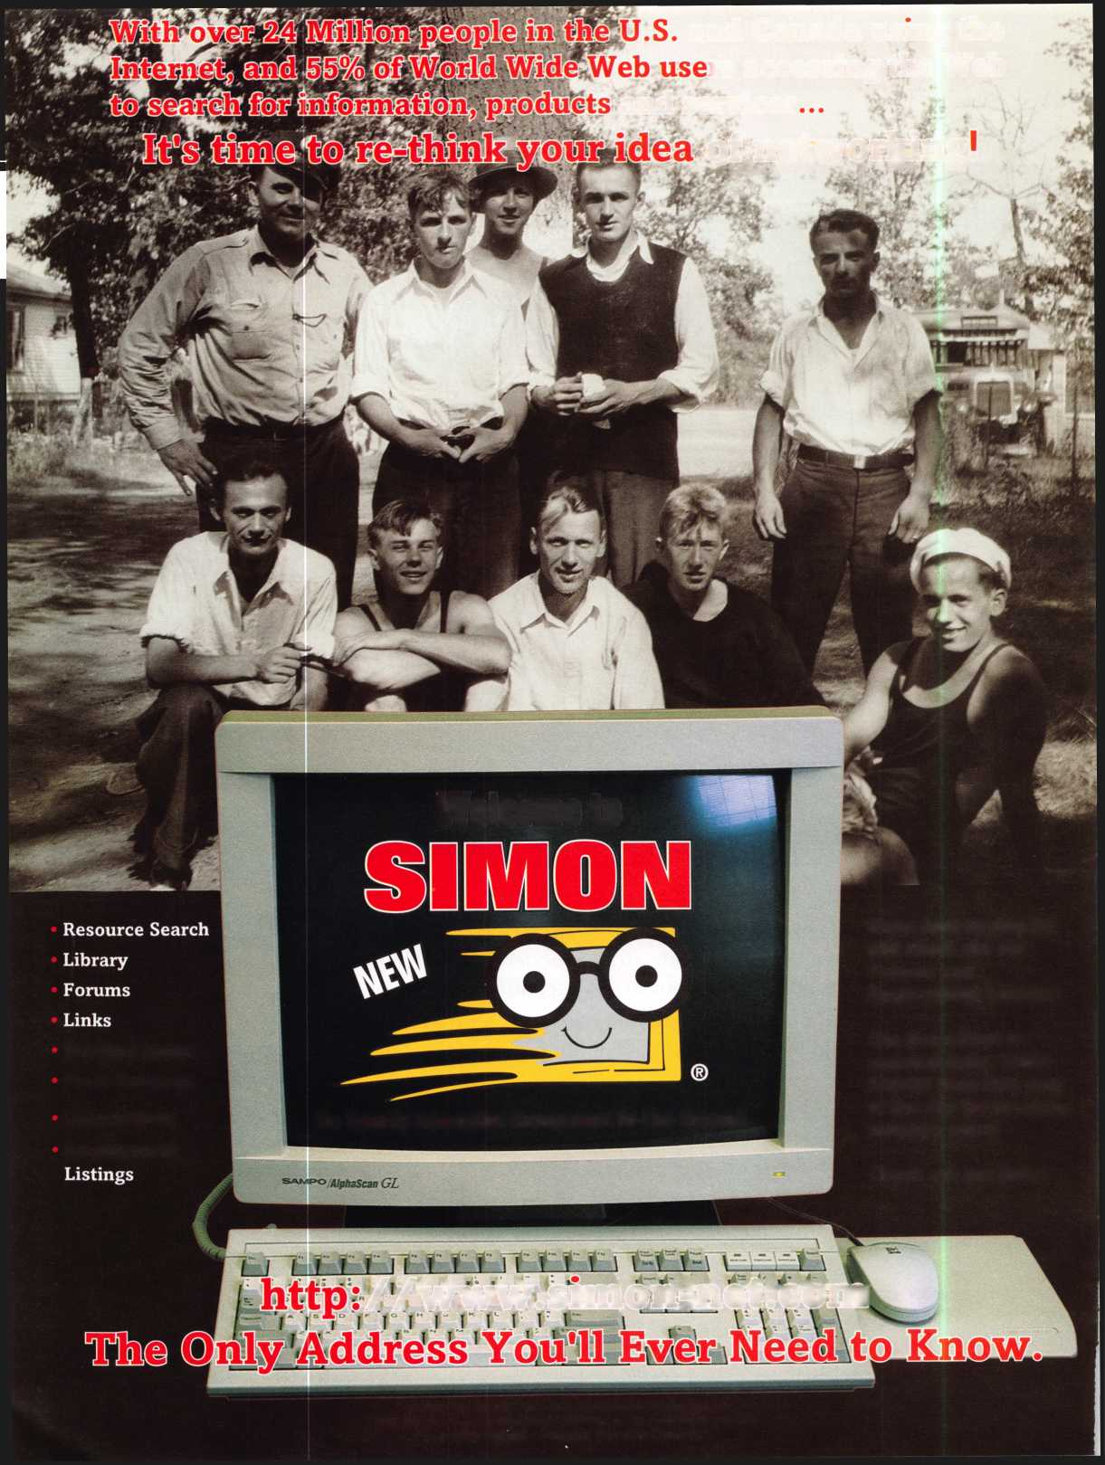

|  |  |
| --- | --- |
| T * 1 . , * | Comment |
| Legislative | Hjotin Greenan |

Committee Chairman

One way to have enforceable standards is through licensing.

Last month, we discussed some reasons why locksmiths should be licensed. Although we started with the question, “Are you for or against licensing?” I believe it is far too late to ask that question. The reality is lock­smiths are and will be licensed. The question is, are the locksmiths going to have any input on how these laws are written and what requirements will be in these laws, or are we going to let the other industries decide what they will leave for locksmiths to do?

The alarm industry has been very active in the legislative arena for many years.

There are 34 states that currently require a license to provide alarms for the public. A recent federal law now allows for the tele­phone companies to participate in the alarm business. The alarm industry has spent a lot of time and money fighting to keep the tele­phone companies from entering the alarm business. The alarm companies use telephone lines for their alarm systems so they must rent the telephone lines from the telephone companies. Imagine how difficult it would be to stay in business if you had to rent your most important tool from your competitor. The alarm industry has seen this coming for many years and has been positioning to turn to other related work.

The alarm industry is changing its name to the electronic security industry and is call­ing alarms “security systems.” These security systems integrate alarms with access control devices so when someone comes to work in

the morning and enters their code into a keypad or passes a card by a card reader, the system can simultaneously turn off the alarm, unlock the door and enter the employee in the time clock. This leads to the gray area of, when is it an alarm system and when is it an access control system? Which then leads to the question, who is going to sell, install and service these products—lock­smiths, alarm companies or both?

Please do not take this the wrong way— the alarm industry is not the bad guy. The alarm industry realizes that what they and we do is provide security for the consumers. They recognize the possibility of abuse and misuse of the trust given to us by the con­sumers. They also realize that elevating our industries from a trade to a profession will require some standards. One way to have enforceable standards is through licensing.

Look at Illinois where locksmiths are licensed under the same law as the guards, detectives and alarm companies. New Jersey locksmiths are working with the alarm com­panies in their state. In Alabama, the alarm :ompanies and locksmiths share the cost of a lobbyist and are submitting a joint bill. It’s becoming quite clear that our industries are :oming closer together. We are selling, installing and servicing many of the same security products. It is in the best interest of Doth groups to work together to improve the level of service the consumer receives.

John Chwat & Company will no longer oe our lobbyist. We have contracted with a

Legislative Comment is written by John Greenan on behalf of ALOA’s Legislative Committee. Comments or questions can be directed to him at: Fink Safe & Lock; 2307 N. Western Ave.; Chicago, IL 60647; (773) 486- 2030; FAX (773) 486-4268.

different monitoring service. Multistate will be our new monitoring and lobbying provider. The ALOA legislative committee will continue to monitor all 50 states and the federal legislature for bills that may affect our industry. We also hope to increase our channels of communication with the members. I would like to hear your opinions on the legislative trends and how you feel ALOA’s legislative committee can help you.

I About the Chairman: John Greenan

represents the fifth generation locksmith and is vice  
president of Fink Safe & Lock in Chicago, IL. A  
locksmith for the past 12 years, John has also  
served on ALOA’s Convention and Strategic  
Planning committees. He is chairman of the  
Allied Locksmiths of Illinois.

**Legislative Action Contact Network**

Date

Name

Company Address

I am interested in:

* Working on Legislative Issues
* Fundraising
* Gathering/Giving Information

Home Address

Telephone

FAX

e-mail

February 1997

KeynotesL



They tell you your kid has spina bifida.

**Upcoming**

Events

Date

You cry. And you curse. And you clench that tiny new baseball mitt in your hands and vow never to throw it away.

It may take time, but you will play catch with your son.

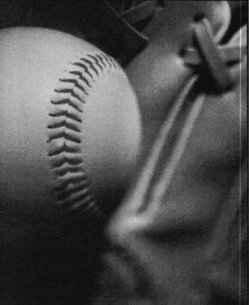

Hope. That’s what Easter Seals  
is all about. At some point in their  
lives, 1 in 5 Americans will be  
affected by a disability. We  
provide physical, recreational  
and speech therapies to help  
children born with disabilities  
live with independence, dignity

and equality. But we  
can’t do it without  
your help. Support  
Easter Seals. Give  
ability a chance.

© 1995 National Easter Seal Society

February ’97

5-9

Texas Locksmiths Association Convention and Trade Show Corpus Christi Omni Corpus Christi, TX Contact: Michelle Spears (409) 297-2413

8

Grand Canyon Chapter, ALOA • Door Closer & Safe Deposit Mini Classes Bostrom High School Phoenix, AZ Contact: John Ilk, CRL (520) 474-0147 (work)

(520) 474-8879 (home)

(602) 420-2174 (page)

8 & 9

West Coast Lock Collectors Association Event Embassy Suites Hotel Arcadia, CA

Contact: Robert Heilmann (310)230-3004

21

Vindicator Corporation Training Classes for Microlock Contact: Tamara Martell (512)314-1200 [lock@vind.com](mailto:lock@vind.com)

March ’97

8 & 9

Ozark Professional Locksmith Association

Annual Retreat and Classes Inn of the Ozarks Eureka Springs, AR Contact Betty Gray at (501) 524-3660 or

Janis Reves (evenings) at (501) 631-6406

11-14

ISC Expo 1997 Conference and Exposition

Las Vegas Convention Center Las Vegas, NV Customer Service (203) 840-5602

15

Vindicator Corporation • Training Classes for Vindica­tor Lock II

Contact: Tamara Martell

(512)314-1200

[lock@vind.com](mailto:lock@vind.com)

15-16

Southern Lock

Annual Southern Lock Buyers Trade Show

St. Petersburg Bayfront Hilton St. Petersburg, Florida Contact: Bill Underwood (813) 541-5536

April ’97

7-11

mark bates Associates 5 Day D.O.D./D.O.E. Combination Lock Training (888) 622-5495

17-21

Master Locksmith Assoc, of New Jersey Somerset, NJ Contact: (201) 267-8884

19

Vindicator Corporation Training Classes for Microlock Contact: Tamara Martell (512)314-1200 [lock@vind.com](mailto:lock@vind.com)

May ’97

16

Vindicator Corporation • Training Classes for Vindica­tor Lock II

Contact: Tamara Martell

(512)314-1200

[lock@vind.com](mailto:lock@vind.com)

19-23

mark Bates Associates 5 Day D.O.D./D.O.E. Combination Lock Training (888) 622-5495

S' Future Conventions

1997

ALOA ’97 July 28—Aug. 2 Reno, NV

SAFETECH ’97 May 5-10 Louisville, KY

SERLAC Sept. 24-28 Grenelefe, FL

24th annual Tri-Regional Security Conference Oct. 21-26 Bellevue, WA

1. ALOA ’98 June 15-20 Nashville, TN

SAFETECH ’98 May 4—9 Valley Forge, PA

1. ALOA ’99 July 25-31 Cincinnati, OH

SAFETECH ’99 May 3-8 Las Vegas, NV

2000

ALOA 2000 Date TBA Las Vegas, NV

SAFETECH 2000 May 8-13 Lexington, KY

2001

ALOA 2001 July 15-21 Baltimore, MD

For PRP dates, see p. 52. For ACE dates, see p. 56. Send in the dates of your organization’s activi­ties today!

j

*j*

Keynotes

February 1997



Applicants

For Membership

CALIFORNIA

Eureka

026524, Bill H Davidson, A

COLORADO

Louisville

026540, John B Apjoke, A

CONNECTICUT

Bozrah

026539, Mark D Bennett, A SPONSOR: Charles McPherson

Stamford

026542, Alfonso C Sgritta, A SPONSOR: Alfonso Sgritta

FLORIDA

Mary Esther

026548, John W Leach, A

IDAHO

Boise

026522, Randy P Godfrey, A

ILLINOIS

Belvidere

026529, Arthur T Pankhurst, A SPONSOR: Bill Robertson

INDIANA

Hammond

026515, Patrick T Loughney, AP SPONSOR: Allen Konrath

LOUISIANA

Lake Charles

026547, David J Gramger, A SPONSOR: Kenneth Andrews

Metairie

026516, Dera A DeRoche, A

MASSACHUSETTS

Boston

026512, Keith S Mathews, A Bridgewater

026527, Peter V Bumpus, A SPONSOR: Michael Cornell

Stoughton

026517, Todd W Hewins, A

Worcester

026510, Fred T Rubio, A

MARYLAND

Lanham

026521, Eric O Perry, A

MICHIGAN

Detroit

026546, Michael J Hubbard, A SPONSOR: Matthew Knoche 026518, Kevin J Sykes, A SPONSOR: Matthew Knoche

East Lansing

026523, Karl F Gruber, AP SPONSOR: Julio Hernandez

MISSOURI

Chesterfield

026545, Michael D Gaines, A SPONSOR: Steven Wehofer

MISSISSIPPI

Columbus

026551, David J Turner, AP SPONSOR: Thomas Cole Stennis Space Center 026519, Richard Brady Sr , A

NORTH CAROLINA

Charlotte

026538, Joe J Silvestri, A SPONSOR: A Hoffman

Gastonia

026533, Michael H Martin, A SPONSOR: UW Hunt 026535, Timothy P Martin, A SPONSOR: UW Hunt

Lenoir

026543, Matthew S Eggleton, AP SPONSOR: Harold White

***The following applicants are scheduled for clearance  
as members of ALOA The names are published for  
member review and comment prior to March 1, 1997, to  
ensure applicants meet standards of ALOAs Code of  
Ethics***. ***Protests, if any, should be addressed to the Mem-  
bership Department and must be signed***1 ***Active Mem-  
bership applicants (A) have worked in the industry two  
or more years***. ***Allied Membership (AL) applicants are  
not locksmiths, but work in a security-related field***L

NEW HAMPSHIRE

Rindge

026525, John F Weir, A SPONSOR: Ronald Hagstrom

SOUTH CAROLINA

Surfside Beach

026528, Michael Chaky, A

SOUTH DAKOTA

Yankton

026550, Thomas C Petersen, AP SPONSOR: Scott Hansen

HONG KONG

Kowloon

026536, Shiu Chan, A SPONSOR: Hin-chor Mak

MACEDONIA

Skopje

026532, Jane V Skenderov, A SPONSOR: Nikolay Trendafilov

TENNESSEE

Knoxville

026549, Hobert C Banks, AP SPONSOR: Marian Swann

TEXAS

Arlington

026526, Lyndon Armour, AP SPONSOR: Kent Mikesell

Houston

026513, Gary E Bartlett, A SPONSOR: Ruben Lopez

Odessa

026511, Frank M Beam, AP SPONSOR: Dale Shaw

San Antonio

026530, James A Rowell, A

WASHINGTON

Vancouver

026520, Richard L Sweet, A

WISCONSIN

Neenah

026541, Todd S Laflin, A SPONSOR: Robert Erdmann

BAHAMAS

Nassau

026531, John N Zervos, A SPONSOR: Clinton Harding

ENGLAND

Essex

026544, David K Crossman, A SPONSOR: Peter Wosahlo

k_

February 1997

Keynotes

Industry

News

SPX Strategic Staff

SPX Corporation has named Richard U. Jelinek as vice president of the company’s strategic change area. Jelinek was brought in to work closely with SPX’s tool and equipment group to accelerate the compa­ny’s expansion to Europe and Asia.

SPX is a leading supplier to specialty ser­vice tools and equipment and original equipment components to the motor vehicle industry.

First Guy

Ernesto Ramon has been appointed the first president of Ingersoll-Rand, Latin America. Based in Miami, FL, Ramon will lead Ingersoll-Rand’s overall operation in Latin America and will manage centralized func­tions such as finance, administration and human resource.

For 30 years, Ramon worked at The Dow Chemical Company, where he held positions in marketing, sales and business manage­ment in the pharmaceutical products divi­sion, chemicals and plastics divisions and its agricultural division, located in Brazil, Mex­ico, El Salvador and Puerto Rico. He moved into the position of president of Dow Chemical-Brazil, and when he left, he was president of Dowell Chemical-Latin America.

Cybermark CEO

James B. Graham has been appointed chair­man and CEO of CyberMark, LLD, a joint venture company founded to bring “smart card” systems to college campuses, hospitals, corporate business centers and mass transit systems.

Under development since 1993, the CyberMark technology is one of the first to offer fully integrated hardware, software and services platform. The system features a microprocessor chip that is embedded in the smart card itself. The card provides positive identification, enhanced security and access control, and streamlined information exchange.

The Ohio based company hopes that future applications will include additional security within prison systems and delivery of



unemployment benefits and food stamps.

It’s All in the Cards

Cardkey Systems, Inc. has a new manage­ment team. Richard Kelly has recently been named the Vice President of Domestic Sales, and Dr. Leonard Chansky has just been named the Vice President of Engineering.

Kelly brings 16 years of sales manage­ment experience to Cardkey, and he is a for­mer Presidents Club member (for outstand­ing sales performance) at Honeywell. Before joining Cardkey, Kelly worked for Ameri­can Magnetics where he was the Vice Presi­dent of the Access Control Division and Director of Integrated Systems.

With 20 years of experience in the design of leading-edge products, Chansky was Vice President of Engineering at Colortran, Director of Advanced Development at Ter­minal Data Corp. and Product Manager at Xerox Corporation.

NAPCO’S New Names

Roy Bryan has just been named NAPCO Security Group’s Regional Sales Manager in the UK. Bryan has 35 years of security industry experience, including former posi­tions with Thorn, Shorrocks, Castle Caretech and Microtech. Bryan will be responsible for supporting the security requirements of dealers in the UK, as well as expanding the company’s presence abroad.

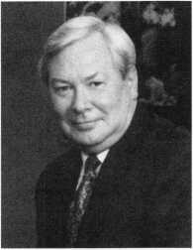

Roy Bryan

Charlie James was recently named NAPCO'S Regional Manager for London and the Southern countries in the UK and he will focus on promoting product lines in the UK. James has held positions at CSD

Professional, A&A Wholesale and Microtech.

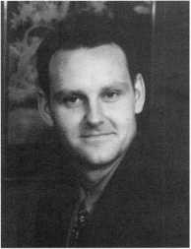

Charlie James

Zedella on DMAC Crew

James Zedella has joined DMAC—a large U.S. purchaser of residential security system monitoring contracts—as vice president of sales marketing. Zedella is to manage over­all sales and extend the company’s brand awareness among independent dealers, cen­tral station monitors, and the investment and banking communities.

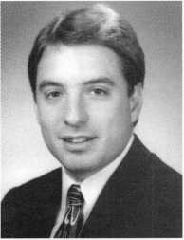

James Zedella

Putting on a Show

From April 24 to 27, 1997, IDN’s Arm­strong, Inc. will be holding the 18th Annu­al Security Show for Security Professionals in Atlanta, GA at the Georgia International Convention and Trade Center. For more information, contact the marketing depart­ment at:

(800) 726-3332 or (404) 873-0136

Taking a Survey

According to the Pinkerton Security Issues survey, workplace violence is the most important concern for American corpora­tions. Employee theft, ethical business con-

Keynotes

February 1997

Industry

News

duct, employee selection and crisis manage­ment rounded out the top five concerns.

The survey also found there is an increased concern of computer theft and Internet security. Because employees access the Internet during work hours to “surf the net,” valuable time is wasted. Other employees may copy sensitive internal com­pany information.

The concern for terrorism dropped from 15th to 14th in 1995.

Free Training

Vindicator is continuing its free training program for its line of electronic safe locks. Classes, which are held in Austin, TX, are offered monthly to safe manufacturers, lock­smiths, service providers and end uses.

For registration and class information, call: **(512) 314-1200**

Now You’ve Gone and Done It

A 21-year old man was arrested in Austin, MN for failing a sobriety test. What tipped off police? He was seen using the bathroom on the side of his car. His reason? He was trying to thaw out frozen car locks, and his solution worked. When police circled the block, they saw him driving away. The man was charged with drunken driving.

ASIS Theme

The American Society for Industrial Securi­ty (ASIS) has chosen, as its 1997 annual seminar and exhibits theme, “Your Connec­tion to Innovation.” The event is scheduled for Sept. 8-11 in St. Louis and will feature a variety of security topics such as workplace violence and public/private law enforcement partnerships. For more information, contact ASIS at 703-522-5800 or visit their Web­site, ASISOnline.org

Security’s Changing Future

A recent ASIS report predicts the evolution of security responsibilities for positions such as facility, human resources and general management that in the past have been mostly non-security jobs. Because of ever changing technology developments in com

puters, increased use of the Internet, and heightened concerns over industrial espi­onage and workplace violence, companies are beginning to view security as an integral part of daily business operations.

This trend may well have positive effects on the security industry as the base of pro­fessional people involved in the industry increases. Security is being considered in the early phases of design of new facilities, employee screening and monitoring, and use of electronic mail systems. Experts also predict the integration of fire systems with company s’ access control systems.

Consumer Info

The Winter 1997 **Consumer Information Cata­log** is available and includes pamphlets such as “Home Fire Safety” and “Home Electrical Safety Check”—information that retail lock­smith shop owners might consider having available by the registers to show customer additional concern for residential safety. The booklets may be ordered at a cost of $.50 each from: R. Woods; Consumer Informa­tion Center—7A; P.O. Box 100; Pueblo, CO 81002.

Big Deal for Detection

Detection Systems, Inc., has announced that its Safecom Wireless Security Network Sys­tem has been chosen as the communications component of a gated community system in Highland Park, TX. The contract represents the largest single order for this product and Detection hopes it will serve as a model for other multiple user applications—most espe­cially commercial and governmental.

The company designs, manufactures and markets electronic detection, control and communication equipment for the security industry. Its product line includes fire and access control components and systems.

■Other Local Reports NWLA Elections

The Washington State-based Northwest Locksmith Association has elected the fol­lowing officers:

Mike Forbraged, CML—President Chuck Pigue II—Vice President Robert Kotovic—Treasurer Burt Balch—Secretary Mike Stanley—Director Dean Nickel—Director Ernie Robinson-Education—Chairman Darrin Walters-Asst. Ed.—Chairman John Navin—Certification

LADC Officers

The Locksmith Association of Washington D.C. Area, Inc. has elected the following officers:

Lester Brodsky—President

Bill Smith—Vice President

Dave Griffin—Secretary

Open Position—Treasurer

Jim Wilson—Sg. At Arms

Lonnie Wilson—Benevolence Chairman

John Speakes—Education Chairman

Bill Breazeale—Membership Chairman

New Members

The Penn-Ohio Locksmiths Association have added three new members: Frank J. Read, Jerry P. Gaugler and Scott Hilton. The association also voted to re-elect current officers and trustees.They are as follows: William Mandlebaun—President Robin Turner—1st Vice President Gerald Shaw—2nd Vice President Mark Echard—Treasurer Richard Dout—Secretary Sharon Ostheimer—Recording Secretary Robert Phillips—Sg. At Arms Philip Echard Alvin Ostheimer George Paris Jerry Eggler Martha Eggler Ron DeVall

February 1997

***Keynotes***



Marketplace



Dept)

Strong Saws

Lockmasters’ Carbide Tipped Hole Saw cuts through hardened draw-head bolts, offers greater wear-resistance and heat-resistance than bi-metal, 38 mm cutting depth, preci­sion ground angles and clearances and faster cutting rates. The new High Speed Hole Saw with pilot bit and arbor cuts through the outside skin of GSA Red Label security files. Both hole saws have carbide-tooth tips and cut through materials that standard bi­metal hole saws can not.

To order, call 800-654-0637.

Reader Service **#2**

American Tough

American Lock introduces a 2 3/4-inch stainless steel discus padlock sold in both retail and commercial packaging. The dis­cus lock is designed for residential, business and industrial use.

The solid brass cylinder is designed to sustain adverse weather conditions and can be used to lock bicycles, motorcycles, store­front gates, fences, garages, refrigeration units, freezers and other commercial appli­ances.

Call 800-PADLOCK for more information. **Reader Service #3**

Don’t Panic

Security Door Controls’ Paniclok is designed to work in conjunction with Dor- O-Matic, Kawneer, Jackson and Adams Rite concealed vertical rod panic devices.

When installed in the frame header, the product controls the top latch assembly of the panic device for controlled access from the outside only. Access is by way of card readers, keypads, key switches or electric controls.

When installed, PanicLok is completely concealed. Fail safe models are available, for further information, contact SDC at (805) 494-0622, FAX (805) 494-8861.

Reader Service #4

Do Not Disturb

A new push/pull latch with an added priva­cy function is now available from Glynn-

**14 I Keynotes** February 1997

Johnson. The latches are available for use on commercial and institutional doors up to 1 3/4”, including fire doors. The short throw angle of these latches allows an easy push or pull motion to open the door, even when hands are not free. The privacy function is actuated by a thumbturn.

Information is available upon request from Glynn-Johnson representatives or from the customer service department: (800) 525-0336; FAX (800) 525-0337.

Reader Service **#5**

High Security Software

SAM 3.00—high security access control software that runs on Windows 95 and Windows NT 4.0—is now available from Hirsch Electronics. The program can be used for either entry level and high-end applications. Sam 3.0 now runs ID Manager (photo badging software) and ALARM*TRAC2 (graphical guard station software) on the same PC and LAN.

For more information, contact Hirsch at (714) 250-8888 and fax (714) 250-7372.

Reader Service #6

Speak a Little Brighter

Trine Products Company is now marketing a wireless strobe chime for door signaling applications. It was developed for the 32% of the U.S. populations that is hearing impaired. By using both light and sound, there is total awareness of a visitor’s arrival. The chime has a range of up to 100 feet, 64 security codes and adjustable volume con­trol. Multiple wireless pushbuttons as well as receivers can be sued to identify different door locations by producing two or eight flashes.

The strobe chime also can be sued as a light “notice” in manufacturing environ­ments where loud noise prevents notifica­tion by sound.

Complete information is available on request from Trine by calling (718) 829- 4796 or fax (718) 518-7022.

Reader Service **#7**

Smokin’ Battery

A high-energy lithium 9-volt battery is manufactured by UltraLife Batteries, pri­marily for use in long-life smoke detectors. Model U9VL-X is warranted for 10 years and upgrades any existing ionization smoke detector. Ultralife provides a choice of in­store merchandising aids to enhance visibili­ty of this high-profit product.

The suggested retail price is $7.99. The product is packed 72 units per master car­ton. For more information (including a color catalog sheet) call Ultralife at (800) 332-5000.

Reader Service #8

New UL Listing

Architectural Control Systems, Inc. (ACSI) Series 1500 electric lock modification is now UL listed for the Sargent 8200 mortise lock. The lock is available in fail safe or fail secure control. ACSI offers a number of options including request to exit monitor­ing, latch bolt monitoring or locked status monitoring.

For more information, contact Mark LeGrand at ACSI, (800) 753-5558, fax (314) 432-2090.

Reader Service **#9**

Color CCTV Bargain

CCTV Corp. is currently offering the GBC Colorsentry “Smart Value” Color BC-865C at prices comparable to many black-and- white models. The weatherproof ball camera is designed for indoor or outdoor use and is adjustable plus or minus 90 degrees in all directions. The product is engineered for accurate color rendition under most lighting conditions.

For more information, contact CCTV Corp. at (800) 221-2240; FAX (201) 489-0111.

Reader Service **#2** 0

Safe Vindication

Vindicator has announced that its MicroLock 40 has received UL approval.

The product is a combo key (combination plus electronic MicroKey) electronic safe lock. The major distinction of Vindicator’s

newest offering is its ability to provide multi-door control for multiple users while maintaining a complete audit trail.

Programmable time locks and time delays are standard features of the MicroLock 40. For more information, con­tact Howard Dame, (512) 314-1220.

Reader Service #11

Air Bag Man

Autolok 2000 is an adjustable, heavy-duty steel security device that immobilizes a steering wheel as well as protects an air bag against attack or theft. The product has recently received the “Sold Secure” rating from a group on independent crime preven­tion authorities in Britain. According to this standard, a product must withstand continuous attack for at least five minutes— considered double the amount of time most thieves are willing to spend to steal a vehi­cle. And, unlike bar devices, it cannot be removed when the steering wheel is cut.

The product utilizes a disk-detainer lock and can acommodate vehicles with steering wheels from 13 3/4” to 15 3/4”. For more information, contact Rebecca Fallow at (216) 247-0282.

Reader Service #12

Cool Keypad

Securitron Magnalock Corporation has introduced a new line of keypads designed to interface with access control systems that normally use wiegand technology card read­ers. The DK-11W and DK-26W act as a unique “front end” to nearly all access con­trol systems with the keypad connecting electronically to the customers’ existing or new access control system—exactly as a tra­ditional card reader.

The DK-11W is a self-contained indoor unit that fits in a single gang box. The DK- 26W has a narrow stile design suitable for mounting on door frames, and is suitable for both indoor and outdoor use. Both keypads provide the user immediate feedback through LEDs controlled by the access con­trol system and beeper. The weigand keypad series features simple on-site programming

**Security**

Marketplace

of the facility code.

For more information, contact Mark Henderson at (702) 355-5625, fax (702) 355-5636.

Reader Service #13

Totally Modular

The new Security Door Controls (SDC) 630 series power supplies are designed to com­ply with any access control and fire life safe­ty application. The series power supply has a field selectable voltage of 12 or 24VDC @ 1.5 amps. There is a choice of two models, unregulated less charging circuit or regulat­ed with a separate 13-8 or 26.5 voltage out­put used only for battery charging.

Additional features include interface to fire alarm panel for emergency release of all doors and LED indicators for system status and troubleshooting. For additional informa­tion, contact Marina Josho at (805) 413-8783.

Reader Service #14

The Defiant Ones

In a recent burglary attempt on one of their customers, Defiant Safe Incorporated is pleased to report that their UL TL-15 sur­vived 14 hours of torching, hammering and prying. The owners of the safe were suffi­ciently impressed to invest in another larger unit.

For more information, contact Defiant at (800) 225-2984 or fax (214) 241-7669.

Reader Service #15

■Reference Material

Private Eyes

The seventh edition of The Guide to Back­ground investigations is available from the publisher. The publication provides the name, address, phone and fax number, and ordering procedures for accessing more than 15,000 pub­lic records sources. Information obtained from these sources can be used for such purposes as examining criminal records, verifying diplomas, checking driving records and detecting job-relat­ed injuries.

The Guide is priced at $129-50, and can be ordered by calling (800) 247-8713 or fax (918)

9074 for additional information.

Reader Service #16

Security Fastener Catalog

Tanner Bolt & Nuts Corporation has released its new Security Fastener Catalog #97 A. The latest is a series of special appli­cation catalogs, the publication is intended as a resource for both the designer and the installer. It includes specifications, suggest­ed applications and pricing for a variety of tamper-resistant fasteners, anchors and tools.

The product line includes standard, self drilling, self piercing and tamper-resistant fasteners; a comprehensive line of anchors, security and drill bits; and a complete line of power tools.

The catalog is free upon request by phon­ing (888) 456-2658 or fax (718) 434-3215.

Reader Service #17

The Mark of Zero

Zero International’s expanded, comprehen­sive catalog for 1997 combines information about its fire and smoke seals into one refer­ence source. The 36-page catalog provides full-size schematics along with specification guidance for all Zero sealing systems for windows and doors. In addition, informa­tion is included on Zero’s high-performance continuous hinges—such as Unigear—and its Traction Tread systems.

To request a catalog, contact Zero at (800) 635-5335 or fax (800) 851-0000. Reader Service #18

h_

February 1997

Keynotes

**Installing The Von Duprin Electric Strike**

Electric strikes can provide both the extra protection and convenience that business owners want for their doors. The Von Duprin 6210 Electric Strike is the newest of 22 models available for most door applications, including wood, aluminum, hollow metal, single and double doors.

The Series 6000 are heavy-duty electric strikes, constructed of stainless steel and featuring continuous-duty solenoids. They have earned the Underwriters Laboratories (UL) Burglary Resistant listings for use in both fire doors and frames.

When installed correctly, it should then deliver many years of depend­able protection and service.

*About the Author. Patrick R. Olmstead is the Marketing Communications Manager for the Von Duprin Division of Ingersoll-Rand Architectural Hardware.*

6210

The strike is provided with a convenient plug connector (photo two). Connect the wires to this connector and replace the wire nuts. Tape the wires to the frame to keep them out of the way until the frame is cut to fit.

Visually check the solenoid (photo three) to be sure it matches the power supply— either 12 or 24 volt. The voltage is marked on the solenoid, and the wires are color-coded: green for 12 volts, and black for 24 volts.

The strike is designed to fit a stan­dard ANSI cutout, with a mini­mum of cutting required. Mark the frame at the top and bottom of the return opening with a square (photo four). The depth should measure 1%”, as shown in the installation instructions.

Before beginning the installa­tion procedure, remove the existing strike, if any (photo one). Have an electrician drop the necessary wiring and pull it through the strike opening. Check the wires with a meter to be sure the voltage is cor­rect; then turn off the power before proceeding.

**16**

***Keynotes***

February 1997

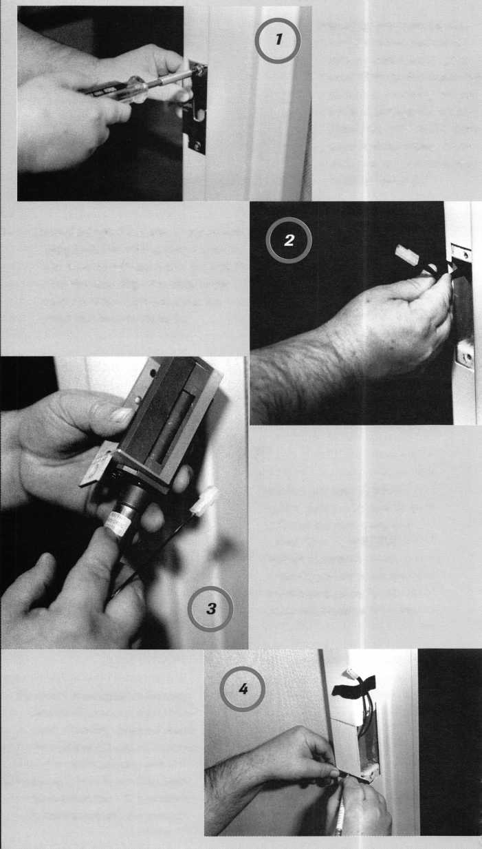

A handing kit is provided with the installation package, and you will need to determine handing prior to installing the strike (photo six). To do this, check the mortise block in the door to determine whether the dead­locking trigger is located at the top or bottom. A plate is fur­nished to block the deadlocking trigger. Remove this plate, and reset it at either the top or bot­tom, as determined by the handing.

Now insert the strike into the frame (photo eight), and secure it with the screws pro­vided. The installation is now complete and ready to be checked for operation.

Make the cut straight back and straight down (photo five). When finished, touch up the edges with a file if needed.

Untape the wires, and plug the strike into the wire connectors (photo seven).

February 1997

Keynotes



BY **PATRICK R. OLMSTEAD**

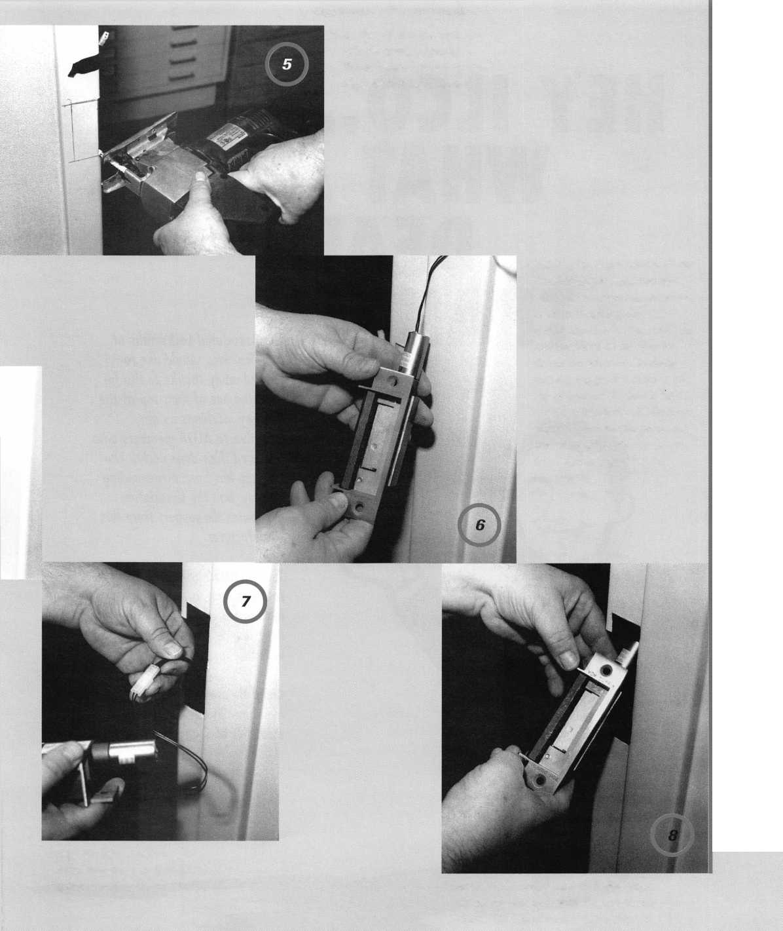

HEY ILCO... WHAT A DEAL!

The llto KD56 prize sported features such as precision jaws; locking cutter and guide; built-in light; and is known to be versatile and durable.

Congratulations to winning member Vincent Guarino,

#20574, of Stony Point, NY.

THANKS!

The Associated Locksmiths of  
America, Inc., would like to  
extend many thanks to llco for  
donating one of their top-of-the  
line key machines as an  
incentive to ALOA members who  
renewed their dues early. The  
pogrom has been a resounding  
success, and the association  
qpeciates the support from this  
*manufacturer.*



In Part One, I explained the basic theory of impres­sioning. This month I’ll get into a more detailed practical application of those principles. Understanding the theory is much easier than actu­ally impressioning a key to a lock. Don’t be disap­pointed if you’re not immediately successful fitting keys by this method. It takes a certain touch and decent eyesight. Most of all, it takes practice, persis­tence and patience.

**The Key Blank**

Before you begin to impression a key to a particular lock, you will first need a key blank with a keyway that matches the keyway broaching of the lock. Usually that will be fairly obvious. You will normal­ly just use the standard blank for the particular brand of lock. If you don’t have the precise blank for the lock, one with a compatible key way will usually

< *€ r 4,* Jr *f*

\ \

> v v s V y s /

**s**

accomplish the same task. Let me be more specific as to what constitutes a compatible keyway.

The first consideration of compatibility is whether or not the key will physically enter the lock. Once it is determined that the key will enter, we should consider how it fits. If it is a very tight fit, it may be nearly impossible to generate vertical motion. That up and down motion is what allows us to impression a key. Impressioning becomes prac­tically impossible if no motion can be generated within the key way.

The opposite condition can be nearly as bad, although it may not seem to be a problem. An extremely sloppy fit will allow a great deal of up and down motion. The greater motion will generally create deeper (and easier to see) impression marks. That seems to be a good thing, except that the pins will continue to mark on the key even after they’ve reached the shear line.

In part three under the section on complications,

I will illustrate much more specifically what hap­pens with a sloppy fitting key. For now, we’ll just say that the key blank should insert easily into the keyway without excessive slop. Also, make sure the key is long enough to engage all the tumblers in the lock. A key designed for a five pin lock (even with the proper keyway) will not extend far enough inward to impression a six pin lock. When not cer­tain about the number of tumblers, it is better to err on the high side. A key blank for a six pin lock can be used to impression a lock with five pins, but not the other way around.

For impressioning to work, the tumblers must press into the top surface of the key and generate impression marks. That should suggest to us that the material of the key blank should be softer than the tumblers. Typical key blanks are either nickel silver, nickel plated brass or brass. Brass (being the softest) is generally recognized as the best standard production key blank material for impressioning.

Silca has recently introduced a new line of colored aluminum key blanks. In years past, aluminum keys have been generally consid­ered too brittle for impressioning. Silca sug­gests that their new aluminum (alloy?) key blanks are stronger than the earlier genera­tion aluminum keys. I have not tried them for impressioning. You may be inclined to try them, if you find that they don’t crack easily and generate impression marks better than brass.

The Impressioning File

Your choice of an impressioning file will affect your ability to clearly see impression marks and the amount of material removed per file stroke. Impression marks will tend to be fairly faint and difficult to see (more diffi­cult for some than others). As you choose the tools for the task at hand, you will want them to simplify rather than complicate the job. The finer the surface we can generate on the key, the easier it will be to see impres­sion marks on that surface. Among the most popular types used for impressioning are the #2 or #4 swiss-cut round tapered files. Some locksmiths prefer a pippin file, which has an end profile that resembles a tear drop or an apple seed. They also come in a #2 or #4 swiss-cut pattern. Both types of impression­ing files are generally available at most lock­smith supply companies.

The #4 file generates a finer cutting sur­face, while the #2 file cuts more material per stroke. Your eyes may help you choose a file that will work best for you. If the slightly rougher pattern generated by the #2 file doesn’t make it too difficult for you to see the impression marks, you will be able to file the key faster. If even the #4 file can’t create a smooth enough surface to reveal the impression marks to your eyes, you may be inclined to seek out an even finer file. Just remember that the finer the file is, the more

file strokes it will take to generate a working key. I personally prefer the #4 file, but in years past I have also impressioned with a #2 file.

The Key Holding Device

Most locksmiths use some type of tool or device to hold the key blank securely during the impressioning process. Although the unaided hand can also do the job, the force required tends to cause discomfort and cramping. Since the key must be held firmly, a pair of locking pliers (like vise-grips) tends to be most effective for holding the key.

Specially made tools are available for holding keys for impressioning. Many of them are modified locking pliers and others are completely custom designed. Those tools can sometimes be quite expensive compared to a standard pair of vise-grips.

I would normally choose the shorter vise- grips. If you get them too long, you will tend to have too much leverage. Consequently, you would generate greater torque than you need and tend to break off the head of the key during impressioning. **Getting Started**

To get started, I will need a key blank, a key holding device and an impressioning file. As described earlier, my preferred choice for those items would be a brass key blank (of the proper keyway), a pair of six-inch vise grips and a #4 swiss-cut round impression­ing file. You’ll develop your own preference for specific tools as you find what works most effectively for you. Don’t feel forced to use a technique that works best for another locksmith if it does not work for you.

Before I can expect to get clear impression marks, I must prepare the key blank surface that comes in contact with the tumblers. That surface is normally quite rough and pitted from being stamped out of sheets of brass stock at the factory. If I don’t use my file to create a smooth working surface, it will be extremely difficult to distinguish an impression mark from the assorted marks that you would normally find on an unpre­pared blank.

I use my impressioning file in even strokes across the top surface of the key blank until I see a smooth, even pattern.

This should take off no more than a few thousandths of an inch. If you take off too

much, you may lose your shallowest key depth. Some locksmiths prefer to use a very fine, flat file to prepare that top surface.

The prepared surface will not be perfectly smooth, but it should have a fairly consistent pattern of fine striation marks. If it does, the dot-like impression marks (for a pin tumbler lock) should stand out in contrast to that pattern.

Generating Impression Marks

Figure One shows a side cutaway view of a pin tumbler lock. With a prepared key blank inserted, all five bottom pins rest on the key’s top surface. They are pushed down­ward in each of the pin chambers by the force of the tumbler springs. Although the pointed end of the bottom pins is up against the top surface of the key blank, the tumbler springs do not generate sufficient force to create impression marks. To impression suc­cessfully, we must find a way to generate suf­ficient force (between the tumblers and the key) to create those marks.

The shell and plug of a pin tumbler lock cylinder are shown in figure two. This top view shows the pin chambers and their alignment along their separate center lines. The top view of the shell shows the pin chambers fairly straight along the center line. The plug is intentionally exaggerated, with most of the pin chambers dramatically off center. This exaggeration is merely to illustrate a point, and is not likely some­thing you would see on a production lock cylinder.

If you look back at figure one, you will see that all of the bottom pins lie in the path of the shear line. If you tried to use your key blank to rotate the plug, the rotating motion would stop almost immediately. The plug in figure two shows the fifth pin chamber the furthest off center in the clockwise direction. If the key blank was rotating the plug clock­wise (figure three), the right side of the bot­tom pin in the fifth pin chamber would come in contact with the right side wall of the upper pin chamber. Shortly thereafter, the left side wall of the bottom pin chamber would come in contact with the left side of the bottom pin. The pin would become bound between those two pin chamber walls and further rotation would cease. Although the other four bottom pins would lie directly

***Keynotes***

February 1997

in the path of the shear line, the one pin that was furthest off center (in the direction of rotation) would be the only one that kept the plug from rotating any further.

Look back at figure one. Let’s presume that this is the assembled shell and plug shown in figure two. If the key blank is rotating the plug clockwise, the bottom pin in the fifth pin chamber (from the front) will be bound from that force. Within the limit­ed movement of the key inside the keyway, the key should be rocked or bumped up and down. Remember to maintain rotational force while the key is being moved up and down.

While the key is being rocked up and down within the confines of the keyway, the pins are also being moved. The pins in the first four pin chambers are not bound. Because of that, the movement within those pin chambers will be very much the same as if no rotational force was being applied to the plug. That means if the key moves upward, the pins move upward. When the key moves downward, the tumbler springs push the pins back down and maintain physical contact between the bottom pins and the top surface of the key. Since there is no binding pressure on those pins, only the tumbler springs will produce any counter­force downward. That force is too minuscule to generate impression marks.

That brings us to the bottom pin in the fifth pin chamber. Since it is the only pin bound, it is the only pin capable of generat­ing an impression mark through its physical resistance to the upward movement of the key blank. As the key moves upward, the top surface of the key pushes into the nearly pointed tip of the bottom pin. That pointed tip pushes into the soft brass and generates a small dot like the one near the tip end of the key in figure four. The five arrows point to the relative position along the top surface of the key where each pin chamber is located. The pins that did not bind left no mark. Only the bound pin left an impression.

The impression marks alone can tell us when and where to file. Certain procedures and techniques are required to optimize those marks.

Binding and Bumping

In very simple terms, the procedure required

to generate usable impression marks involves binding and bumping. Rotational force (torque) binds one or more pins, and the up and down motion presses the key into the bound pins. If you use bad technique for binding and bumping, you will waste a lot of time and key blanks. Lets review ways to improve technique and increase your likeli­hood of success at impressioning.

First of all, you must face the fact that the lock will dictate the order in which the pins will bind and mark. Each lock (even those of the same brand) will have its own sequence as its own identity. Just because you’d prefer the pin in the first chamber to mark first won’t make it so. That also means that pins that don’t bind, won’t mark. Filing some­where because you think it ought to be marking there will only get you into trou­ble.

The amount of torque applied will deter­mine how tightly the pin will bind within its chamber. A more firmly bound pin will tend to mark deeper and clearer into a key. There will be some practical limitations to the applied torque. If you exceed the strength of the key, you will just break off the head of the key. You will just have to experiment to determine how much force you can generate without excessive key breakage.

The up and down bumping will not just cause the pin to press into the top surface of the key. It will also (after repeated attempts) eventually push the pin out of contact with the surface of the key. When the pin is out of contact with the key surface, continued torque and bumping will not improve the depth or visibility of the impression mark. It will only stress and eventually fracture the key.

Economy of Motion

When applying torque to your key, try bumping your key up and down two or three times. Then relieve the pressure and allow the tumbler spring to push the pin back down and in contact the key surface again. Repeat the bind and bump action.

Your eyesight and ability to recognize impression marks will dictate how many times you will need to repeat that same action. Some very fortunate locksmiths will see the marks the first time and won’t need

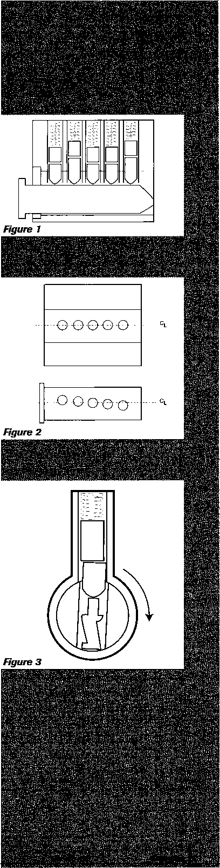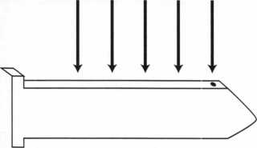

Figure **4**

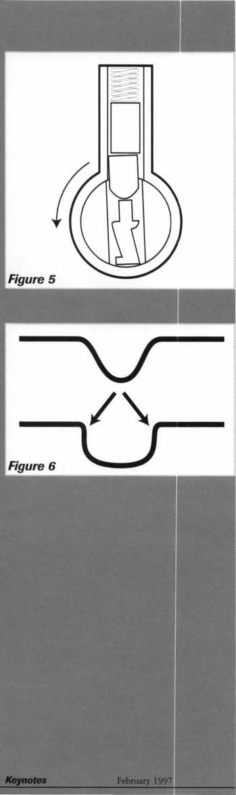

to repeat the action at all. Other locksmiths may find themselves repeating the procedure many times before they’ve generated marks visible to them.

I have already indicated that only bound pins will mark. If clockwise rotation only generates one or two marks, you may be able to get additional marks by rotating counter­clockwise too. Figure five shows the key rotating counter-clockwise. This will nor­mally cause different pins to bind (than bind from clockwise rotation) and generate more impression marks.

Filing to Depth

Impression marks tell you where to file, but they don’t tell you exactly how deep to file. When it comes to depth, the only thing you know absolutely from an impression mark is that it is not deep enough yet. This is one area where practice may be your best teacher.

When you see an impression mark, you could choose to make only one file stroke (so the mark disappears) and immediately bind and bump to generate a new mark. I suppose you could call that the extremely cautious approach, and it would be possible to suc­cessfully impression a key in that way. It would also be extremely slow.

The other extreme might be to see a mark and proceed to wail away at the key. With that method, you might find yourself filing too deep and having to start over again. Somewhere in between you will have to find a compromise between precision and speed.

No matter how bold you are in your fil­ing technique, you must always obey one rule. If you don’t see an impression mark, you don’t file. When a pin binds, it will mark. When it stops binding, it will stop marking. This is where patience is so impor­tant. You must wait for the pins to mark. Some pins will not mark until nearly all the other pins are at the shear line. When you have filed some cuts to depth, the plug will rotate further and the pins that are not as far off the center line will finally make contact with the side walls of the pin chamber and bind.

Figure six shows two different examples of key cut shapes. The one on top is pre­ferred with its relief angles on each side of the cut. Those angles allow for easy insertion and removal of the impressioned key. The

pins can ride up and down the slopes with­out grabbing.

The cut shape on the bottom is an absolute no-no. Inserting a key with cuts shaped like that will make the key very diffi­cult (if not impossible) to remove. You could get yourself into unnecessary trouble espe­cially if the lock is secured and you’re on the outside. You may ultimately limit your options to drilling out the lock since, with the jammed key, picking no longer becomes a practical option.

When Is It Done?

Finally you may ask, “When is an impres­sioned key done?” I guess the simplest answer to that question is, when the key turns. It’s not really quite that simple. We know that the basic rule is to file where you see an impression mark. When the key no longer marks, presumably the key is turn­ing. If your technique or eyesight is lacking, you may either not be generating marks or you simply may not be seeing them. This is where the three P’s come in— Persistence, Practice and Patience. Except for a few with an apparent natural talent for it, most of us have to really work at it to get any good at impressioning. It often helps to share some hands-on experience with another locksmith who is already somewhat skilled at impres­sioning.

In part three, I will explain some of the complications related to impressioning, and a few specialized and/or speed techniques for impressioning.

I About the Author: Sal Dulcamaro,

CML, has been in the locksmith business for over  
21 years. He is the president of All Pro Security,  
Inc. in Michigan and has been an ALOA member  
for 13 years. A past president of the Locksmith  
Security Association of Michigan, Sal currently  
serves as editor of the association newsletter. He  
was named “Keynotes Author of the Year” for  
1996.

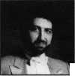

**RENO, NEVADA**

**LOA ’97  
ND SECURITY**

**XPO**

**UGUST 2,1997  
ONVENTION CENTER**

**WITH QUESTIONS OR COMMENTS CONTACT:**

**ASSOCIATED LOCKSMITHS OF AMERICA, INC. 3003 LIVE OAK ST.**

**DALLAS, TEXAS 75204**

**214-827-1701**

**800-532-2562**

CONSTRUCTION v AHEAD y

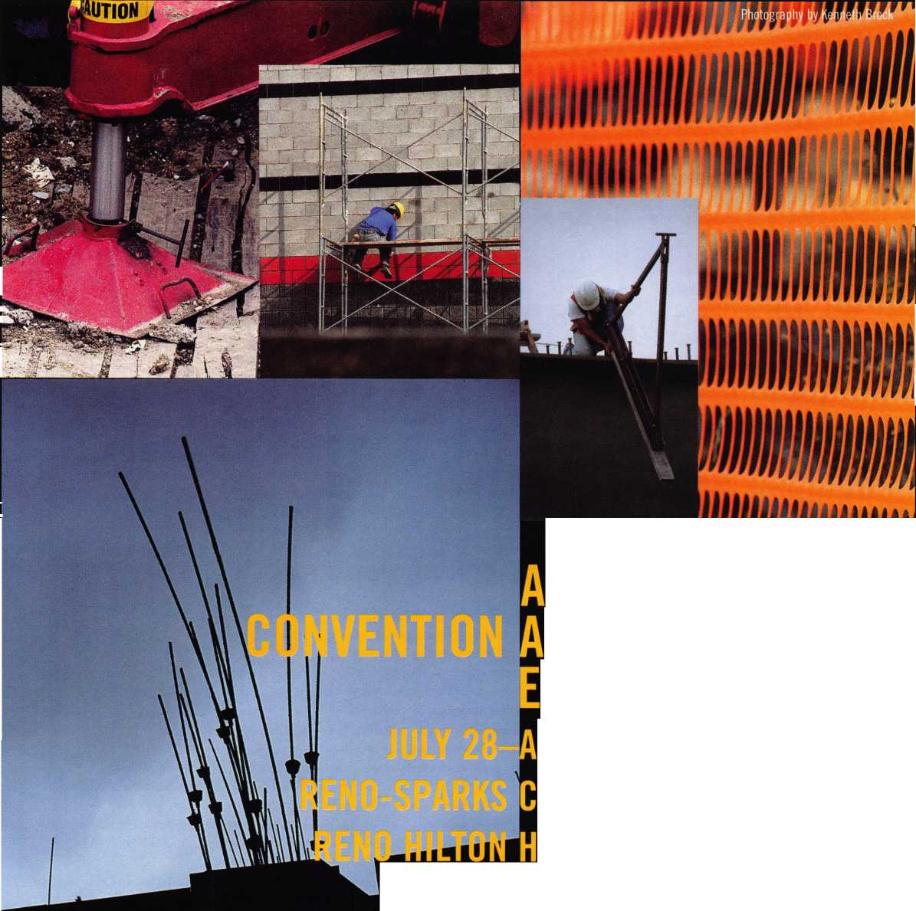

*corner*

A s Worst ^^iQlotryzctr(?!

By Bob DeWeese, CPL

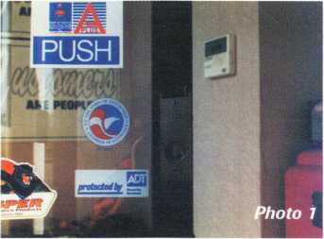

It couldn’t have been long after the inven­tion of super glue that some jerk discovered that it was a great way to wreak havoc with the locks of one’s enemy. From angry cus­tomers to disgruntled employees, it seems to be the method of choice for effectively lock­ing someone out of their own business. Sometimes, it’s not even personal. There have been occasions when vandals have super glued the locks on just about every door in an entire shopping center, leading to a regu­lar “locksmith reunion.”

After this had happened to one of my regular customers twice in as many weeks (disgruntled ex-employee—in case you were curious), we decided that something had to be done. I remembered seeing a device advertised a couple of years ago that was designed to slide down over the cylinder and prevent a key, or in this case glue, from entering the keyway. After a few phone calls, I located the manufacturer (Securitech), who in turn directed me to a distributor (Accredited Lock Supply) who handled the product. The following procedure will result in a trouble-free installation of this product.

First, remove the cylinder from the lock and set it aside. Next, align the metal tem­plate, furnished with the Securiguard, with the cylinder hole in the lock—not the hole

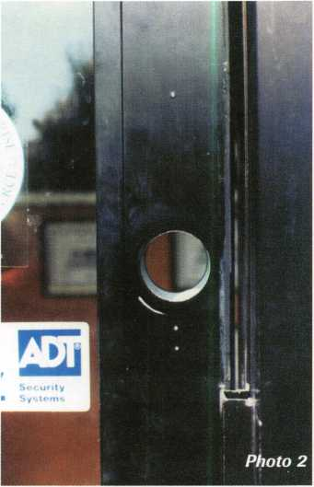

in the door. Make sure that they template is perfectly centered around the hole, and tape in place (photo one).

Next, center punch the top and very bot­tom holes in the template (photo two). Yeah, I know that the picture shows three marks, but I’ll get into why that is unnecessary in a minute. Suffice it to say for now—hindsight is 20/20.

Now remove the rest of the lock from the door. The manufacturer’s instructions say that you don’t have to do this, but I did and I have my reasons. I’ll tell you what they are in a minute.

Drill a 1/8-inch” hole on the top mark, completely through the door, making sure that you drill straight and level. Then enlarge the holes inside and out to 3/8”.

Drill the outside 3/8” hole from the outside

u\

Keynotes

February 1997

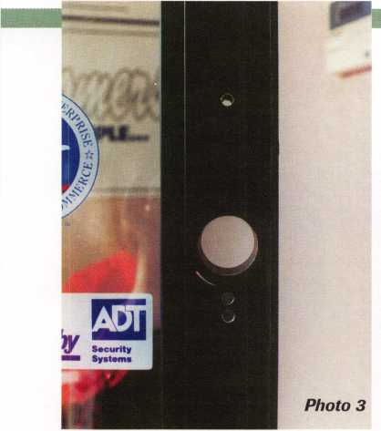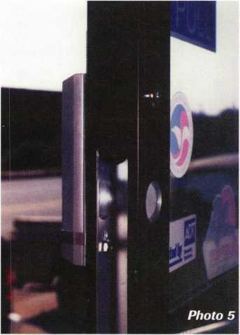

***protected by***

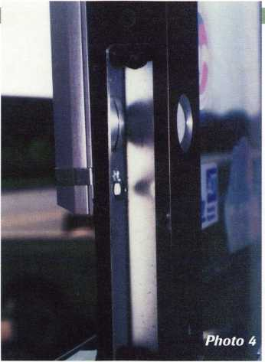

***protected by***

about telling a beginner to drill into the door with the lock still in it. After installing the top screw from the inside (photo five), you’re ready to reinstall the lock.

Photo six shows the Securiguard in the open position and photo seven shows it in the locked position. To operate, place the magnetic key (photo eight) against the face of the sliding cover and lift up. To close, the Securiguard can simply be pushed down. It is also field adjustable to allow lowering only with the key if preferred.

You may notice that it was necessary in this case to cut out part of the stop (photo seven) to allow the Securiguard to clear, and the door to close. I made it a point to bring it to the attention of the business owner before I started, and got his approval first. Although I hate to do it, sometimes you have to sacrifice aesthetics for security. This would not have been an issue had the door opened out instead of in.

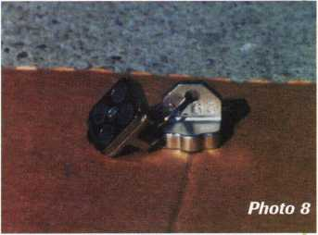

and the inside hole from the inside. Then drill a 1/8” hole on the bottom mark through the outside of the door only, and enlarge it to 3/8” also (photo three). Disregard the upper bottom hole—as with this installation, I found it to be unnecessary.

Okay, to end the suspense, the manufac­turer’s instructions say to drill the two holes and enlarge the upper bottom hole to 1/2” giving you a hole shaped like an upside down teardrop. Their intent is to allow the installer to install the Securiguard, without having to remove the entire lock from the door, by putting the lower nut through the larger of the two bottom holes and slipping it down. I opted for my way for two reasons: 1) I wanted to be able to tighten up the nut, securing the bottom of the Securiguard to the door (photo four), which would have been impossible to do with the lock still in the door, and 2) I’m just a little apprehensive

This was the first time I’ve installed one of these (obviously), and installation took me about a half hour, including the photography.

In addition to mortise cylinders, the guard can also be used with most rim cylin­ders. For more information on the Securiguard, contact the Securitech Group, Inc. at 718-392-9000.

I About the Author: Bob De Weese,

CPL, #19138, owns and operates Bear Lock and  
Security Service, Inc. in Baltimore. He has been a  
locksmith for 13 years and an ALOA member  
since 1990. He was awarded MLA’s President’s  
Awardfor his efforts on behalf of locksmith educa-  
tion and was named Keynotes’ 1994 author of

February 1997

Keynotes125

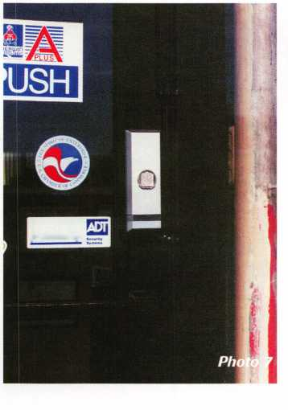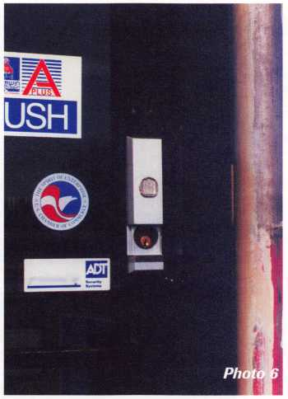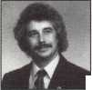

Does Your INSTITUTION Really Want Key Control



261 Keynotes February 1997

I find that most of the institutions I have dealt with say they want key control, but they have a misunderstanding of what key control is and what they have to do to accomplish it. After reviewing an institu­tion’s key issuing procedure, I often find that it is management who is at fault. What hap­pens is that management has this impression that a key only costs around one or two dol­lars. Therefore, it is no big deal to have a locksmith just issue a key to Dr. Lowell, Dean Brooks, or Professor Cannon when they want one. It only becomes a problem when the key—that only costs about one dollar—that went to Dr. Lowell happened to be a GGMK operating 14,143 Medeco Cylinders in Corbin Russwin Lever Handle Undoes—and he loses it. The cost to rekey the system at $20 per cylinder is $282,860. If you figure it takes an hour’s labor per lock, that’s over 14,000 man hours.

At a large university in Dallas, the Dean of Engineering, Dr. Brooks, requested a key to the Science Building. The university lock­smith recommended to management that Dr. Brooks have a departmental master instead of a building master. The building master operates every cylinder in the build­ing including other departments in that building. Dr. Brooks has no business having access to other departments, but again, man­agement’s mind takes over: It's only one key and he is a Dean, so we'll give him what he wants.

Two weeks later, Dr. Brooks gave the key to one of his student workers. The key was never returned and he can’t remember who the student worker was. The cost to rekey 478 cylinders—Schlage-D at $15 per cylin­der—is $7,170. The labor, at only two installations per hour, is 239 man hours.

This is equivalent to one man working six weeks, and this six-week time period does not include system design, key cutting or record keeping.

Next, the Security Department returned a key #1700 with serial #3. It was found in one of the girls’ dormitories. A look through the computer showed that the key #1700 with serial #3 was issued on 9/24/95 to Professor Cannon. It was a GGMK for all seven of the girls’ dormitories. I don’t want to know why he needed to have that key or how he lost it, but I have a pretty good idea. By the way, the key was returned to Professor Cannon.

My definition of key control is knowing

***S3>ei3d0***

*\**

-o

By Robert H. Stafford, CPL

. N.



who has what key, and knowing what cylin­ders that key operates. Whether the key is a change key or a GGM or anything in between, the value of any key should be brought to the attention of management and it should be explained in terms that they will understand. If you guessed dollars, you’re right on the money. Do your home­work, make sure you have all the facts and give an honest dollar value of what it will cost for material and labor if a rekey is need­ed. You will see some eyebrows raise when you give them the facts. You have just start­ed a management education program, and the management is probably not even con­sciously aware of it. In the middle of this article, I received the following work request:

Bob Stafford, please make a master key to Auerback Hall (Auerback Hall is an academ­ic building that has about 13 different departments in it) and a key to the elevator for Dean Raymond Lusk. An approval letter signed by Rick Ohmit was attached. This is what the inter office memorandum said:

To: Rick Ohmit

From: Raymond Lusk (Dean)

Date: January 16, 1996 This is to request a master key for Auerback Hall and also a key for the elevator for my exclusive use. I have many occasions to require access to my office on weekends and other out of office hours when the building is normally closed.

Thank you for your help.

It was signed by Rick Ohmit, the Associate Provost. I then walked the request over to the Security Department and asked the Security Director, E. Wersonick, to okay or deny the request. She okayed it, saying that there was no way she was going to say “no” to a Dean.

Okay, so I lost that one, but I also have won a few. Just keep on trying to do what you believe is the right thing, and whenever the opportunity arises, keep trying to edu­cate management. It will pay off in time.

(The names in this article have been changed to protect the guilty and also keep me on the payroll.)

m, ^

fslf t

I About the Author: Robert H. Stafford, CPL is the locksmith for the University of Hartford. He is on the ALOA Board of Directors.

February 1997

Keynotes



Locksmithing

**In The '90s**

In case you haven’t noticed,

locksmiths tend to be an independent breed. Working for someone else is fine for some people, but not all of us choose to follow that path.

I have been a mobile lock shop for 13 years in eastern Montana, and for my particular case, it is the only way to go. The population density for my area is about three people per square mile and most of them are located in small towns within my traveling area. I cover an circle of about 120 miles from Miles City. I know many lock shops would not even consider going 120 miles for a call, but here you have to travel to succeed.

Making the choice between being totally mobile or having a storefront is as individual as you can get.

By Ken Holmlund, CRL

Mobile locksmithing is not without its pitfalls and prob­lems. First and foremost is, how do I know what to carry with me on the road? I have a shop setup in Miles City, but it is not a storefront. I have many things there that I do not carry with me all the time because of space limi­tations. The best indicator of what to take on the road comes with experience. Know the area you are covering and what will be needed to do the job. Over a period of time, you will learn which brands of locks are most pop­ular and you will take what is needed to work with the customers you will be servicing. In our area, Weiser, Schlage and Corbin/Russ win are the most popular brands. Your area will probably be different. Also, if you have to make a 90 mile return trip for a part you do not have, you will take notice of the most common problems and what is needed to fix them.

Another major consideration is your vehicle. I spend a great deal of time in my pickup, and I want it to be dependable and comfortable. The first two pickups I had did not have air conditioning. Now I know some of you are saying, why does he need air conditioning in Montana, it never gets warm there? WRONG!

Contrary to popular opinion, Montana does have a sum­mer. I have known it to get as hot as 113 degrees. One thing we do not have is humidity—thank goodness. Enough of the sales pitch for Montana.

Keynotes

February 1997

I have had calls at two o’clock in the morning to travel 90 miles—immediately. The last thing I need is to fear that my vehicle will break down. For that reason, I have chosen to lease a new vehicle every two years (photo one

shows my rig), but leasing versus buying is another whole article.

storage space and

able spot will be

What type of vehicle will you chose? I have used pickups with a camper shell fixed up for my needs. Why? Primarily because of the noise factor. Those of you who have open vans know what I mean. The noise would drive me crazier than I already am. Nerves can get frayed enough without the added exposure to key blanks slapping together— especially when you drive the kind of dis­tances I do.

My camper shell is standard, with a few modifications. I had the door moved to the middle of the back so I could have benches and a work area on either side. I use the dri­vers side for my work bench and the passen­ger side primarily for parts. My key blanks are on removable boards, so when I get a new shell, I can just take them out and put them in the new one. Have you ever tried to move a couple of hundred hooks of blanks, one at a time? Another change I had done to my shell was to have the passenger side window lowered for better vision, especially when backing out of a nosed-in parking sit­uation. The last modification was to have extra studs put in the walls so I could hang more things, like small storage compart­ments. It seems as if we never have enough

Life is not lived by driving alone, and some­times you will have to stop and go to work.

I like the camper shell setup because it allows me to work either sitting down or standing, albeit for only a short period. I have a chair on wheels in the shell and do most of my work from the seated position. Caution must be exercised to be sure you have secured the seat before taking off for the next job, or you may be replacing a win­dow in the back of your work area. You soon learn to put everything back in its place or you will be picking it up at your next stop.

Keeping accurate records of your travels is a necessary evil. The IRS is a fact of life for all of us and they frown on our guessing about our travel expenses. Keep a log in your vehi­cle and get into the habit of using it daily. It will pay off as time well spent.

Have you upgraded to computer based code information? If you have, a laptop computer will be a valuable purchase for you. I have found that since I have the computer with me in the truck, I seldom refer to the books. Isn’t it funny how quickly we become so attached to our computers?

How about power, and I mean the 110 volt variety? I use a 1300 watt inverter as my power source. It is large enough to run both key machines at one time and I can even used my 1/2 inch Makita drill. That really comes in handy in the field. If you are still dragging extension cords or using 12 volt equipment, I suggest looking into an invert­er. There are several brands on the market. Check with your supplier for advice and their experience with various brands.

Communication on the road is critical. The advances of the cellular phone network has been a boon to locksmiths, even in Montana. Our area has many dead spots where I can’t be reached, but it sure beats paying someone to answer the phone. When you rely on someone else, you do not have immediate contact with that customer. Sure, cellular phones can be expensive, but so are missed calls. I use call forwarding from my office to the cellular to make it easier for customers to reach me. Call it coincidental, but my busi­ness has doubled since I got the phone.

One of the arguments I hear is that the mobile locksmith does not portray the feel­ing of stability that is achieved with a store­front. I guess that is a personal choice you will have to make, but I feel that if service and customer relations are a priority for your mobile business, the stability will be there. The customer is more concerned with whether you can solve their problem than whether or not you have a pretty shop with lots of displays. If you chose to have a store­front, fine—but make sure it will pay for itself and not drag you down.

About the Author: Ken Holmlund owns and oper­ates Holmlund Mobile Lock & Key in Miles City, MX

February 1997

Keynotes

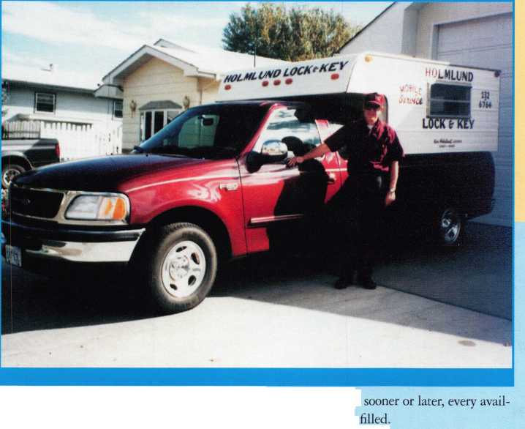

The campus at the University of Hartford in Connecticut buzzes with sounds of busy stu­dents, faculty and staff. And tucked away quietly in a very modern shop in the middle of all the intellectual hubbub, is the man responsible for the security of the entire col­lege campus. That man is Bob Stafford. He supervises the locksmith department.

The University of Hartford has over 55,000 locks on campus, and approximately 100 campus vehicle locks. Every lock on every dorm, academic department, universi­ty vehicle and building has been installed, repaired and maintained by the locksmith department with one goal in mind: keeping the campus as secure as possible. But what happens if a key is lost? Stolen? What series of events unfolds if a lock refuses to open?

For Bob and his two-man crew, the chal­lenges of institutional locksmithing make every day interesting.

Hey! Is That a Knock?

Bob entered institutional locksmithing when opportunity knocked at his door. He was looking for a career move that allowed him to dedicate more time to his family on weekends, and also provided good medical and dental benefits. With institutional lock­smithing, Bob could have the best of three worlds: free weekends, great benefits, and steady work in the career he loves. But Bob’s love for locksmithing didn’t come without riding some tough roads.

The locksmith industry as a whole has had to fight for recognition, and institution­al locksmiths have been hit with another whammy: Institutional locksmiths have had to struggle to find recognition within their own industry.

“We’re segregated from the rest of the industry and I don’t understand why. In fact, we are locksmiths—we just work for a large employer. Even today, an institutional lock­smith isn’t considered to be as proficient as the rest of the locksmiths in the country and I really don’t understand that. I had a lock­smith tell me once that an institutional lock­smith isn’t a real locksmith because we got paid even when we didn’t work. What he meant by that was, if there was a really bad

301 KeynotesFebruary 1997

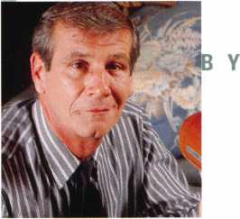

snowstorm and he couldn’t get out to do his work, he wouldn’t make any money for that day, but if we work for an institution and they close the institution, we would get paid for it. I don’t know what that has to do with being a locksmith, but now that I know the difference between being a real locksmith and just a locksmith, I think I’ve chosen wisely.”

Doing It All

Between juggling a full time job with the university, his own locksmithing business and his family and friends, Bob rarely has time for anything else, including fishing, his favorite hobby. But once in a while, Bob manages to have some downtime.

“You know when I get a break? When I go to a board meeting. It’s away from the phone and I get to meet and talk with a lot of neat people.”

There’s no doubt that Bob has a strong work ethic. Every year, at the ALOA conven­tions, Bob contributes his time and energy. During ALOA ’96, Bob and a crew could be counted on to get the rooms and equipment ready to go each day for the ACE classes.

“He’s an extremely talented, highly quali­fied individual who is concerned about our industry and the institutional locksmiths in particular,” said John Cannon, CML. “He’s an all-around good guy.”

Bob Stafford’s reputation as a dependable, funny, hardworking person has made him a favorite among locksmiths.

All This and a Bag of Chips!

At the University of Hartford, Bob and his crew jam-pack their days with designing and maintaining masterkeying systems, key con­trol, hardware installation and repairs, safe work, vehicle keying and special projects.

R I E KLINE

“We’re in charge of all physical security,” says Bob. “There are three of us in the shop. We all work from 8 o’clock until 4:30, which is an eight-hour day, but rarely do we walk out the door at 4:30.”

With over 9,000 students running in and out of buildings, inevitably some keys will get lost or stolen in the shuffle. If a student loses his/her key and doesn’t find it within 72 hours, Bob and the guys must do a lock change.

“We could get three, four, five, ten, fifteen lock change requests a day,” he said.

Hopefully not all from the same student.

The locksmith department is also respon­sible for the key activity of the faculty and staff. The Chairperson or Dean of an academ­ic department is issued a masterkey to the department building. Losing that key can be very costly to the academic department.

“If you lose a key, it’s $50 for every lock that that key opens,” said Bob. “So if it’s a masterkey and it opens up 100 rooms, it’s $5,000.”

The $50 per-lock charge covers the cost for equipment and labor expenses, and is also a strong incentive for people to recognize the value of a key and the security it represents.

“You have to put a cost on something in order for people to consider it valuable or not,” said Bob.

Replacing lost or stolen keys and rekeying occupies a big chuck of time, but the lock­smith department doesn’t stop there. At a medium-sized university, projects pop up constantly.

Take a Number, Please

With thousands of students, faculty and staff members, the locksmith department must have a system to accommodate every person’s

j

keying needs. The solution? The locksmith department operates on a work order system. Anyone who wants work performed must submit a work request which goes into the locksmith department’s operations office.

The operations office turns the request into a work order. The work orders are sent to the locksmith department, where they are reviewed, prioritized and handled according­ly. In emergency situations (like a frantic teacher about ready to break down the door to a lecture room when, five minutes before class time, he finds his key won’t work), Bob and his crew come to the rescue.

There are some requests, however, that have to be completed at specific times of the day. Maintenance, for example, has to be carefully planned around high traffic times. If a student mailbox has to be repaired, the best time to tackle the project is in the morning. Imagine fighting your way through a lunch time crowd of chattering, energized students. It’d be easier to survive the Running of the Bulls.

Mr. Stafford, This is Your Assignment-Should You Choose to Accept It.

On occasion, a person or company will loan,

for a specified period of time, a valuable piece of sculpture to the University. When this happens, the locksmith department receives a call for a special request. Since the loaned art is usually worth a lot of money— anywhere from $80,000 to $150,000—Bob and his crew must find a way to keep the sculpture safe until the sculpture is returned to its home.

“They’ll mount it in front of the comput­er center where the president’s office is, and we’ll get a strange request to lock this huge sculpture down,” said Bob. “So we have to come up with some innovative ways to do things like that.”

Do they use ultra-sensitive, super sonic motion detectors? High powered laser beams? Invisible casing?

“We can’t throw chains around it,” said Bob. “We come up with some pretty unique things.”

In one instance, they used a hammer drill, lead plugs, brackets, and a padlock. But whatever creative solution they find to keep the sculpture secure, they must make sure it doesn’t detract from aesthetics of the art.

Until next time—mission completed.

Umm...Aren’t You Forgetting Something?

Bob and his crew work year-round. During one winter break, after the students had gone home for the holidays, the housing department asked Bob and his staff to change the locks on a few dorm rooms where rowdy students, who had since been kicked out, had lived during the semester. With the task of rekeying finished, Bob entered the rooms to replace the cylinders.

In one room, he got quite a surprise.

The room looked like a disaster—smelly trash covered the floor and furniture was missing. Bob weeded through the mess and started working on the door. Out of the cor­ner of his eye, he noticed a blanket on the floor, but didn’t pay much attention to it. Until it started moving.

He had just finished changing the cylin­der when he saw the blanket slide to one side. He blinked his eyes several times to make sure he wasn’t just seeing things. The blanket remained still. Bob slowly turned to leave. Suddenly the blanket fluttered again, and this time a seven-foot boa constrictor with slimy skin and pea green eyes stuck its head out!



“I do not like snakes, and I do  
not like big snakes, “ said Bob.

“I tell ya, chills ran up and  
down my spine, and no matter  
how warm I got after that, I still  
felt cold ‘cause I had those chills  
all over my body!”

The dorm room resident, in  
his or her haste, had left behind  
the reptilian friend. Just exactly  
how does one forget a seven-foot  
boa? You can bet Bob didn’t  
stick around to contemplate the  
possibilities.

“I called Public Safety and  
they called Animal Control and  
came down and took this mon-  
ster out!”

Thank goodness he’d already

February 1997

Keynotes



finished installing the locks.

On Equal Ground

In the past, a locksmith wasn’t specialized—  
he was a jack-of-all-trades. When institu-  
tions saw a need for locksmithing, they bor-  
rowed a carpenter or an electrician and  
deemed him “locksmith for a day.” Placing  
untrained people in a locksmith’s role has

watered down the credibility of professional

rsity and on the  
ing management

locksmiths. If popular perception of lock-  
smithing is that “anyone can do it,” then  
locksmithing is seen as less valuable.

Today, although institutions employ  
highly trained, qualified locksmiths like  
Bob and his crew, locksmiths have to work  
even harder to be perceived as professional

trades people.

According to Bob, the key to rebuilding

credibility for all locksmiths, not just insti-  
tutional locksmiths, comes from education.  
By inundating popular perception with  
information about the training, skill, and  
overall work that encompasses lock-  
smithing, people will realize the value of  
locksmithing.

“Within the university and on the out-  
side, I have to keep educating management.  
Every time someone comes in, we have to

train them. Sometimes you have people who  
feel locksmiths are a valuable asset, other  
times people think, ‘Big deal, what’s a key?  
it’s only worth about twenty cents or half  
a buck.’”

That is, of course, unless he or she loses a  
key or gets lock out of their home, office or  
automobile. In these situations, people  
quickly realize the value of the locksmith  
profession.

“I feel we have to get the United States  
government to notice us as a viable trade—  
they haven’t in the past. Once they do that  
then we can work on getting the perception  
changed in the public eye.”

The Real Key is Education  
Changing popular perception begins with  
the realization that locksmiths are in a class  
all by themselves. Most professionals enjoy  
the prestige of a title and government  
recognition for the uniqueness of work

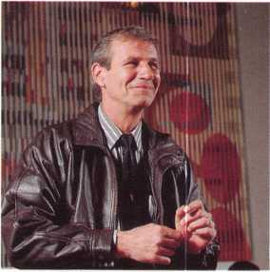

within a particular field.

“Electricians have an electrician’s title—  
they’re classified by themselves. Plumbers  
have a plumber’s title—they are classified by  
themselves,” said Bob. “There’s a bunch of  
us who they throw in together because we’re  
misfits and the government doesn’t know  
where to put us.”

But starting in 1997, locksmiths will

outside, I have to

V) 1

•

have the same leverage as other trades peo­ple, thanks to a new and separate code list­ing in the Security Industrial Classification.

“That’s definitely a feather in our cap as locksmiths,” said Bob. “And ALOA should get a great deal of that credit because they’ve been working on it for nine years.

It’s for all locksmiths—not just ALOA lock­smiths. The next thing we have to do is get to the public and make them realize that we’re no longer guys who shoe horses and sharpen lawnmower blades. We are security professionals.”

Bob and the New Millennium

After 30 years as an institutional locksmith, Bob has learned that education and aware­ness of new technological developments are the best ways to stay on the right course to the new millennium. In Bob Stafford’s world, education is the key to progress.

What does he foresee for the future?

“I see myself here fighting to preserve locksmiths and to keep educating. The fight will be to keep locksmithing viable.

Hopefully I’ll be better educated in five years than I am now.”

About the Author: Laurie Kline is the Associate Editor (/Keynotes and a freelance writer. With a master's degree in Communications from the University of North Texas, her writing back­ground includes travel, human interest, music and advertising!promotional.

February 1997

Keynotes

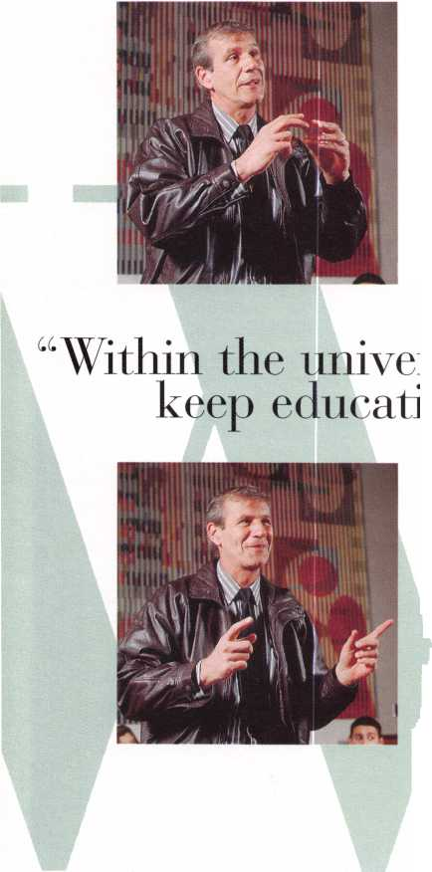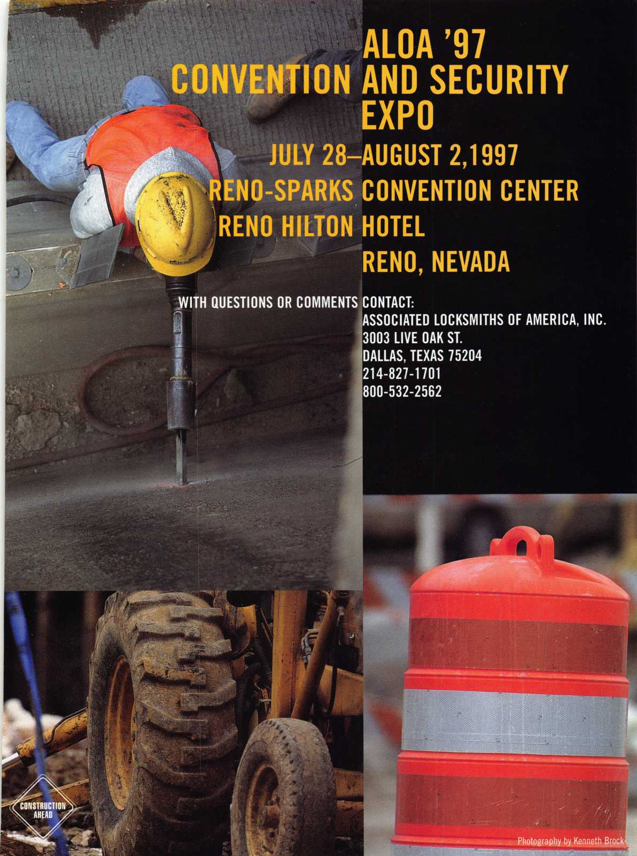

hen I read that the February issue of Keynotes was going to focus on “specialization,” I immediately thought about the most specialized guy I know. This customer of mine only sells and installs three things. I’ll call this fellow Ollie. Ollie used to work for a glass com­pany repairing storefront-type doors. He observed that more and more shopkeep­ers were installing door annunciators and electric locks. Upon further exami­nation, he realized that neither of these was very hard to install, so he quit his job and went into business for himself. He printed up a quarter-page flyer— door annunciators on one side of the page and electric surface deadbolts (Alarm Lock 103) on the other. He would install the door annunciator for one price and the electric deadbolt (with a transformer and toggle switch) for another price. That was it.

Ollie sold his specialized services the old-fashioned way. He would drive around looking for retail strip centers.

At each center he would go from store- to-store handing out his flyers. Sometimes he would get into a discus­sion with the owner, but usually he just left his flyer. And pretty soon the phone started ringing. Ollie started spending most of his time installing annunciators and electric deadbolts. But he never stopped cold-calling with his quarter- page flyers.

I said that Ollie sold three products, but so far I’ve only mentioned two. That’s where I enter the picture. I intro­duced Ollie to electromagnetic locks. He was skeptical at first, but he soon real­

Chandler, CRL

34 | Keynotes

February 1997

uy I Know,

ized how much better they were than electromechanical locks. Before long he had redesigned his flyer. Now he offered a choice of electric deadbolt or Rofu mag lock. (Mag locks were $100.00 more but they included a one year warranty. He offered no warranty on the troublesome electric deadbolts from that time onward.)

I can’t tell you that Ollie got rich spe­cializing in this way. I don’t think Ollie wants to be rich. Nor am I suggesting that you would be better off limiting yourself to three products. Most readers of Keynotes are progressive locksmiths who are growing the scope of their busi­ness constantly.

One lesson we can learn from Ollie is the timeless wisdom of personal market­ing. It doesn’t cost much to drop in on a few stores or offices to leave a flyer, a brochure or just a business card. No amount of Yellow Page space can match a handshake and a smile.

Another thing Ollie demonstrates is the benefit of being specific. Lots of locksmith advertising is geared toward getting potential customers to, “call me the next time you need a locksmith.”

But chances are they need a locksmith right now. They just don’t know it yet.

By highlighting one or two specific products or services that would immedi­ately benefit most businesses, you see rapid results and you actually generate new market activity.

Finally, specialization is easier in a huge metropolitan area like Houston than it is in a small or even medium­sized town. Whether you specialize in mom-and-pop stores, luxury car dealer­ships or financial institutions, there are just so many of them here that you can carve yourself a niche. And big city crime makes all kinds of security easier to sell. All of this tells me that specializa­tion is here to stay. As locksmithing and security technology becomes more diverse and complex, I expect to see many more “Ollies” at my will-call counter.

*About the Author: Paul Chandler, CRL, is the manager of the Electronic Security Department for I. D.N—ACME in Houston, TX.*



Yes!!!

You read about it last month  
You’ve known about it for years  
Now is the time to do something about it

ALOA ACE Certified classes The best in the business

iteter HocfcSmitftf gggociation of j&JL..The oldest in the business

Gala banquet Excellent food and entertainment

What more could anyone ask for

How about more information

Classes like Auto Opening with Steve Young

Masterkeying with Jerome Andrews and more

**Free** clinics like Tricks of the trade with Rick Ohmit

And who can forget a floor show that includes Manufacturers and  
Distributors from all over the country

Just remember one thing. .iSlaslter Hocksimttfjsl &$£foctatton of **M3** Convention

Garden State Convention Center Somerset, NJ

April 17th until the 20th of 1997

For more information Jllaater Hodtfmitf# gfetfoctatton of **M3**

P.O. Box 2441 Morristown, NJ 07962-2441 Phone (201) 267-8884 Fax (201) 538-2248 E-mail: [btimmann@early.com](mailto:btimmann@early.com)

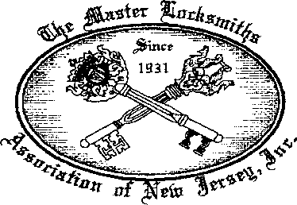

Working toward a better tomorrow

Free Information - Reader Service Card #21

GM

After The

By Ken Holmlund, CRL

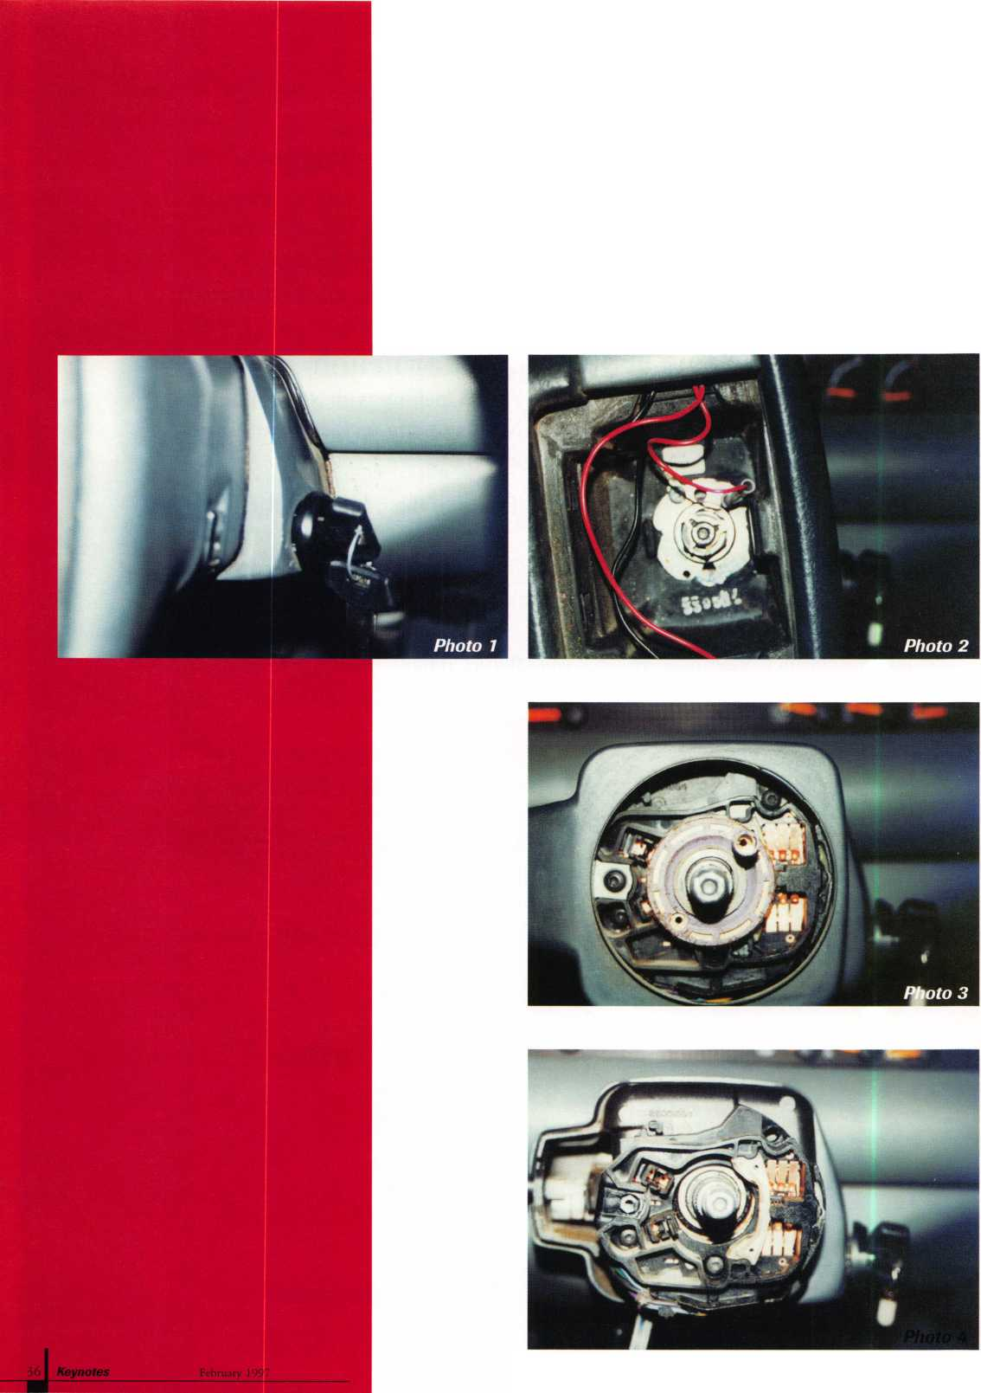

>agmaw

^ The Saginaw steering column

Photo 6

was a standard

in the industry for many years. We all  
remember it as the round one with the lock-  
on column. If you have done any car work at  
all, you have worked on the Saginaw. Several  
years ago, GM decided to move away from  
the familiar, partly due to security reasons, I  
guess. The result is a newer, square body col-  
umn.

If you have not taken one of these apart, have no fear. I think they are easier to work on than the old Saginaw. They don’t require as many specialty tools either, mainly just the puller and a T-20 torx.

If a new key is needed for most any new GM, I will call the GM emergency number for the make of the vehicle. If you are not listed with them, I suggest doing it quickly so you can get the codes. It is one of the best time savers you have available. In this case, the ignition would not turn to the lock posi­tion so the key could be removed, and I had no choice but to take it apart.

Photo 1 shows what you will see when the pad is removed. To get the pad free, only one connection is necessary to remove. The connection is made with the plastic tube that turns and pulls out. Do not disconnect the push-on connectors—it is not necessary.

Next, remove the clip and the nut, and pull the steering wheel. A puller is recom­mended. Photo 2 shows the steering wheel removed. You now have a new world in front of you. It definitely looks different than the Saginaw. To remove the square housing, remove the upper right hand torx screw, the emergency button and the torx screw that holds the turn signal. The housing will now lift off. Watch for a piece of molding about four inches long and curved. It will fall out. It must be installed before replacing the housing to give the job a finished look.

With the housing removed, you can now lift the horn connection off with nothing to loosen. The turn signal harness is removed by taking out the remaining two torx screws and lifting it from the shaft (photo 3).

Photo 4 shows the spring loaded mecha­nism for the tilt steering. A flat screwdriver will easily turn the bright silver colored cap. To remove it, push down and turn. It is a heavy spring so it will need some pressure, but it is not difficult to do. Watch for a large amount of grease on the spring. Be careful where you lay the spring and cap so as not to get grease on something you may have to clean.

In photo 5, the cavity left by the spring is shown. At the bottom of the cavity, about four inches down, is a wire harness. It must be pulled upward and moved out of the way to get to the retaining screw. Use care when working with the wire harness since the wires are not very heavy. Now you can remove the torx screw holding the lock in place and it will come right out. Photo 6 is of the ignition used in this particular vehi­cle. STRATTEC makes the replacement ignition. Contact your supplier for the cor­rect ignition for the vehicle you are facing.

When replacing the parts, just reverse the order. When you put the tilt spring and cap back in place, look for the little knob just above the buzzer harness. The bottom of the spring has a recess that must fit over the knob. If you find that the tilt doesn’t work correctly when you are done, the probable cause is the location of the spring. If it is not right, you will have to take it all down again and fix it. The solution: do it right the first time.

After the first time you work on this igni­tion, I think you will agree with me: it is easier to work on than the Saginaw and the pay is just as good.

If you have been giving away the work from automobiles because you are not sure how to do it, get the education and join the field. It is fun, challenging and lucrative.

About the Author: Ken Holmlund owns and oper­ates Holmlund Mobile hock & Key in Miles City, MX

February 1997

Keynotes

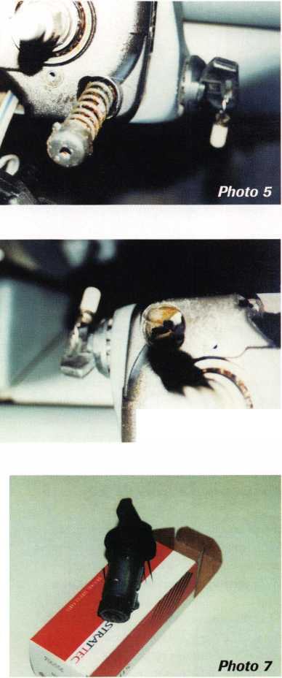

The BBC'S Of CCTV:

In previous articles, we have discussed the function of cameras, lenses and housing in a CCTV system. If you have designed this portion of your surveillance system properly, each camera will be able to convert the light it “sees” into an electronic signal that can be decoded elsewhere into a viewable image. This signal is carried to the decoder by means of wire, or by some other method of transmission. The signal decoder, which converts the analog electronic signal to something we can see, is called

the monitor.

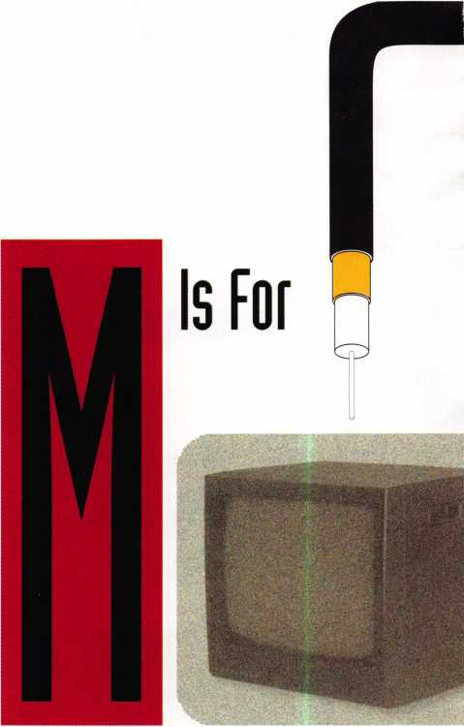

By far, the most common method of transmission (93%) is coaxial cable. Coax is composed of a solid cop­per conductor, surrounded by a dielectric material (a nonconductor of electricity). This dielectric material is encased in a braided or woven mesh of copper (or alu­minum). On top of all this is an outer PVC jacket. The inner conductor is the actual signal carrying part of the coax. The copper braid serves as a shield, preventing ran­dom RF signals from contaminating the signal. It also serves as a ground path for completing the electronic cir­cuit.

Coaxial cable is available in various thicknesses, or gauges. RG59U, which contains a 20AWG conductor, is good for transmissions up to 750 feet. RG6U contains a thicker 18 AWG conductor and is usable up to 1500 feet. For runs up to 5000 feet, RG11U—with a huge 14AWG conductor—must be used.

In commercial CCTV applications, coaxial cable is usually terminated in connectors called “BNC.” You can attach your own BNC connectors to coaxial cable, or you can order finished pieces in various lengths.

If your wiring path is going to pass through a ceiling plenum, you must use coax that is CL2, plenum-rated. A plenum exists whenever the space between a dropped ceiling and the stmctural surface above is used as a return-air space for the heating/cooling system. Plenum­rated, or “smokeless” wire, is required by National Electric Code and most local enforcement jurisdictions.

Keynotes

February 1997

By Paul F. Chandler, CRL



To determine whether your above-the-ceil- ing space is a plenum, look for supply and return ductwork. If there are ceiling grids which are not connected to ductwork, you’ve got yourself a plenum.

There are other methods of carrying a video signal to the monitor location, and I’m sure some of these will become more com­mon as they become more affordable and more technologically advanced. Video can be sent over telephone lines, but special send­ing/receiving equipment must be used. This technique is currently very expensive and cannot produce real-time video. Fiber optics is increasing in use, especially for very large installations like airports. Fiber optics can be sent over extremely long distances with no signal deterioration. This technology also requires special sending/receiving equip­ment, which makes it very expensive to use. Twisted pair wire can also be used, with spe­cial sending/receiving equipment, to trans­mit a good video signal up to one mile, for considerably less than fiber optics. Then there is wireless transmission. By converting the video signal to RF (radio frequency), it can be broadcast and received by radio- equipped monitors. There are currently inex­

pensive systems of this type being used for baby-watch applications, as well as for portable business surveillance. Longer RF transmission is hindered, though, by the effects of weather and other RF signal inter­ference.

The single cable, “plug-and-play” system, which I’ve mentioned in earlier issues, use a miniature coaxial cable combined with two twisted pairs of wires—all in a single PVC jacket. These are terminated—not in BNC connectors, but in RJ11 plugs (similar to modular phone plugs) that simply plug into the camera and the monitor. These systems carry video, audio, power for the camera and control signals in a single cable.

Once the signal reaches the monitor, what happens? The electronic data is converted into a series of lines running horizontally across the screen. The number of these lines determine the resolution of the monitor. Generally speaking, the more lines of resolu­tion you have, the sharper an image you will perceive on the screen.

Black and white CCTV monitors should deliver between 650 and 800 lines of resolu­tion. Color monitors have fewer lines— between 380 and 420. Although the resolu­

tion of a color monitor is considerably less, identification and watchability are much better in colpr.

Screen size is the main thing you will consider when choosing a monitor. The fur­ther away the observer will be from the monitor, the larger the screen should be. Use the following chart:

|  |  |
| --- | --- |
| Monitor | Distance |
| 9" | 3 ft. to 7 ft. |
| 12” | 4 ft. to 9 ft. |
| 14” | 4 ft. to 12 ft. |
| 17” | 4 ft. to 13 ft. |
| 19” | 4 ft. to 15 ft. |

Additional features you may need include a speaker, if audio is desired; a looping out­put, if the video signal is to be shared with a recorder or other equipment; and front panel controls for installations where the rear of the monitor may be inaccessible.

The information we’ve covered thus far deals with connecting a single camera to a dedicated monitor. What if you want to monitor several cameras on a single monitor? We will discuss switchers, quads and multi­plexers in a future issue.

About the Author: Paul Chandler, CRL, is the manager of the Electronic Security Department for I.D.N-ACME in Houston, TX.

February 1997

Keynotes

39

***Do you belong in the***

ALOA

President’s

Club?

How can I join the President’s Club?

You can earn membership in this  
prestigious club by recruiting just  
10 new members for ALOA.

Any ALOA member may participate.*

What do I get?

When you recruit 10 members, you receive a handsome blue blazer with  
a President’s Club crest. For each additional five members you recruit,  
you receive a lapel pin with gold-filled numbers, indicating your  
recruiting successes.

You also get the satisfaction of knowing that

you are helping your association, helping your industry grow, and you  
are helping fellow locksmiths achieve success.

How do I get started?

Contact the ALOA office for a supply of applications. One President’s  
Club credit is awarded for each new applicant. Credit is awarded only  
after the membership application is approved. However, the credit will  
apply for the period in which the application is received. Failure to  
identify yourself as the sponsor on

the application form at the time it is submitted to ALOA for processing  
will forfeit any credit.

*ALOA Board of Directors not eligible for membership in the  
President's Club**.**

|  |  |  |
| --- | --- | --- |
|  | PRESIDENT'S CLUB ROSTER | |
| 131 Members | 013186 | Kwok-kei Leung |
| 73 Members | 019882 | Henry Raymond |
| 67 Members | 005354 | Stewart Levine, CML |
| 58 Members | 012566 | Mary Ohmit, CPL |
| 50 Members | 022598 | Allen Konrath |
| 40 Members | 012103 | Jack Hobin, CPL |
| 36 Members | 021172 | Myeong-Rae Cho |
| 36 Members | 022907 | Toshihiro Asano |
| 31 Members | 011133 | Salvatore Dulcamaro, CML |
| 29 Members | 006072 | Charles Robertson, CML |
| 27 Members | 008951 | William Neff, CML |
| 27 Members | 010464 | Jeanne Lodge, CML |
| 26 Members | 016675 | Roy Renderer, CML |
| 23 Members | 018521 | David Federico |
| 22 Members | 003296 | Danny Rudd, CPL |
| 22 Members | 014474 | Robert Carroll, CPL |
| 21 Members | 004371 | John Elliott, CML |
| 21 Members | 007215 | Jerome Cohen, CML |
| 20 Members | 004475 | Larry Wamick, CML |
| 20 Members | 019244 | Eugene Altobella |
| 18 Members | 007051 | D Lee, CPL |
| 18 Members | 009049 | John Heckman, CML |
| 18 Members | 014144 | James Fowler, CML |
| 18 Members | 014996 | David Harris, CML |
| 18 Members | 019138 | Robert DeWeese, CPL |
| 17 Members | 002501 | John Kerr, RL |
| 17 Members | 015283 | Ronald Heidzig |
| 16 Members | 007012 | Joseph Ferrero, CML |
| 16 Members | 008154 | Diana Bamum, CRL |
| 16 Members | 008617 | William Grant, CRL |
| 16 Members | 018691 | Brian Reetz |
| 16 Members | 023788 | Jim Williams |
| 14 Members | 001657 | Rex Parmelee, RL |
| 14 Members | 005329 | Marian Swann, CRL |
| 14 Members | 007129 | Thomas Vandersteen, CML |
| 14 Members | 008168 | Charles Cole, CML |
| 14 Members | 008361 | James Cawby, CML |
| 14 Members | 015696 | Barbara Watt |
| 14 Members | 016056 | Elvis Hammerschmidt, CPL |
| 13 Members | 001825 | Walter Lascar, RL |
| 13 Members | 007009 | John Dorsey, CPL |
| 13 Members | 008916 | James Gruber |
| 13 Members | 009172 | Peter Gauthier, CPL |
| 13 Members | 022358 | Russell Fuller, CRL |
| 12 Members | 000712 | Edwin Scott |
| 12 Members | 004361 | Robert Rodocker, CRL |
| 12 Members | 015305 | Lonnie McKinney, CML |
| 11 Members | 003430 | Lawrence Smith, CML |
| 11 Members | 009546 | Gary Teams, CPL |
| 11 Members | 010266 | William McElheney, CML |
| 11 Members | 010909 | Rolando Bouza |
| 11 Members | 016525 | Philip Rovenolt, CPL |
| 11 Members | 018034 | Michael Robinson, CRL |
| 11 Members | 018805 | Robin Horsley |
| 10 Members | 004993 | Ernest Wright |
| 10 Members | 009305 | Frank Hartung, CML |
| 10 Members | 009482 | Lester Brodsky |
| 10 Members | 010602 | Herbert Dusenberry, CML |
| 10 Members | 011316 | Robert Duman, CML |
| 10 Members | 016726 | Dale Knowles, CPL |

Yes! I want to loin the ALOA President’s Club.

Please rush meapplications so I can start now to earn credit toward membership in the ALOA President’s club!

Name:

Company:

Address:

City: State: Zip:

Planning

**J7 rpi**

ror Ine  
Successful Sale

Of Your

Business

*Every business owner ultimately faces the question, “What should I do with my business?” This can be a challenging question. Your business probably means more to you than a way to accumulate wealth*—*it’s an extension of yourself. To build it, you invested a great deal of your time, energy and resources.*

cq



Parting from your business will be difficult, yet suc­cession is inevitable. The reasons for selling can be as individual as each business owner and each business. For example:

* My business has matured, and I want a new chal­lenge.
* I want to retire, but I have no apparent successor.
* I just received an unexpected buyout offer, and I won­der if it is reasonable.
* I want to ensure that my business prospers after I leave.

competitors, economic conditions in your industry, and the strengths and weaknesses of your company—infor­mation you can use to enhance the value of your business now and in the future.

Preparing for Potential Buyers

When you’re contemplating the sale of your business, you need to get it into good shape. Attend to the many details that will show your business to its best advantage and address any outstanding issues that may give a prospective buyer second thoughts. You may want to

Generally, the seller of a stable, profitable and easily-run business is likely to receive a large part of the total price in cash.

All business owners need to plan for the smooth dis­position of their business. If it is planned for in advance and carried out wisely, the sale of your business may be among the most rewarding moments in your career.

Making the Best Start

No matter what you envision the future of your busi­ness to be, the starting point is to determine its fair mar­ket value; in other words, the value it would have to a prospective buyer whose primary concern is its profit potential.

While you may be tempted to assess this value on your own, it really pays to seek a professional valua­tion—a service frequently found at a full-service broker­age firm. You may know the original cost of your plant and equipment, and you may have a good idea of their current market value, but tangible assets like these are likely to comprise just a fraction of your business’s total worth. It also has intangibles, such as goodwill and going-concern value. Determining the value of a private­ly held business is a complex task.

By seeking expert advice, you can save yourself a great deal of time, money and grief. Without it, you run the risk of underestimating your business’s worth and accepting too low a price for it, or overestimating its worth and wasting time trying to reach an unrealistic goal.

An accurate valuation puts you in an excellent posi­tion to negotiate a sale on the most advantageous terms. It will also be critical if you intend to create an employ­ee stock ownership plan (ESOP), sell a minority stake, execute a buy/sell agreement or develop an estate plan. Even if you do not foresee an imminent sale, a profes­sional valuation will give you information about your

spruce up your facilities—for example, expand your business base or sell off non-operating assets.

If you plan to sell your business to a third party, develop a professional management team that can oper­ate the business in your absence. Potential buyers should be confident that your company can operate successfully after the sale. Teach customers and suppliers to rely on your new management team.

A good financial advisor can help you decide on the best timing for your transaction, suggest the marketing plan that is most likely to fulfill your particular objec­tives and help you prepare an in-depth profile of your business to show to prospective buyers.

A financial advisor can also help you identify the most viable buyers for your business. Potential buyers of your company may be found among competitors, suppliers, customers, investment groups and domestic or foreign companies. You and your advisor should discuss the advantages and disadvantages of selling to these different buyers.

Typically, a prospective buyer will want to know about your business’s past performance—its revenue and income, consistency of growth, workforce stability and return on investment. Have your business’s financial statements audited by an independent accounting firm. Audited financials going back three to five years can add credibility to your record of achievements.

The future of the business will be of equal, if not greater, interest to potential buyers. A buyer will want to know the prospects for your industry, and, more specifi­cally, will want to see projections of your business’s growth potential, risk profile, working capital needs and return on sales, equity and assets.

Be sure to anticipate questions that potential buyers

Keynotes

February 1997

may ask. For example, can you explain any significant variations in sales, expenses or profits from one year to another? Do any balance sheet items fail to reflect cur­rent fair market value? Can any personal expenses charged to the business be added back to reported pretax financial results? Be prepared to answer these types of questions knowledgeably and succinctly.

Negotiating a Good Contract

Once a serious and qualified buyer has been found, nego­tiations begin. You, your financial advisor and your lawyer should address issues such as price, terms, con­sulting agreements, employment contracts and non­compete agreements. Key sections of the agreement should include assets or stock to be sold, purchase price and allocations, financing arrangements, escrow, repre­sentations, warranties and indemnification

Generally, the seller of a stable, profitable and easily- run business is likely to receive a large part of the total price in cash. If your business is less stable, you may decide to receive part of the sale price in installments, or you may agree to adjustments in price based on future results. Keep in mind, however, that there may be tax advantages to a more structured transaction.

Your future role in the business should be clearly stat­ed in the contract. The buyer may ask that you stay on as an employee or consultant for a time, or may not want to retain you at all. Decide in advance how strongly you feel about your role with the business after it changes hands, and try to be flexible.

Money may not be the only factor to consider in structuring a sale. As the seller, you will want to know what the buyer can and will do for your business, your managers and employees, your customers and, most importantly, your own long-term plans. Of course, hav­ing more than one interested qualified buyer will give you a better opportunity to find one whose objectives are consistent with your own ideas.

After the Sale

Once your sale is completed, you may look forward to starting or joining another business, consulting full or part time or retiring. No matter what you plan, an important part of any sales transaction is to simultane­ously draw up a comprehensive financial plan with your financial consultant. He or she can help you set specific investment objectives for the proceeds you receive from your sale and map out the investing strategies that will help you reach those goals.

About the Author: G. Stephen Thoma is Senior Vice President and Director, Business Financial Services, for Merrill Lynch Private Client Group.

STOCK THE PATIO DOOR  
LOCK THAT SURPASSES  
ALL OTHERS IN

DURABILITY

AND

QUALITY!

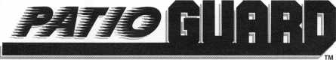

COMBINATION HOOK LATCH & DEADBOLT

WOT

* **EASY INSTALLATION. 1 w**

**SMOOTH OPERATION.**

* **MADE OF STEEL AND ALUMINUM.**
* **ALUMINUM, ANTIQUE BRONZE  
  AND WHITE FINISHES.**
* **NON-HANDED.**

**ALSO USED FOR:**

Camper Tops, Pocket Doors,

Storm Doors, Cabinets, French Doors,

Mobil Homes and Recreational Vehicles.



# «

l I

«

# «

**Call Today For A Distributor Near You**

**1-800-397-4631**

**■rfA'-d** H11:1:11

A Division Of

MIWA Lock USA, Las Vegas, NV

Reader Service #19

February 1997

***Keynotes* |** 43

|  |  |
| --- | --- |
| Members | vy |
| Manufacturers | Allied-Gary Safe Company  West 425 2nd Ave.  Spokane, WA 99204 (509) 458-2633; FAX (509) 458-2633  40 g |
| Access Protection Mfg.  216 Plaisto Rd.  Plaisto, NH 03865  (603) 382-0822; FAX (603) 382-0833  • | American Lock Co.  3400 West Exchange Road  Crete, IL 60417-2099 (708) 534-2000; FAX (708) 534-0531  © © |
| ASSA High Security Lock  10300 Foster Ave.  Brooklyn, NY 11236 (718) 927-2772; FAX (718) 257-2772  © | American Security Products  11925 Pacific Ave.  Fontana, CA 92337-6963 (909) 685-9680; FAX (909)685-9685  g g |
| Abloy Security, Inc.  6015 Commerce Drive Ste. #450  Irving, TX 75063  (972) 753-1127; FAX (972) 753-0792  © | Arrow Lock Company  10300 Foster Avenue  Brooklyn, NY 11236 (718) 257-4700; FAX (718) 649-9097  g g g g |
| Abus Lock Company  P.0. Box 47507  Plymouth, MN 55447-0507 (800) 225-5348  © | Auto Security Products (A. S. P.)  P.O. Box 10  Redmond, WA 98073-0010 (206) 556-1900; FAX (206) 558-1205  g g |
| Adams Rite Manufacturing Co.  4040 S. Capital Ave.  City of Industry, CA 91749 (310) 699-0511; FAX (310) 699-5094  g g | Baton Locks & Hardware Co.  14275 Commerce Dr.  Garden Grove, CA 92643 (714) 265-3636; FAX (714) 265-3630  g g |
| Adrian Steel Company  906 James St.  Adrian, Ml 49221  (517) 265-6194; FAX (517) 265-5834  © | Best Locking Systems of Louisville  10310 Bluegrass Pkwy  Louisville, KY 40299 (502) 491-4042 |
| Aiphone Intercom Systems  1700- 130th Avenue, NE  Bellevue, WA 98005 (206) 455-0510; FAX (206) 455-0071  g g g | Cannon Safe, Inc.  9358 Stephens St.  Pico Rivera, CA 90660 (800) 242-1055; FAX (310) 692-7252  g |
| Alarm Lock Systems, Inc.  345 Bayview Ave.  Amityville, NY 11701 (800) ALA-LOCK; (516) 789-3383  © | Chicago Lock Company  P.O. Box 0069  Pleasant Prairie, Wl 53158 (414) 947-7177; FAX (414) 947-7178  © |
| All-Lock Company  900 Ravenwood Dr.  Selma, AL 36701  (334) 874-9001; FAX (334) 874-6011  g <g | Corbin Russwin Architectural Hardware  P.O. Box 25288  Charlotte, NC 28229 (704) 283-2101  g g g g |
|  |  |



Associate members of the Associated Locksmiths of America (ALOA) manu­facture or distribute materials or equip­ment, or provide services, for the securi­ty industry. Many have donated money, services and equipment to ALOA in addition to their annual dues. Their sup­port of ALOA projects enhances overall membership benefits and we encourage our members to patronize these firms. If you know of a potential candidate for associate membership, please contact the ALOA Sales staff at (214) 827-1701. Associate member dues are $500 per year and entitle the payor to use the ALOA logo, and selected discounts on ALOA products and services.

**Legend**

**© Alarms:** Personal, vehicle, electronic, fire, burglar, and exit

© Bank security equipment

**© Automotive:** Lockout equipment, key chains/rings

**© Builders Hardware:** Door closers, furniture/decorative hardware, viewers, emergency exit devices

© Business/Technical & Educational:

Books, reference guides, publications, computer software

**© CCTV/Photo Imaging:** Cameras, monitors, photo ID equipment, cables

© **Electric/Electronic Security:** Card access control and readers, surveil­lance, electric/magnetic locks and strikes, keypads

© **Lock Devices:** Auto locks, cylinders, emergency exit/entrance control, locks (various types), strikes

© **Tools & Supplies:** Key blanks, cutters, picks, rings/hooks, custom van/truck supplies

© Safes/Vaults

® Other

Keynotes

February 1997

Associate

Members

|  |  |  |
| --- | --- | --- |
| Curtis Industries  6140 Parkland Blvd.  Mayfield Heights, OH 44124 (800) 555-5397 | Grobet File Co. of America  750 Wasahington Ave.  Carlstadt, NJ 07072 (800) 962-7242; FAX (800) 243-2432 | KABA High Security Locks  P.O. Box 490  Southington, CT 06489 (860) 621-3601; FAX(860) 621-9727 |
| ® • | • | • |
| DOM Security Locks North America  100 Central Ave,  Brockville, Ontario, Canada K6V 5W6 (800)363-4803; FAX (613) 498-5820 | GT-85 International, Inc.  P. 0. Box 21185  St. Petersburg, FL 33742-1185 (800) 525-GT85; FAX (813) 526-1234 | Kenstan Lock Company  166 W. Hills Road  Huntington Station, NY 11746 (516) 271 -2700; FAX(516) 271 -2759 |
| • | • | • ® |
| Don-Jo Manufacturing, Inc.  P.O. Box 929  Sterling, MA 01564 (508)422-3377; FAX (508) 422-3467 | H.E.S., Inc.  2040 W. Quail Ave.  Phoenix, AZ 85027 (602) 582-4626; FAX (602) 582-4641 | KEY-BAK; Div. of W. Coast Chain Mfg. Co.  1460 S. Balboa Ave.  Ontario, CA 91762 (909) 923-7800; FAX0O9) 923-0024 |
| • i | • • • | • • • • |
| Door Controls International  2362 Bishop Circle East  Dexter, Ml 48130  (800) 742-3634; FAX (800) 742-0410 | Highland Glen Products, Inc.  218 Parkdale Ave.; P.O. Box 924  Buffalo, NY 14213 (716) 883-1110; (800) 248-KEYS | Knaack Manufacturing Co.  420 E. Terra Cotta Ave.  Crystal Lake, IL 60014 (800) 456-7865; FAX(815) 459-9097 |
| • • • • | • • | • |
| Emtek Products, Inc.  15250 E. Stafford St.  City of Industry, CA 91744 (800) 356-2741; FAX (800) 577-5771 | Hill Security Products  711 East Walton Avenue  Spokane, WA 99207 (509) 487-1142; (800) 722-1142 | Kwikset Corp.  One Park Plaza, Suite 1000  Irvine, CA 90638  (714) 474-8818; FAX (714) 474-8879 |
| • • | ® | • ® |
| ESP Lock Products, Inc.  375 Harvard Street  Leominster, MA 01453 (508) 537-6121; FAX (508) 537-1699 | HPC, Inc.  3999 N. 25th Avenue  Schiller Park, IL 60176 (847) 671-6280; FAX(847) 671-6343 | LCN Closers (Division of Ingersol)  121 W. Rail Road Ave.  Princeton, IL 61356 (815) 875-3311; FAX (815) 875-3222 |
| i | • • • | ® |
| Federal Lock Company  14247 E. Don Julian Rd.  City of Industry, CA 91746 (800) 682-9851; FAX (708) 378-4767 | Hurd Corporation  Box 1450, 503 Bohannon Ave.  Greeneville, TN 37744-1450 (423) 787-8800; (423) 787-8817 | LAB Security  700 Emmett St.  Bristol, CT 06010  (800) 243-8242; FAX (203) 583-7838 |
| • | • • • | ® |
| Folger Adam Company  16300 W. 103rd Street  Lemont, IL 60439  (630) 739-3900; FAX (630) 739-6138 | llco Unican  400 Jeffreys Road  Rocky Mount, NC 27804 (919) 446-3321; FAX (919) 446-4702 | La Gard, Inc.  3330 Kashiwa Street  Torrance, CA 90505 (310)325-5670; FAX (310) 325-5615 |
| • • | ••••••• |  |
| Fort Lock Corp.  3000 N. River Rd.  River Grove, IL 60171 (708) 456-1100; FAX (708) 456-9476 | Industries, C.L. Inc.  9730 Gouin Blvd. West  Pierrefonds (Qc) Canada H8Y 1R5 (514) 683-6282; FAX(514) 683-9015 | Locksmith Publishing Corp.  850 Busse Hwy.  Park Ridge, IL 60068 (847) 692-5940; FAX (847)692-4604 |
| •••••• | • • | • |
| Gardall Safe Corporation  P.O. Box 30  Syracuse, NY 13206 (315) 432-9115; FAX (315) 434-9442 | International Electronics, Inc. (I.E.I.)  427 Turnpike St.  Canton, MA 02021 (800)343-9502; FAX(617) 821-4443 | Lockmasters, Inc.  5085 Danville Rd.  Nicholasville, KY 40356 (606) 885-6041; FAX (606) 885-7093 |
| • | • | ^ (|^ (p |
| Glenncraft Corporation  205 Fortin Dr.  Woonsocket, Rl 02895-6116 (401) 769-0101; (401) 766-1170 | Jet Hardware Mfg. Co.  800 Hinsdale Street  Brooklyn, NY 11207 (718) 257-9600; FAX(718) 257-0973 | Lori Lock/Delta  P.O. Box 1040  Southington, CT 06489 (203) 621-3605; FAX (203) 621-5972 |
|  | • | • • |
| ® Alarms  ® Banksecurityequip.  ® Automotive^  ® Builders Hardware |  | MIMMI |

**February 1997** **Keynotes I 45**

**Associate**

Members

|  |  |  |
| --- | --- | --- |
| Lucky Line Products  7890 Dunbrook Rd.  San Diego, CA 92126 (619) 549-6699; FAX (619) 549-0949 | New England Lock & Hardware  46 Chestnut St.  South Norwalk, CT 06856 (203) 866-9283; FAX (203) 838-4837 | Schlage Lock Co.-PRIM US  3899 Hancock Expy.  Security, CO 80911 (719) 390-5071 |
| • | • • | • © |
| Lund Equipment Co., Inc.  P.O. Box 213  Bath, OH 44210  (216) 659-4800: FAX (216) 659-9347 | Newman Tonks  P.O. Box 548  Shepardsville, KY 40165 (502) 543-2281; FAX (800) 777-8229 | Schwab Corporation  3000 Main Street  Lafayette, IN 47903 (317) 447-9470; FAX (317) 447-8278 |
| • • • | • © | • |
| M.A.G. Engineering & Mfg. Inc.  15261 Transistor Lane  Huntington Beach, CA 92649 (714) 891-5100; FAX (714) 892-6845 | NT Falcon Lock  2650 Orbitor Street  BreaCA, 92621-6265 (800) 266-4456; FAX (800)777-8229 | Securitron Magnalock Corp.  550 Vista Blvd.  Sparks, NV 89434  (800) 624-5625; FAX (702) 355-5636 |
|  | • © | © • |
| MARKS USA  5300 New Horizons Blvd.  Amityville, NY 11701 (516) 225-5400; FAX (516) 225-6136 | Pach & Company  941 Calle Negro  San Clemente, CA 92672 (714) 498-2951; FAX (714) 498-6879 | Security Door Controls  P. 0. Box 6219  Westlake Village, CA 91359-6219 (805) 494-0622; FAX (800) 959-4732 |
| • | • • | © |
| Master Lock Company  2600 North 32nd Street  Milwaukee, Wl 53210 (414) 444-2800; FAX (414) 449-3114 | Prime Line Products Company  4185 Hallmark Pkwy.  San Bernadino, CA 92407 (909) 887-8118; FAX (909) 880-8968 | Sentry Group  900 Linden Ave.  Rochester, NY 14625-2784 (716) 381-4900; FAX (716) 381-8559 |
| • ® | • ® | • |
| Medeco Security Locks  P.O. Box 3075  Salem, VA 24153  (540) 380-1684; FAX (540) 380-5010 | Pro-Lok  655 North Hariton Street  Orange, CA 92668-1311 (714) 633-0681; FAX (714) 633-0470 | Silca Key U.S.A. Inc.  5633 Hudson Industrial Pkwy.  Hudson, OH 44236 (216) 656-5613 |
| • • • | • • | • • |
| Meilink Safe Company  111 Security Parkway  New Albany, IN 47150 (800) 634-5465; FAX (800) 896-6606 | Rainbow Technology  261 Cahaba Valley Pkwy.  Pelham, AL 35124-1146 (800) 637-6047; FAX (800) 521-6896 | Star Key lndustries,lnc.  145 Brite Ave.  Scarsdale, NV 10583-1426 (914) 235-1700 |
| • | • | • |
| Metalurgica Odis S.A.  Porto Seguro 4395 Quinta Norma  P.O. Box 107-2; Santiago, Chile (562) 776-6511 | Rev-A-Shelf, Inc.  2409 Plantside Dr.  Jeffersontown, KY 40299 (502) 499-5835 | STRATTEC Security Corp.  3333 W. Good Hope Rd.  Milwaukee, Wl 53209 (414) 247-3333; FAX (414) 247-3329 |
| • | • | • • • |
| MUL-T-LOCK USA, Inc.  300-1 Route 17 South Suite A  Lodi, NJ 07644  (800) 562-3511; FAX (201) 778-4007 | Rofu International Corp.  2004-B 48th Ave.; Court E  Tacoma, WA 98424 (800) 255-7638; FAX (206) 922-1728 | Sully Tools Inc.  3515 Nodding Pine Ct.  Fairfax, VA 22033  (703) 689-3416; FAX (703) 787-0869 |
| • • • | © | • • • |
| National Cabinet Lock  200 Old Mill Road, P. O. Box 200  Mauldin, SC 29662 (864) 297-6655; FAX (864) 297-9987 | Rutherford Controls Inti.  2697 Internal Pkwy, Bid 5 #100  Virginia Beach, VA 23452 (804) 427-1230; FAX (804) 427-9549 | Treskat USA  725 Adriane Park Circle  Kissimmee, FL 34744 (800) 645-5657; FAX (407) 870-9696 |
| © | © | • |
| The National Locksmith Magazine  1533 Burgundy Parkway  Streamwood, IL 60107 (630) 837-2044; FAX (630) 837-1210 | Sargent & Greenleaf, Inc.  P.O. Box 930  Nicholasville, KY 40340-0930 (606) 885-9411; FAX (606) 887-2057 | Trine Products Corporation  1430 Ferris Place  Bronx, NY 10461  (718) 829-4796; FAX (718) 792-9127 |
| • | • • • • | • • • |
| -:'jS' Alarms , .  © {lank security equip. \  ®BuihtersHanlware | © Rusiness/Tech & Ed.  ©^  II; Electric/Ilectronic Sec.  © LockDevices | © Tools & Supplies © Safes/Vaults © Other |

46

***Keynotes***

February 1997

Associate

Members

|  |  |  |
| --- | --- | --- |
| U-Change Lock Industries  1640 W. Hwy. 152  Mustang, OK 73064 [405)376-1600; FAX [405) 376-6870 | Armstrong’s Lock & Supply, Inc.  1440 Dutch Valley Place NE  Atlanta, GA 30324  (800) 726-3332; FAX (404) 888-0834 | Foley-Belsaw Company  6301 Equitable Road  Kansas City, MO 64120 (800) 821-3452; FAX (816) 483-5010 |
|  | 9999999999 | • • • • |
| Vindicator Corp.  3001 Bee Caves Rd.  Austin, TX 78746-5561 [512) 314-1200; FAX [512) 314-1270 | Boyle & Chase Inc.  P. 0. Box 74  Accord, MA 02018-0074 (800) 325-2530; FAX (617) 335-5342 | Fried Brothers, Inc.  467 N. 7th St.  Philadelphia, PA 19123 (800) 523-2924; FAX (800) 541-3489 |
| • • • • | 999 | •••••••••• |
| Weiser Lock Company  6700 Weiser Lock Blvd.  Tucson, AZ 85746  [520) 741-6231; FAX [520) 741-6363 | Canada Lock Products Ltd.  70 Floral Parkway  Toronto, ON Canada M6L 2C1 (416) 248-5625; FAX (416) 248-9945 | H. Hoffman Company  7330 West Montrose  Chicago, IL 60634 (708) 456-9600 |
| 9 9 | 9999999999 | 99999999 |
| Wilson Safe Company  3031 Island Avenue/P.O. Box 5310 Philadelphia, PA 19153 [215)492-7100; [800) 345-8053 | Clark Security Products, Inc.  4775 Viewridge Ave.  San Diego, CA 92123-1641 (800) 854-2088 | HS&S Wholesale Distributors  12915 West 8 Mile Road  Detroit, Ml 48235 (800) 521-2202 |
| • | 00^0(0(0(0(0(00 | 9999999 |
| Yale Security Inc.  P.O. Box 25288  Charlotte, NC 28229-8010 [704) 283-2101 | Cook’s Building Specialties  2441 Menaul Blvd. NE; P.O. Box 37320 Albuquerque, NM 87176-7320 (505) 883-5701; FAX (505) 883-5704 | Hans Johnsen Company  8901 Chancellor Row  Dallas, TX 75247  (214) 879-1550; FAX (214) 879-1530 |
| 9999 | 999999 | •••••••• |
| Distributors | DiMark International  3117 Liberator St., Unit A  Santa Maria, CA 93455 (800) 235-2435; FAX (805) 928-8034 | Hardware Agencies, Ltd.  1220 Dundas Street East  Toronto, ON M4M 1 S3 (416) 462-1921 |
|  | • • | •••••••• |
| Accredited Lock Supply Co.  P.O. Box 1442  Secaucus, NJ 07096-1442 [800) 652-2835; FAX (201) 865-5031 | Dire’s Lock & Key Co.  2201 Broadway  Denver, CO 80205 (303) 294-0176 | Hardware Suppliers of America  P.O. Box 2208  Winterville, NC 28590 (800) 334-5625 |
| 9999999 | 00000000000 | 0 0 |
| Ace Lock & Security Supply Co.  565 Rahway Ave.  Union, NJ 07083-6631 (908) 688-7666; (800) ACE-FAX4 | Doyle Lock Supply  2211 W. River Road N.  Minneapolis, MN 55411 (800) 333-6953; FAX (612) 521-0166 | IDN, Inc.  1000 S. Main, Suite 280  Grapevine, TX 76051 (817) 421-5470; FAX (817) 421-5468 |
| ^J} @ (0 ^ | • • • •• | 0000000000 |
| Akron Hardware Consultants, Inc.  2579 South Arlington Road  Akron, OH 44319  (800) 321-9602; FAX (800) 328-6070 | Dugmore & Duncan Inc.  30 Pond Park Rd.  Hingham, MA 02043 (800) 225-1595; FAX (617) 740-4043 | IDN-Armstrong’s, Inc.  1440 Dutch Valley Place NE  Atlanta, GA 30324 (800) 726-3332 |
| • • • | 9999999 |  |
| American Security Distribution  4411 E. La Palma  Anaheim, CA 92807 [714) 996-0791; FAX (714) 579-3508 | Ewert Wholesale Hardware  4709 W 120th St  Alsip II 60658 (800) 451-0200 | Intermountain Lock & Supply Co  2300 W. 2nd Ave., Unit B  Denver, CO 80223  (800) 323-8046; FAX (303) 698-2094 |
| O 999999 | 999 99 | 0000000000 |
| Andrews Wholesale Lock Supply  544 S. 9th St.  Lebanon, PA 17042-6608 (717) 272-7422 | Fairway Supply, Inc.  2631 Lombardy Lane  Dallas, TX 75220  (214) 350-0021; FAX (214) 352-4299 | Jo-Van Distributors Inc.  929 Warden Ave.  Scarborough, Ontario MIL 4C6 (416) 752-7249; FAX (416) 752-3845 |
| • | ^ 9 ^ | 0 0 0 00000000 |
| , _ 0 Alarms ••  # Bank security equip. m Automotive  0 Builders Hardware | 9 Business/Tech & Ed. *  0 Electrie/Electronic Sec. ' - ■  0 | - 1 . - ; v 7/ - ; - '77;  0 Safes/Vaults ' - |

February 1997

***Keynotes***

47

**Associate**

Members

|  |  |  |
| --- | --- | --- |
| JLM Wholesale, Inc.  3095 Mullins Ct  Oxford, Ml 48371-1643 (800) 522-2940; FAX (800) 782-1160  e • m | New England Business Service, Inc.  500 Main St.  Groton, MA 01471 (508) 448-6111 | U.S. Lock Corporation  77 Rodeo Drive  Brentwood, NY 11717 (800) 925-5000; FAX (800) 338-5625  <0 (0 (0 4$ 0 |
| Key Sales & Supply Co., Inc.  9950 Freeland Ave.  Detroit, Ml 48227 (313) 931-7720; (313) 931-7758 | Omaha Wholesale Hardware  1201 Pacific Street, PO Box 3628  Omaha, NE 68108 (800) 238-4566  (0 (0 (0 | Webster Safe & Lock Company, Inc.  3020 Millbranch  Memphis, TN 38116 (901) 332-2911; FAX (901) 332-2878  ••••••• |
| Lockmasters, Inc.  5085 Danville Road  Nicholasville KY, 40356 (606) 885-6041  • • • • | E. L. Reinhardt Co., Inc.  3250 Fanum Road  Vadnais Heights, MN 55110 (800)328-1311; FAX (612) 481-0166  •••••• | Service |
| Locks Company  2050 N.E. 151 St  N. Miami, FL 33162 (800) 288-0801; FAX (305) 949-3619  ••••••• | Security Lock Distributors  40 A Street  Needham Heights, MA 02194 (800) 847-5625; FAX (800) 878-6400  • • • | Allstate Insurance Company  2775 Sanders Road, Suite A5  Northbrook, IL 60062 (847) 402-8196; FAX(847) 326-7509  • |
| Locksmith Store Inc.  1229 E Algonquin Rd. Suite E  Arlington Heights, IL 60005 (847) 364-5111; FAX (847) 364-5125  • • • • | Sentry Security Fasteners  8109 N. University  Peoria, IL 61615  (309) 693-2800; FAX (309) 693-2872  • • | GE Capital Fleet Services  Three Capital Drive  Eden Prairie, MN 55347 (612 828-2928; FAX (612) 828-1766  • |
| M. Zion Company  17 Murray Street  New York, NY 10007 (212) 349-8677  0 @ (0) <0 (0 (0 | Southern Lock and Supply Co.  Box 1980, 10910 Endeavor Way  Pinellas Park, FL 34664 (800) 237-2875; FAX: (800) 447-2299  ••••••••• | Gil-Ray Tools, Inc.  P.O. Box 801, 1306 McGraw St.  Bay City, Ml 48707 (517) 892-6870; FAX (517) 892-6870  • |
| Mayflower Sales Company, Inc.  614 Bergen Street  Brooklyn, NY 11238 (718) 622-8785; FAX (718) 789-8346  ••••••• | Southwest Mini-Keys Inc.  2323 N. Central Expwy, Suite 165  Richardson, TX 75080 (214) 669-1704  • | National Key & Road Service  124 Stratford Dr.  Louisburg, NC 27549 (919) 497-0474; FAX (919) 497-5555 |
| McDonald-DASH Locksmith Supply  5767 E. Shelby Dr.  Memphis, TN 38141 (800)238-7541; FAX (901) 366-0005  •••••••• | Stone & Berg Wholesale  99 Stafford Street  Worcester, MA 01603 (800) 225-7405; FAX (800) 535-5625  •••••••••• | Pine Technical College  1000 4th Street  Pine City, MN 55063 (800) 521-7463; FAX (612) 629-7603  • |
| McManus Locksmith Supply, Inc.  P.O. Box 9231, 1309 Central Ave.  Charlotte, NC 28299 (702) 333-9112  • • • | Strauss Safe & Lock Company  1801 Second Avenue  Des Moines, IA 50314 (515) 288-9571; FAX: (515) 288-9752  •••••• |  |
| McMaster-Carr Supply Company  600 County Line Rd,  Elmhurst IL 60126-2081 (708) 833-0300; FAX (708) 834-9427  •••••• | Top Notch Distributors, Inc.  P.O. Box 189  Honesdale, PA 18431 (800) 233-4210  • • • |
| Monaco Lock Co., Inc.  339-345 Newark Ave.  Jersey City, NJ 07302 (800) 526-6094; FAX (800) 845-LOCK  • • • | Turn 10 Wholesale  P.O. Box 746  Marietta, OH 45740 (800) 848-9790; FAX (800) 391-4553  • |
| -- .. | Tools ^Supplies ' | | |

48

***Keynotes***

February 1997

Keynotes

Classified

Classified Advertising Policy

**Classified advertising space is provided free of charge to ALOA members, and for a fee of $.60 per word, $15 minimum for non-members. Classified ads may be used to advertise used merchandise and overstocked items for sale, “wanted to buy” items, business opportunities, employment oppor­tunities/positions wanted and the like. Members or non-members wishing to advertise services or new merchandise for sale may purchase a “Commercial Classified Ad,” for a fee of $1.30 per word, with a minimum of $40. Each ad will run for two issues. For blind boxes there is a $5 charge to members**

**and non-members. All ads must be submit­ted in writing to the ALOA office by the fif­teenth of the month, two months prior to issue date. Send to Keynotes Classifieds, 3003 Live Oak St., Dallas TX 75204-6186. ALOA reserves the right to refuse any clas­sified advertisement that it deems inappro­priate according to the stated purpose of the classified advertising section.**

■Employment Opportunities Help Wanted

Growing company in Orlando seeks inside and outside techni­cians. We are looking for dependable team players with a neat apprearance and good dri­ving record. Must be familiar with residential/commercial work. Access control and safe knowledge a plus. We offer paid life and medical insurance, uni­forms and vacations. Sailary commensuarate with abilities. Contact Chris at:

Armstrong Lock and Security 1120 North Mills Avenue Orlando, FL 32803 or call: (407) 894-7233 fax: (407) 893-1137

Locksmith Wanted

Locksmiths wanted for growing company in Dallas area. Applicants should have back­ground in all phases of lock work, professional attitude and appearance and a desire to grow and advance. Five day work week, good wages and fun atmosphere.

Key Express Locksmith 2319 N.Josey Lane Carrollton, TX 73006 (972) 243-9383

Experienced Locksmith

Experienced locksmith good with hands, excellent with peo­ple. Room to grow with expanding company in Texas. Five day week, health and life insurance, paid vacation and holidays, profit sharing plan and uniforms. If you want a profes­sional work place with multiple locations, send resume with ref­erences and earnings record to: Darvid, Inc.

^4621 Belt Line Road Suite 104

Dallas, TX 73244-2322

Locksmith Wanted

Experienced in service work. Must have communication skills and clean driving record. Paid vacation/holidays and sick leave. Insurance is also available.

Salary negotiable according to experience. We are a 20-year company with two shops and five vans in a growing commu­nity.

Contact:

Bill at Bill’s Lock and Safe No. Little Rock Arkansas (800) 374-4604 (phone)

(301) 376-0046 (fax)

Experienced Locksmith

Fast paced, rapidly growing company in Chicago NW sub­urb seeks self motivated profes­sional individual(s). Must have experience in door repair, resi­dential and commercial hard­ware installation and basic knowledge of safes a plus. Send or fax resumes to:

Fox Valley Lock Service, Inc.

827 E. State Street Geneva, IL 60134 (630) 232-8281 (FAX) foxlock @ inil. com (e-mai)

Security Technician

No gamble here! Come join our people-oriented firm and gross 5 OK plus per year in thriving Las Vegas. We are a fast-paced results-oriented company of 17 motivated people. Annual com­pany sales at $1.5 million and growing fast. Paid holidays, paid vacations, health insurance, retirement, new vans, clean work environment. Come and be on the winning team and make all your dreams come tme. Must be a qualified CRL or better, drug free, clean cut, no criminal record, good with people and a team player. For the opportunity of a lifetime, FAX your resume or contact: Gary Schaff

A&B Security Group, Inc.

3400 West Desert Inn Rd., Ste #14 Las Vegas, NV 89102 (702)362-0222 (702)362-9646 (FAX)

Experienced Locksmith

We are a 28-year old company seeking the qualified individual who is motivated, clean cut, with excellent communication and salesmanship skills. Must

be bondable. Salary negotiable upon experience. There is an option to purchase our well- established company with excel­lent reputation to that person. Located in east Tennessee area near the great Smokey Mountains, we are the only full service locksmith in over a 40- mile radius. Respond to: Keynotes Classified 3003 Live Oak St.

Dallas, TX 73203 (214)827-1701 (214) 827-1810 (FAX)

Need Two Locksmiths

Looking for two automotive specialists with residential expe­rience. Your own vehicle and tools a plus. Great crew. Great opportunity. Great money. Live in the area that Money Magazine called “the best place to live in America.

Call (919) 286-2383 and tell them you saw this ad!

Experienced Locksmith Wanted

Knowledgeable in all facets of commercial, residential and automotive locksmithing. Must be bondable and flexible to do service calls or assist in busy shops. Positions available for day and some nights or all night position. Group health insurance and 401K plan avail­able. Send resume or fax to:

A to Z Lock & Safe 100 Love joy Rd.

Ft. Walton Beach, FL 32348

(904)664-7337

(904) 664-6768 (FAX)

Locksmiths Wanted

Locksmiths wanted for growing company in Dallas area. Applicants should have back­ground in all phases of lock

work, professional attitude and appearance, and a desire to grow and advance. Five-day work week, good wages and fun atmosphere.

Key Express Locksmith 2319 N. Josey Lane Carrollton, TX 73006 (972) 243-9383

Team Wanted

Man and wife couple wanted to run night locksmith service in Houston, TX. $50,000- $100,000 per year. Please call or send resume to:

10210 Westheimer Houston, TX 77042 (713) 497-3333 ATTN: Mark

High Skill Opening

Highly skilled lock work involving electronics card access programming, repair and some installation; making data entry of card access records. Performs skilled lock work in installation, maintenance and repair of locks, panic bars and key system.

Excellent benefits. Equal Opportunity Employer. Send resumes and applications.

Georgia Tech

Office of Human Resources 933 Fowler Street NW Atlanta, GA 30332-0433

■Business for Sale

For Sale

Well established locksmith business in Casa Grande, halfway between Phoenix and Tuscon. Successful family busi­ness for 27 years in downtown location. The only full service locksmith in Pinal County.

Excellent business and invest­ment opportunity. Call Milton Thompson, CML or Florence

February 1997 Keynotes | 49

Keynotes

Classified

Thompson:

(520) 836-7662 (daytime)

(520) 836-8810 (evenings)

Business For Sale

Locksmith shop in upper mid­west town of 60,000. Business is eight years old and still grow­ing. Avg. gross for ’93, ’94, ’95—$220K. 1996 gross— $260K+. Three person opera­tion, could easily support more. Little competition, 80% com­mercial accounts, two fully equipped service vans (1200’s, Adrian Steel cabinets, 110vt., power, etc.) Good lease on shop w/option to buy. Lots of regular commerical accounts. Buyer must be competent in all aspects of the trade. Owner will stay on as needed to insure smooth transition. $170,000 includes all inventory, equip­ment, vans, accounts and a very good reputation. No CD’s. Serious inquiries only.

Respond to:

Keynotes Classifieds 3003 Live Oak St.

Dallas, TX 75203 (214)827-1701 (214) 827-1710 (FAX)

Locksmith Shop For Sale

Turnkey operation, well estab­lished, successful family busi­ness since 1968 with good repu­tation. The only full service locksmith in 40-mile area. Located near Gatlinburg in East Tennessee. Complete inventory, store front location and stocked mobile shop with all tools and machines. Gross income over $100,000. Respond to:

Keynotes Classifieds 3003 Live Oak St.

Dallas, TX 75203 (214)827-1701 (214) 827-1810 (FAX)

For Sale

Home-based locksmith business for sale in Menomonie, Wisconsin. Owner willing to assist in transition period. College campus located in city just 70 miles from Minneapolis/St.Paul. Grossed $22,300 by end of 1996 third quarter on a part-time basis. With a full time person, could be a lot more. Asking $11,500

**February 1997**

firm. Service vehicle not includ­ed. Contact:

Dale Dohms All-Dunn Locksmithing (715) 232-9043 (phone)

(715) 232-9043 (fax)

For Sale

North central Indiana locksmith business. Over 70 years old, grossing over $350,000 in 1995. Growing, high volume employment area. Three service vans on the road. Owner retir­ing because of health and age. Owner will partially finance. Write to:

P.O. Box 204 Elkhart, IN 46515 (219) 264-6940 (phone)

Albuquerque Metro Area

Locksmith and security systems business for sale. Exclusive high profile location. A generation of established customers, large commercial and institutional accounts. Ask for Laura.

Cumbre Investment Co.

(505) 243-2300

Excellent Opportunity

Excellent opportunity for owner/operator in retail/service locksmith business located in northeastern Connecticut. $200,000 total price with 50% seller financing, inventory, equipment, trucks and training included. Large no-competition service area.

Michael Rice Century 21 (860) 456-9288

■Wanted to Buy/Sell

For Sale

Locknetics model 268-10- 24VDC, New, $200.

Acme Lock (203) 787-6105

For Sale

Having retired from operating a Mobile Locksmith business for over 15 years, I wish to sell all of my locksmith tools and inventory.This would be a good start-up inventory for a new locksmith or for anyone adding another van. Included are: new and used Kwickset, Schlage, Weiser and Westlock locksets

and parts; hundreds of different keyblanks with various quanti­ties of each; hundreds of Kwikset, Schlage and Westlock factory pre-cut keys; mortise cylinders, cam locks, depth and space key sets; Ford and GM tryout keysets; auto lockout tools; many lock servicing kits; Taylor 144MT key machine; Curtis #15 clipper; Locksmith instruction publications cover­ing many subjects; and more. Value is well over $4,000, but will sell all for $1,800 plus shipping. Will not divide.

Call Ray Hanson, CRL at (317) 726-0980.

For Sale

Framon two code machine, seven spacing blocks, three slot­ting blades (safe deposit), Medeco blade. Spacing and depth book. Guaranteed excel­lent condition. $975 plus ship­ping. Contact:

R.W. Staples, CML 219 S.lOth St.

Mt. Vernon, WA 98274 (360) 336-1020

For Sale

Automatic pick gun. Paid $150 for it from Australia; will sell for $50! Lee safe manipulation kit, used once-$150. GM total pick kit with extra combs, big battery and vibrator cost $509. Will sell for $340. Nose and door safe deposit puller kit- $160. Hundreds of levers and parts for Yale and S&G locks- $.80 each. Medeco locks and cam box, dealer less 1/3.

Kit to install locks on alu­minum doors-$250. 40 differ­ent keying units, mostly auto­mobile, dealer less 1/3.

3 GM VATS adapter kits-$35 each. Auto tryout keys for most autos, dealer less 1/3. IBM com­patible computer 386, 200 MB 28.8 Hayes modem, 25 MHZ, 4MB RAM, 3.5-inch floppy, other items and software avail­able $450-$ 1250. Champion total bookkeeping system, never used-$500.

Call Stan: (303) 795-7600

For Sale

Microfiche viewer and reed codes-$300; ILCO style D25

key machine-$ 125; automatic key machine-$150. You pay shipping. Call Carol at:

(618) 372-8090

Wanted

Best/Falcon I.C. Cores, any fin­ish, length or keyway. prefer used, but will buy any amount of new as well. Also want cap­ping blocks, new or used. Contact:

Randy Main 13630 2nd St.

Yucaipa, CA 92399 (909) 795-2320

For Sale

Two tons locksmith equip­ment—deadbolts, code machine, padlocks, key duplica­tors, codebooks and more. $18,000. Training available.

Call: (909) 654-2079.

Wanted

Old original Hurd and Briggs & Stratton auto key blanks.

**Will pay $1.00 each. Contact:** Douglas Vogel 1100 Shady Oaks Ann Arbor, Michigan 48103

For Sale

Turret Key machine in very good condition with all up-to- date cutters. Best offer. Contact: **Iffy’s Lock Shop 448 Pleasant St.**

Brockton, Massachusetts 02401 (508) 584-4055

For Sale

Ilco-Orion KD55, new, cut less than 25 keys. With 62 HS blanks. Sell for $1,000 plus shipping. Call Russ at:

(609) 327-2878

For Sale

Lightly used Reed (general) code books, numbers 1 through 11. Reed padlock: **#1,2,** and 4. Microfiche machine with Master Combo lock, plus GM general codes. All 14 books and fiche for $450. I’ll pay freight.

Los Osos Lock and Key 1440 Pismo Ave.

Los Osos, CA 93402 (805) 528-4350

For Sale

IIco Duplicon-$500



New Belsaw key machine with space micrometer added-$150 Magnetic drill rig and 12-inch borescope, new-$2,000. Four-foot, flexible borescope straightview with 90-degree adapter, color camera with lens attachment, five-inch color monitor, etc. All new-$3,600 or trade for ??? Curtis #14 clipper with American set-up and metal box-$200. X07 Lock. New in box-$550. S&G 8500 MP locks in lots of six, new-$75 each. FBI 4600 XL alarm pan­els. New in box with keypad and transformer-$75 each.

For any items listed call:

(314) 865-4720

For Sale

Safe deposit locks, parts, sec­tions of S.D. boxes and bank equipment parts, etc. For infor­mation, price list, or ordering,

call: (800) 642-8763 (972) 289-8476 (fax)

Wanted

Used Curtis #15 Clipper with or without cams and carriages. Call from 8 to 5, Monday through Friday: (512) 575-0080.

■Joint Ventures

Israel Seeking US

We are a small factory in Israel with a worldwide reputation (since 1935) as producers of mechanical care protective prod­ucts against robbery (special products). We are interested to achieve a trade and business relationship with a similar enterprise or a serious agency in the safety branch.

Mr. O. llani P.O. Box 7653 Ramat-Gan (Nave-Ram) forY.

ISRAEL

iiCommercial Classified

Aero Lock

Did you get a backed-up writ­ten guarantee when you bought your tryout keys? If you bought them from Aero Lock you did! 3675 New Getwell #9 Memphis, TN 38118-6053 (800) 627-9433 (901) 362-1197

aerolock @ix. netcom.com

http: 11 www. clear star, com! locked!ae

ro.htm or http:!I[www.aerolock.com](http://www.aerolock.com)

Aero Lock

Are the tryout keys you are buying cut between service calls on a duplicator in the back of a service van? Aero Lock’s are not! Original cuts each time. It’s our full time business.

3675 New Getwell #9 Memphis, TN 38118-6053 (800) 627-9433 (901) 362-1197(TAX) aerolock @ix. netcom.com www!clearstar.com! locked!aero, ht or [www.aerolock.com](http://www.aerolock.com)

Help! Masterkeying.

Let us do your masterkeying. Computer generated custom systems created. We can: for­mulate only (key schedule/bit­ting); formulate and supply sys­tem (“soup to nuts”); key your cores sent to our facility; high security-Medeco, Schlage, Primus, etc.; cut all keys neces­sary.

Commercial Lock, Inc.

Ill Broadway NY, NY 10006 (212)-766-0744

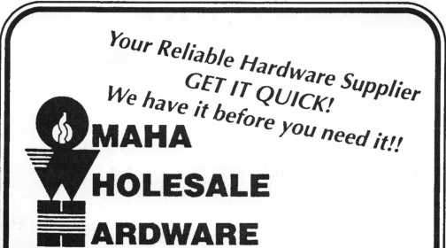

LCN

Von Duprin ILCO

Sargent & Greenleaf

(Arm-A-Door)

Roton

Detex

Simplex

Norton

Stanley

* Rixson
* Glynn-Johnson
* Adams Rite
* Jackson
* Master Padlock
* Folger Adam
* Locknetics
* Rutherford

(EFF-EFF)

* Telkee

To Order Call Toll Free

Phone: 800-238-4566 • Fax: 800-538-4566



Call Or Write for our FREE Full Line Catalog

Omaha Wholesale Hardware  
P.O. Box 3628 • Omaha, Nebraska 68103



Reader Service #20

CHANGE

THE WORLD

ONE

TOOTHBRUSH AT A TIME.

Some four-year-old children don’t

even have a toothbrush. That’s

one of the reasons there’s  
Head Start.

We give low-income  
preschool children what  
other children already  
have. The chance to learn.

To be healthy. To be happy.

But we need health care

volunteers. Especially medical

professionals like you, who want

to make a difference in the life of a

child. Come show a child how

to use his first toothbrush.

Give an eye exam. Or  
lend a child a trained,

sympathetic ear.

Because if you change  
the world of a child, you

change the world.

Call 1-800-27-START

for a brochure on volunteer

opportunities with Head Start.

§

HEAD

START

(4

February 1997

Keynotes

51



PRP

Report

llamesl^att, CML

Committee Chairman

world.

**Illinois, The PRP and You**

The contract between ALOA and the Illinois Department of professional regulation is now Dfficial. The first test will be later this spring. The cost, dates and time are still to 3e determined by the state of Illinois. The PRC, in conjunction with the state of Illinois, will use this column to announce the test dates and location for those interest­ed Illinois ALOA members.

Changes in the PRP

**/PRP Dates**

March 9, 1997

Sacramento, CA

Clark Security Products, Inc.

Contact: Bob Danielson  
(8003 343-1337

March 23, 1997

Livonia, Ml

IDN-Hardware Sales, Inc.

Contact: Fred Strosberger  
(800] 521-0955

April 6, 1997

Fort Lauderdale, FL  
South Florida Chapter of ALOA  
Contact: Jerry Moeller  
(3053 944-0469

April 11, 1997

Bellevue, WA

KDL Hardware Supply, Inc.

Contact: Dean Nickels,CPL  
(2063 483-1702

April 13, 1997

Anaheim, CA  
AM LOCK Security Show  
Contact: Debbie Lussier  
(9 093 371-10 88

April 21, 1997

Somerset, NJ  
MLANJ

(2013 267-8884

April 25, 1997

Red Deer, Alberta, Canada  
P.L.A.A.

Contact: Dave Kennedy  
(4033 9 48-9997

April 26, 1997

Eau Claire, Wl

Wisconsin Indianhead Chapter  
Contact: John Dorsey  
(7153 832-4207

30 Day Application Period on PRP  
Classes0

**I**J

Keynotes February 1997

**Dade County, The PRP and You**

The PRC is presently working on a proposal to present to Dade County, Florida to use the PRP as the required examination for Florida Locksmith Licensing. If ALOA receives the :ontract, locksmiths in Dade County, Florida will be certified as a condition of receiving a locksmith license.

Winning this contract would be another feather in ALOA’s cap for credible recogni­tion of the PRP as standard. Another caveat to be realized as one of the conditions for winning this proposal, the PRP would be translated in Spanish and Creole. While there are not that many Creole-speaking locksmiths, the number of Spanish-speaking locksmiths will welcome the fact that they may be able to take the PRP in their own language—something that has been request­ed many times. Look to this column for fur­ther developments on the Dade County rontract.

**PRP History Requests**

There have been a lot of requests for PRP history reports recently as the 1997 PRP sea­son gets underway. If you do not know what ^our PRP history is, please contact the Chairman by phone at 406-721-9797 or by fax at 406-549-7067. Be sure to have your :urrent ALOA membership number and /or Did ALOA membership numbers you might have taken the PRP under when you call or write. PRP history reports will be mailed or faxed to you upon your written request.

**Give the PRP a Try**

For those of you who may have started the PRP some time ago and found that you

could not pass the Mandatory, please consid­er giving it a second chance. If you have not attended a sitting in the last two years, the Mandatory—while still being the compre­hensive test it has always been—is now easi­er to pass as it is better written and, there­fore, easier to understand. Please give it a try this year.

**PRP Resource Guides**

As a last note, The PRP Resource Guide, although not the last word on the PRP by any means, is an excellent beginning source to use to find the information you need to prepare for your next sitting. The guides are available from either the PRC Chairman or the ALOA office for only $15, which includes shipping. Call today to get your copy.

**New Certifications:**

CRL’s

Cantu, Gilbert A./San Antonio, TX Davis, John L./San Antonio, TX Vega, Rubin/San Antonio, TX

iAbout the Chairman: James Watt,

CML, CPS, owns and operates Art and Ray’s  
Lock and Safe in Missoula, MX He has been an  
ALOA member since 1977 and is also serving as  
the Northeast Regional Vice President of ALOA.

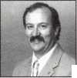

|  |  |
| --- | --- |
|  | Construction |
| Under |  |
| Reno, here we come. | ■ Carmen D. Murphey, CMP  Associate Executive Director |

Last month you were given all the educa­tional reasons for coming to ALOA ’97.

Now I’ll give you all the Reno reasons.

The Reno Hilton Hotel

The Reno Hilton, which is located just five minutes from the Reno Tahoe International Airport, will serve as the headquarters hotel for ALOA ’97. The hotel offers many built- in activities. Enjoy local humor at the Just For Laughs Comedy Club or relax at the Aspen Lounge. Hungry? You have your choice of six different restaurants, all offering delicious entrees, appetizers and desserts. For you athletic types, the hotel sports a 50 lane championship bowling center, an outdoor golf driving range on the lake, a heated out­door swimming pool and a health club. In the mood to try your luck? The Reno Hilton has one of the world’s largest casinos. If you’re looking for entertainment, stop by the shopping mall or see your favorite stars on the silver screen—the hotel offers two movie theaters. And for those of you who are inter­ested, there’s a wedding chapel, too!

If you prefer to stay outside the hotel, there is a RV park nearby.

Sight-Seeing

Reno is a busy town with many great sites to see. Take a trip down memory lane at the National Automobile Museum’s “The Cars You Remember.” The museum is located at 10 Lake Street South, at the Corner of Lake & Mill in Reno, just two blocks from down­town Reno.

At this exhibit, you’ll see more than 200 unique, vintage, classic, special interest, and one-of-a-kind wonders, including the 1907 Thomas Flyer, winner of “The Great Race” from New York to Paris; Lana Turner’s 1941 Chrysler Newport, only one of six made; James Dean’s 1949 Mercury, from the movie “Rebel Without a Cause”; a 1938 Phantom Corsair, the one-of-a-kind experimental car; the I960 Flying Caduceus, the first jet-pro­pelled land speed car; and A1 Jolson’s Classic 1933 Cadillac V-16. The museum also has a multimedia theater featuring automobile history. The price of admission is approxi­

mately 10 dollars for adults and four dollars for children ages six to 18.

The Lake Tahoe Ponderosa Ranch is also nearby. Home of “Bonanza” and “Bonanza, The Return,” the ranch—open to the public since 1967—is located on Lake Tahoe’s North Shore. Visitors can tour the famous Cartwright Ranch House and experience a real western town, including an ice cream parlor, general store, silver dollar saloon, an 1870 church, horse-drawn carriages, vintage cars, Indian artifacts and hundreds of rare antiques.

Tours

There are too many fun activities and sites to mention in this column, but in addition to the activities you can plan on your own, we will be offering three tours. On Monday,

July 28, you can join the Carson City/Vir­ginia City Tour at a cost of $40 per person. The busses will depart the Hilton at 10 am and return approximate at 4 pm. You will first see Carson City, the state’s capital, which was named after Kit Carson in the 1860s. Traditional and contemporary archi­tecture and lifestyles have been blended without compromise to either. En route to Virginia City, the tour will stop at The Chocolate Factory. There are many treats and surprises in store for you. The tour will pre­cede to Virginia City, where you’ll have lunch at the Delta Saloon, one of the finest remaining landmarks of Virginia City. After lunch, you’ll have time to browse the shops, antique stores and museums.

On Tuesday, July 29, we’ll have a tour of art galleries and antiques. Lunch is included. The cost is $40 per person. The busses will depart the Hilton at 10 am and return at approximately 3 pm. The tour begins with some of Reno’s finest art galleries and antique shopping, and ends with lunch and shopping at the Arlington Gardens Mall.

The tour includes a visit to Richardson’s Gallery, Reno’s newest gallery, which fea­tures a wide selection of contemporary art from around the world, and the Nevada Museum of Art, which houses a fine collec­tion of regional art and features a year-round

parade of changing exhibitions and activities to please any follower of the visual arts. There’s plenty of time to shop at one of the city’s largest antique marketplaces featuring vintage clothing, jewelry, furniture, pottery and many other collector’s treasures. Lunch is at the Country Garden Restaurant in the Arlington Gardens Mall.

On Wednesday, July 30, you can join the Emerald Bay Cruise at a cost of $45 per per­son. Busses depart the Hilton at 9 am and return at approximately 3 pm. The Dixie II is climate-controlled with enclosed decks with picture windows, an open promenade deck and a glass bottom viewing area. It is the largest, most sophisticated paddle wheel­er ever to cruise the lake. Participants also enjoy The Sunken Treasures of Lake Tahoe— an exclusive video presentation of what lies beneath the brilliant blue surface of North America’s largest alpine lake—while cruis­ing by Vikingsholm Castle and Fannette Island. Lunch will be on the Dixie II.

The Rig Banquet

“Putting on the Ritz” is the theme for this year’s banquet, which will be held Friday, Aug. 1 at the Hilton Hotel. Join us for a light reception 6:30 to 7 pm, and dinner and entertainment from 7 to 10 pm.

Since the theme is based on a ’40s style night club, there will be a nine-piece orches­tra featuring the Big Band music. A special feature of this evening’s entertainment is our comedienne, Bobbie Shropshire. Bobbie began to develop her unique style while touring all over North America and Aus­tralia with such comedians as Will Durst, Bobby Collins and Joan Rivers.

To top off the evening, we will honor sev­eral fellow industry leaders by presenting The A.L.O.A., ACE, Don Davis and Presi­dent’s Awards. Cost is $55 per person.

We hope to see you at the ALOA ’97 Convention. One thing is for sure—it’s going to be great!

About the Author. Carmen D. Murphey, CMP, is the Associate Executive Director for ALOA.

February 1997 Keynotes hi

Buyer’s

J Guide



Allstate Locksmith Insurance Program

As a retail or  
mobile locksmith,  
you understand  
how important it  
is to rely on a  
solid, reputable  
company to help  
you with your  
business insurance  
needs. If you have  
any questions  
about your insur-  
ance needs in gen-  
eral, an Allstate  
Agent can provide  
you with addition-  
al information. To  
be referred to an

Allstate Agent, please call 1-800-669-6711.

Reader Service #22

SPEEDYPIK"

The automatic key ID system. This com-  
pact unit fits inside your IBM compatible  
computer in a 51/4 bay the same as a disk  
drive. The latest addition is a 5,000 key  
pre-programmed database. Now you can

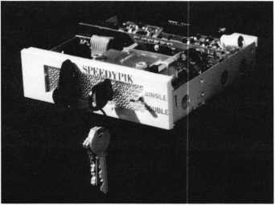

leave the key cutting in the care of an apprentice without a long training period. This will free the locksmith up to do other work.

(617) 567-1111; FAX (617) 277-7777; e-mail: [SPEEDYPIK@juno.com](mailto:SPEEDYPIK@juno.com) Reader Service #23

New SDC 1571 EmLock®

The New SDC 1571 EmLock® is in stock and features the first breakthrough in years

54 **| KeynotesFebruary 1997**

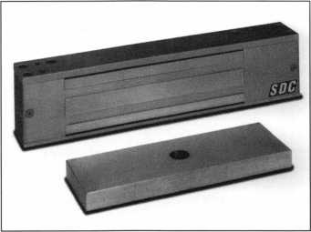

for design, quality and price for the Electro­magnetic Lock. Features include: a patent­ed welded steel core construction that elimi­nates epoxy and increases stability, field selectable 12 and 24 VDC, 1200 pounds of holding force, easy installation and the first all aluminum housing. For nationwide shipping, call Intermountain Lock and Sup­ply at (800) 453-5386 (Salt Lake City) or (800) 323-8046 (Denver).

Reader Service #24

Does Doubling Your Profit Interest You?

Your customers are sure to select one of our North American-made, high quality pewter key chains at the same time they purchase a new lock or cut a new key.

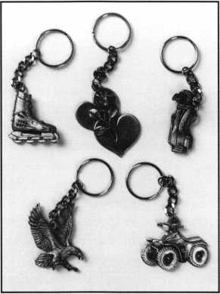

Offer your customers quality at a low price with a money back guarantee. FAX or phone today!

FAX (514) 425-5793 or Phone (514) 425-5794 Milman Manufacturing P.O. Box 1641

Champlain Mall Rd. Champlain, NY 12919 ***Reader Service #25***

Key CAD, Inc.

Master Key Designer is the premier product from Key CAD, Inc., a North Carolina based software development corporation. The software combines a master key system

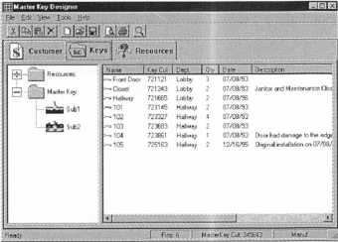

generator with a storage database. Unlike several other master key programs, Master Key Designer does not use any of the stan­dard progression models for its generator. While this tends to limit the number of keys generated, it does allow the customer to have complete control over key assign­ments, with cross-checking between each key. In fact, Master Key Designer will even generate new change key numbers from a preexisting system, regardless of what the system was based on, using its own safety criteria. Other nice features of the program are the details available for each key, and an extensive key locating ability. Toll free (888) 805-0104.

Reader Service #26

Cap with Built-In Light

This cap is the perfect solution for hands­free lock and safe work which requires some

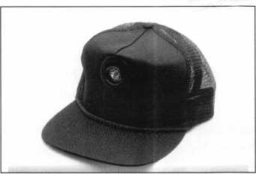

illumination. The light is build right in and can be adjusted to three different positions. The light turns on when it is pushed down in any of the three angles. Operates on two AAA batteries (included). Made from black cotton mesh, the cap is fully adjustable and very affordable. Contact MBA (mark bates Associates) toll free at (888) 622-5495,

(606) 887-0496, Fax (606) 887-9491 or write: 101 Edgewood Plaza Dr., Nicholasville, KY 40356-1850.

Reader Service #27

h.e.s., Inc 7500 Series Strike Passes UL Fire Door Test

The test was a success. The h.e.s. models 7501 and 7505 are now UL listed for fire doors, category 10B, for use on class “A”— three hour or less doors. This is the highest rating an electric strike can obtain from UL.

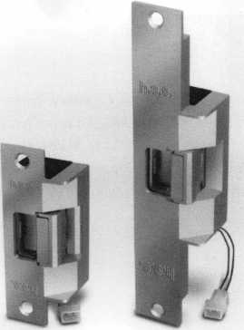

7501 7505

The 7501 and 7505 models are available now for immediate shipment, h.e.s is very excited to offer such a superior electric strike to our customers, and we look forward to a successful partnership in 1997.

Hanchett Entry Systems 2040 W. Quail Avenue Phoenix, AX 85027 ***Reader Service #28***

|  |  |
| --- | --- |
| ALOA | / |
| Extra | \ |

-^Dep^

Make a Date

The dates for the ALOA Convention in Reno, NV have changed. The convention will now run July 28 to Aug. 2, 1997.

Make a note on your calendar!

You’re Invited!

The 1997 ALOA Spring Board Meeting will take place in the big city of Dallas on March 11 through 16th. Guests will stay at the Harvey Hotel Dallas. All ALOA mem­bers are welcome to attend. Contact the ALOA Meetings Department if you plan to attend.

A Real ACE

At the Yankee Security Convention, Inc., C. Allan Halverson was presented the ACE Award on behalf of ALOA and Trustee, Evelyn V. Wersonick, CML, CPS. Halverson has been a strong force in ALOA, and his hard work is greatly appreciated.

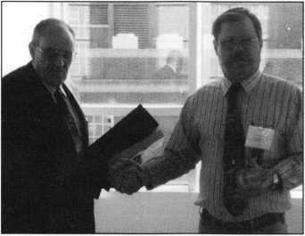

In Passing

H. Roger Grace, a long time member of the craft, died Jan. 10, 1997. He was born Feb. 5, 1905, in Des Moines, Iowa. As a youth, he moved with his family to Omaha and attended the University of Nebraska (Lin­coln).

He worked for AT&T in Omaha for sev­eral years. In 1945, he moved to Hastings, Nebraska, where he bought a business and changed the name to Grace’s Bike and Key Shop. In 1968, he and B. Gifford Sager acquired Circle-Ess (the key machine manu­facturing company) and moved its opera­tion to Hastings.

In 1972, he sold the retail/service portion

of Grace’s Bike and Key Shop, and renamed the supply division to Grace’s Wholesale & Supply. He also continued with Circle-Ess, Inc., until his death.

Roger was a member of ALOA (#1549), and he was the founder of the Nebraska Locksmith Association. He was happy to share his knowledge with others in the trade. His wholesale customers will remem­ber him for the extensive notes of advice on usage, which he often typed on invoices, and for his refusal to establish a minimum order amount.

Roger and his wife Irene Fogarty Grace, who died in 1983, are survived by four chil­dren: Margaret I. (Mrs. Merrill E.)

Westrope, Herbert R. Grace, E. Helen (Mrs. W.L.) Thomas and Dorothy G. (Mrs.

Rocky) Friend, CML.

Legislative Fund

At the November ’96 Board Meeting, the members voted to start the ALOA Legisla­tive fund. Board members donated the ini­tial funds, and the Locksmith Association of Washington D.C. Area, Inc. followed suit with a $1,000 donation. LADC hopes to set an inspiring precedent for other chapters because legislation is extremely important to the locksmith profession.

ALOA ID Cards

Due to a delay in delivery from the vendor, some renewing members and new members may not be receiving their ID cards until late February. This will in no way affect membership benefits in the interim. We appreciate your patience.



Keynotes Advertisers index

|  |  |  |
| --- | --- | --- |
| RS# | Advertiser | Page |
| 100 | Jet Hardware Mfg., co. | BC |
| 29 | Locksmith Publishing Corp. | 57 |
| 19 | MIWA Lock USA | 43 |
| 21 | MLANJ | 35 |
| 20 | Omaha Wholesale Hardware | 51 |
| 1 | Security Technology & Design | 8  IV |
|  | February 1997 | Keynotes |



Focus

Qn Education.

pTrr^TazTer, CML Education Chairman

Knowledge is the key to attending classes.

What do S&G, Ft. Lock, Vindicator,

LaGard, Meilink, AMSEC and Mas Hamilton have in common? Charles Stephenson of Lockmasters asked this ques­tion recently. His reply? “Electric safe locks.” In just a few short years, electronic safe locks seem to be taking over much of the safe lock market. “Convenience” seems to be one of the primary reasons, as well as the security now offered by these electronic locking mechanisms.

ACE is responding to this with the help of Lockmasters and others. We will have a great class on electronic safe locks at Master Locksmiths Association of New Jersey from April 17 to 21, 1997, in Somerset, New Jersey. This class and one on Basic Safe Lock Servicing will be offered here, with Charles Stephenson of Lockmasters instructing for ACE. In addition, we have 19 additional

^Upcoming ACE Classes

Beehive State Locksmith Assoc.

March 15-16, 1997 Salt Lake City, UT Contact: Deloy J. Hamblin, CPL [801) 621-5625 Master Keying Methods

Grand Canyon Chapter of ALOA

April 5-6, 1997 Phoenix, AZ Contact: John Ilk (520) 474-8879

Combination Lock Manipulation Instructor: Ken Lee, CPL

Master Locksmith Assoc, of New Jersey

April 17-21, 1997 Somerset, NJ Contact (201) 267-8884 19 full-day classes and two evening seminars

ALOA ’97

July 27-Aug. 1, 1997 Reno, NV

Contact: ALOA Meetings Department (214) 827-1701 (800) 532-2562 Approx. 45 full-day classes, 30 half-day classes and six evening seminars More information TBA

J



Keynotes

February 1997

success, and this knowledge is gained by

class days and two evening seminars sched­uled for this event. MLANJ has a great show and banquet, so if you are living in the east, you do not want to miss this great time of education and fellowship. Contact MLANJ at 201-267-8884 for full details and a con­vention brochure.

For those in the west, Texas Locksmith Association will be holding their Annual Education Conference/Convention in Corpus Christi, TX from Feb. 5 to 8, 1997. ACE has scheduled eight classes, and Lockmasters will have seven safe related classes available during this same conference. TLA’s Banquet is great, as is their trade show, which will be on Saturday, the eighth. Contact Wanda J. Robbins, at 210-923-4381 for full details on both the ACE and Lockmasters classes.

From March 15 to 16, 1997, the Beehive State Locksmith Association will have a two- day ACE Masterkeying Methods class with .Jerome V. Andrews, CML, instructing. The class will be in Salt Lake City, Utah, and will be a great opportunity for those in the area to obtain one of the finest classes on masterkeying available. Contact Deloy J. Hamblin, CPL at 801-621-5625 for full details.

From April 5 to 6, 1997, the Grand Canyon Chapter, ALOA, is holding a two- day ACE class, “Combination Safe Lock Manipulation,” in Phoenix, AZ, with Ken Lee, CPL, as instructor. Contact John Ilm, CRL, at 520-474-8879 for full details.

Then there will be ALOA ’97 Security Expo in Reno, NV from July 28 to Aug. 2, 1997. ACE has planned 45 full day classes on Monday to Wednesday, four evening seminars on Monday and Tuesday and 30 half-day classes on Thursday and Friday. The Security Expo will open on Thursday at noon, and run through Saturday at 4:00 p.m. at the Reno/Sparks Convention Center. Watch for full details in the brochure that will be mailed to you very soon. You certain­ly do not want to miss this great opportuni­ty for education, fun and fellowship in Reno.

It is my wish that during 1997, ACE and ALOA can provide each of our members the opportunity to be a part of a great class

where they will go away better equipped to meet the challenges of the coming years in our industry. Knowledge is the key to suc­cess, and this knowledge is gained by attending classes, seminars and other educa­tional opportunities. Trade shows are a great education in themselves. One can see, touch and learn about all the new products that are available to us in this growing industry. Security is becoming one of the fastest grow­ing industries in our society. People are more concerned today than ever about their per­sonal and family security. You, the profes­sional locksmith are the security expert! You have gained that reputation through knowl­edge, and that knowledge through educa­tion.

“Education is not cheap,” yet “ignorance is far more expensive!” Looking forward to seeing and meeting you at one of the ACE classes scheduled.

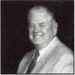

About the Chairman: James

Glazier, CML, #14240, is a retired police officer and operates Security Plus in Mount Airy, MD. He also serves on the Finance, Convention and Personnel Committees of the ALOA Board.



International (surface) $119.00

International (surface) $65.00

3 YEARS (includes 36 issues, 3  
USA $90.00

2 YEARS (includes 24 issues, 2 FREE Annual Directory* issues)

USA $64.00 Canada $91.00 International (air) $179.00

1 YEAR (includes 12 issues, 1 FREE Annual Directory* issue)

USA $38.00 Canada $52.00 International (air) $95.00  
*Comprehensive guide to industry manufacturers, distributors, products and services.

er International

□ **YES! Please**

CARD INVALID UNLESS COMPLETE DATA IS GIVEN

You must indicate your locksmithing affiliation below  
re you a locksmith or individual involved in locksmithing? □ YES Q NO

y position is; □) Owner/Pres. Q3 Employee Q6 Student Q9 Other

isiness classification (check one only): A □Locksmith shop B J Hard ware CQ Wholesaler/Distributor D □ Manufacturer

E □ Security or Maintenance

1. □ Consultant 3 Q Industrial 5 Q Government
2. □ Commercial 4 Q Institutional 6 Q Police

GQ Architect/Specifier ZQ Other (specify)

re you involved in purchasing or influencing the purchase of locksmith products? □ YES □ NO

Name

Company

Address

City StateZip

PhoneFax

Payment: (us funds only) Money Order Charge Card Check #

Complete for Charge Orders Only: VISA Master Card

Account #Exp. Date  
Signature

IM7

Send payment to: Locksmith Publishing Corp. • 850 Busse Highway • Park Ridge, IL 60068  
Phone: 847-692-5940 • Fax: 847-692-4604 • Website: [www.lpc.simon-net.com](http://www.lpc.simon-net.com)

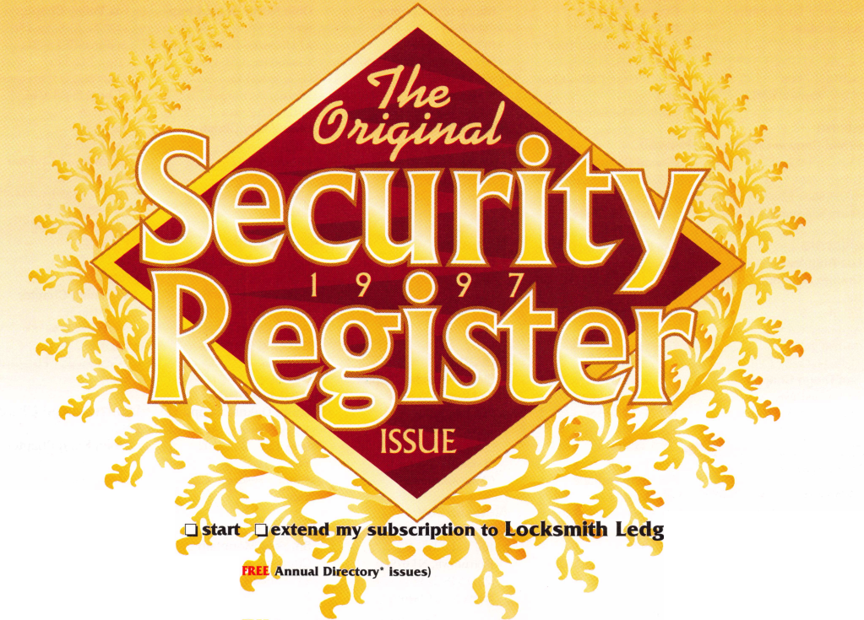

Chapter

Roster



Dept)

**^ The best way to leam about ALOA’s programs  
and to network with locksmiths in your area is by  
participating in local ALOA chapter activities. This is  
your opportunity to exchange management and tech-  
nical information, build your professional image, and  
share trade tips with your fellow locksmiths.**

**If you want to start a chapter in your area, please call  
ALOA, (214) 827-1701.**

Alabama

Alabama Locksmiths Association

411 6th St.

Decatur, AL 35601 (800) 292-5008 *Larry Warnick, CML

Arizona

Grand Canyon Chapter

13016 S. 131st St.

Gilbert, AZ 85233 (602) 786-8182 *Larry Schlemmer, CRL

California

Los Angeles/

Orange Counties Chap­ter

P.O. Box 697

Alhambra, CA 91820-0697 (310) 869-2555 *John H. Cosby, CPL San Diego Chapter

1049 Island Ave.

San Diego, CA 92101 (619) 234-4829 *Frank Hartung, CML— Chairman

Colorado

Colorado Front Range

2603 Pearl St.

Boulder, CO 80302 (303) 443-9740 John I. Shandy, CML— Chairman

*John M. Thomas, CRL— Vice Chairman (303) 666-8980

Connecticut

Nutmeg Chapter

Phil’s Lock Shop 360 E. Main

Meriden, CT 06450-6022 (203) 237-4602 Phillip Hobbs, CPL—Chair­man

Florida

South Florida Chapter

1710 NE Miami Gardens Dr.

Miami, FL 33179 (305) 944-0469 *Jerri Moeller, CRL Secre­tary

Paul Renderer, CML— Chairman

Georgia

Georgia Chapter

P.O. Box 48088 Atlanta, GA 30362-1088 (404) 455-6244 John T. Grist, CML—Chair­man

*M.W. Whitman, Jr.

Hawaii

Hawaii Chapter

4420 Lawehana St.

Unit 4

Honolulu, HI 96818 (808) 623-5914

* Andreas Muenker, CML— Chairman

Indiana

Central Indiana

1237 Wabash Ave.

Terre Haute, IN 47807 (812) 234-6249 *Herbert Dusenberry, CML

Northern Indiana

122 N Orchard St. Kendallville, IN 46755 (219) 347-1754 *Earl Shanfelt

Southern Indiana

P.O. Box 185 Bloomington, IN 47402- 0185

(812) 334-3737

* Daniel W. Hill, CML

Kentucky

Kyana Chapter

510 E. Parrish Ave. Owensboro, KY 42303- 3125

(502) 684-5093

*Timothy Morrison, CML—

Secretary

Maryland

Chesapeake Chapter

700 Rappolla St.

Baltimore, MD 21224 (410) 633-0111

* Bob De Weese, CPL— Chairman

Massachusetts

Massachusetts Chapter

200 Weir Street Taunton, MA 02780 (508) 823-4649 *Stephen Ehrlich, CML— Treasurer

Minnesota

Minnesota Chapter

3M Center Bldg. 223-BE-04 St. Paul, MN 55144-1000 (612) 733-6674 *Douglas Rude, CRL

Montana

Montana Chapter

1000 S. Main Butte, MT 59701 (406) 782-0125 *Aggie Cooney, CPL

Nebraska

Nebraska Chapter

343 W. 2nd St.

Hastings, NE 68901 (402) 463-6661 *Brad Boden

Nevada

Sierra Nevada Chapter

C/O Pamela Vankirk P.O. Box 115 Reno, NV 89504 (702) 328-9285 *Danniel F. Howard,

CML—Chairman

New Jersey

Garden State Chapter

106 Ridgedale Ave. Morristown, NJ 07960 (201) 538-2737 *Steve Frei, Chairman

New Mexico

New Mexico Chapter

917 2nd St. NW Albuquerque, NM 87102 (505) 242-1380 *Evelyn Wersonick, CML Marc McGrannahan, Chair­man

Sunbelt Chapter

South Central Region New Mexico State University

Box 30001 Dept. 3545 Las Cruces, NM 88003-0001 (505) 846-6292 *Don Brazil—Chairman

North Dakota

North Dakota Chapter

Rte. 1 Box 67 Devil’s Lake, ND 58301-

Ohio

Ohio North Coast Chap­ter

#2 Horseshoe Drive Monroeville, OH 44847 (419) 465-4153

*Ronald Betschman,

CML—Chairman

Ohio Valley Chapter

144 Julep

Cincinnati, OH 45218 (513) 825-7528 *James T. Brickler,

Chairman

Pennsylvania

Keystone State Chapter

P. O. Box 0261 Eagleville, PA 19408 (610) 265-3380 e-mail: [KSTATE@aol.com](mailto:KSTATE@aol.com)

* Robert Cook, CML— Chairman

South Dakota

South Dakota Chapter

402 S. Minnesota Ave.

Sioux Falls, SD 57102 (605) 331-6026

* Ronald Heidzig—Chair­man

Tennessee

Smokey Mountain Chapter

2557 Middle Creek Rd. Pigeon Forge, TN 37863 (615)453-8344 *Jessie Swan, RL West Tennessee 1643 Bartlett Rd.

Memphis, TN 38134 (901) 372-7464 *Richard Pat Walker,

CML—Chairman

Texas

Sunbelt Chapter

see New Mexico listing

Washington, D.C.

Washington, D.C. Area

4713 Tallahassee Ave. Rockville, MD 20853 (202) 722-0900 *Lester Brodsky—Chairman

Wisconsin

Fox Valley Chapter

1425 N. Richmond St. Appleton, WI 54911 (414) 731-5400

e-mail [sageinc@athenet.net](mailto:sageinc@athenet.net) *John F. Engal, CRL Chairman Tom Ripp Vice Chairman Indianhead Chapter 201 N. Barstow St.

Eau Claire, WI 54703-3525 (715)832-4207 *John Dorsey, CPL Chairman

Wyoming

Wyoming Chapter

521 Main St.

Spearfish, SD 57783 (605) 642-4542 *Gene Ficek, CPL—Chair­man

International Chap­ters

Hong Kong Chapter

901 Canton Rd, G/Fl Mong Kok Hong Kong

*Timothy Chow—Chairman

Korea Chapter

#1250-7 Bi San 7 Dong Seo Gu TaeGu Korea

(053) 353-0058 *Myeong-rae Cho

* Denotes contact person for this chapter.

All questions regarding chap­ter activities, meetings and events should be directed to this individual.

3907

(701) 662-5625 *James H. Strong, CRL

Keynotes

February 1997

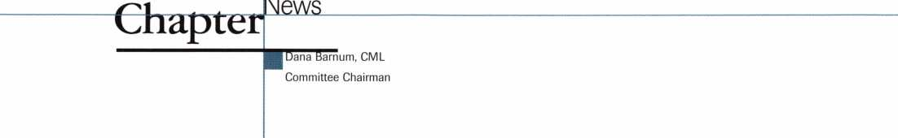

It’s time for each of us to plan ahead and set some goals for the coming year.

Hello again, chapter members!

First, I would like to remind the chair­men and directors of your chapters of the upcoming ALOA spring board meeting. It is scheduled to take place in Dallas, Texas, March 11 through March 16. Since you, the membership, are the real driving force behind your association (ALOA), may I sug­gest that you put this meeting notice into your chapter’s agenda for February. If any chapter members have any suggestions or motions for the board to consider, now would be the time and place to present them. I must have these suggestions, com­ments, or motions in my hand by the first of March in order to get them onto my com­mittee agenda. You may fax me or use my e- mail address at the end of this article.

This month I would like to personally encourage those who have volunteered their time and effort to be your chapter secretary or newsletter editor. Thank you for serving and sharing with your fellow members the meeting minutes, the upcoming events, the humor of the day and personal experiences. Before I sit down to write these articles to all of you out there, I try to get in touch with each of you by reading your chapter meeting reports and/or newsletters. I must say, read­ing all of these reports and newsletters makes me feel like part of your group. I am truly privileged to be the chairman of the ALOA Chapters committee and to be able to serve you in this small way. When I read your newsletters, sometimes I see an inter­esting meeting coming up, and I wish I could be a part of that! Then I look at the cover sheet again and realize that the meet­ing is taking place on the other side of the country! But I always love to see an article from one of you that I have gotten to know through our ALOA conventions.

Looking on into the spring and coming events for 1997, it’s time for each of us to plan ahead and set some goals for the com­ing year. I have said to myself, what can I do to improve first myself, then my business, my ALOA chapter or even my profession of locksmithing? Now, I know all of that being considered at one time is certainly mind-

boggling, but consider this: If every ALOA member, who is a member of a chapter or association, was to set for himself or herself a goal to make some changes to improve themselves and their trade, how much better off our industry would be. Just set yourself a goal this year—to attend every meeting and volunteer your help where needed for any­thing you are capable of doing for your chap­ter or association. Vow to try to make a dif­ference in some small way. Try it and go ahead—make a difference. Until next time.

**From the Chapters**

News from Korea

At the ’96 ALOA Korea chapter meeting, Man S. Seo (#21654) was unanimously elect­ed to the position of the ‘97 Chairman of the Korea chapter. Congratulations!

Spring Fair

The Wisconsin Indianhead Chapter is sponsoring their “Lock Spring Fair” April 24, 25, and 26. This event includes two classes followed by a PRP evaluation, and a locksmith fair. Locksmithing skill events, such as disassembling and reassembling a steering column with an airbag, unlocking several car doors, impressioning several com­mon cylinders and picking open frequently confronted locks, will be featured. Prizes will be awarded in each category. The grand prize will be an all-expense paid trip to the ALOA seminar and convention in Reno, Nevada and a laptop computer. .

For more information contact:

Wisconsin Indianhead Chapter ALOA 201 N. Barstow Street Eau Claire, WI 54703-3525 Fax: (715) 832-8872

Pay Up!

It’s 1997, so remember—the new year brings new chapter dues for members! Be sure to pay your dues on time! Your chapter is counting on you.

I About the Chairman: Dana

Bamum, CML, #05444, operates South Penn Lock & Safe Co. in Media, PA. He also serves on the ALOA Education, Membership and Bylaws committees, as well as having been on the board of directors of the Greater Philadelphia Locksmiths Association (GPLA). Dana has also sponsored many new ALOA members. Dana can be reached at FAX (610) 565-9902 or e-mail him at dlbamum@aol. com.

February 1997

Keynotes

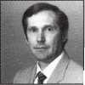

Back

Page

Green Jello sculptures have been  
called art. Googly-eyed puppets  
made from old socks have been  
called art. Even mega-star Arnold  
Swartzenegger’s movies have been  
called art. But could a block of

bronze/aluminum alloy be consid

ered art? It can if the right person

gets hold of it.

Art, as everyone knows, is sub-

jective. For every member in your

chapter, and for every person in  
ALOA, the locksmith profession  
and in the world, there is a  
definition of art.

That’s a lot of stuff to consider.

But when you happen to come

upon an object that has been dili-  
gently and delicately crafted, most  
would probably agree on one  
thing. It’s art.  
Dave Sohngen has been a lock-  
smith for 26 years, and his exper-  
tise, friendly personality, and  
devotion to the profession have

earned him a strong reputation  
among his fellow Ohio Valley

Chapter members. ALOA member t]

Mehdi Zahedi wanted Keynotes

readers to know more.

■0

He wanted to point the spot-

light at Sohngen’s artistic flair.

For nearly two years, Sohn-

gen methodically filed away at a

chunk of bronze/aluminum  
alloy, which has a greater hard-

ness than pure brass. With peri-  
odic help from an electric hand  
drill, the block began to take on

familiar shape. Little by little,

hanks to patience and precise

craftsmanship, the hunk of

metal was eventually trans-

formed. And after careful buff­ing from a buffing wheel, Sohn­gen had created a beautiful three-inch key.

“If you held this key in your hand,” said Zahedi. “You’d think it came from a machine.” The key perfectly fits an old lock from a demolished jail. Smooth and shiny with a deco­rative design, this creative sym­bol of locksmithing is a testa­ment to the dedication and hard work of locksmiths worldwide.

“It’s a beautiful key—not just a key that works,” said Zahedi. “It’s a piece of art.”

If Sohngen could do all that with heavy metal, just imagine what he could do with a canvas, a brush and a little paint.

Keying in on JArr

Laurie Kline

Keynotes

February 1997

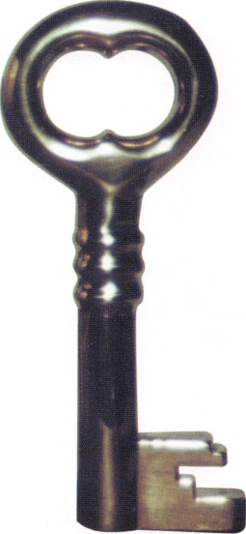

To order, write or FAX:

ciated Locksmiths of America, Inc.; 3003 Live

Oak Street Dallas TX 75204 FAX [214] 827-1810

Credit card orders: Phone (214) 827-1701

Get the best master keying textbook

well- known locksmith instructors

(including shipping and handling]

Fundamentals of Master Keying

write a system

*itroduction to Split Pin Master Keying*

**Jerome V. Andrews, CML**

around, written by one of the most

in the profession. Just $44.00

covers system structure and record

keeping; basic mechanical and

arithmetic concepts; and how to

ISls:

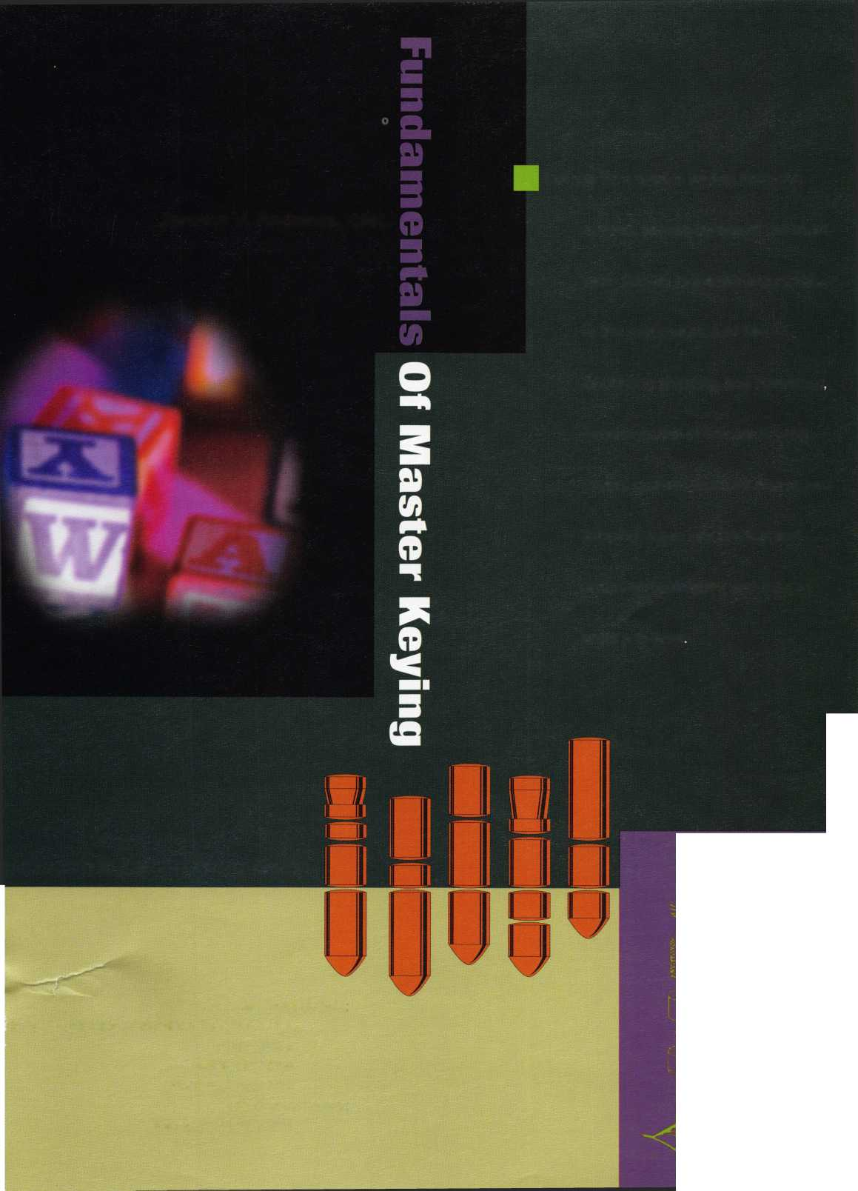

**Jet Silver Line**

In two short years since its initial introduction by jet, the silver line has become a symbol of quality and a monument to precision in the key manufacturing industry. The silver line keys are coined, embossed and designed to look exactly like the originals. Plus the jet pledge guarantees superiority over the originals as well.

jet’s silver line offers regular and sectional keys from

ARROW BEST CORI

DIEBOLD FALCON HHM

KWIKSET LeFEBURE MEDI

MOSLER SARGENT SAR<

SCHLAGE YALE YORI

New keys blanks are constantly added to the silver line to serve Master Keying and Duplication needs. Recent additions included Best 1A1DE1-NS and Best 1A1JK1-NS Composites... Another jet symbol of Quality.

JET HARDWARE MANUFACTURING CORP

800 Hinsdale Street, Brooklyn NY 11207

